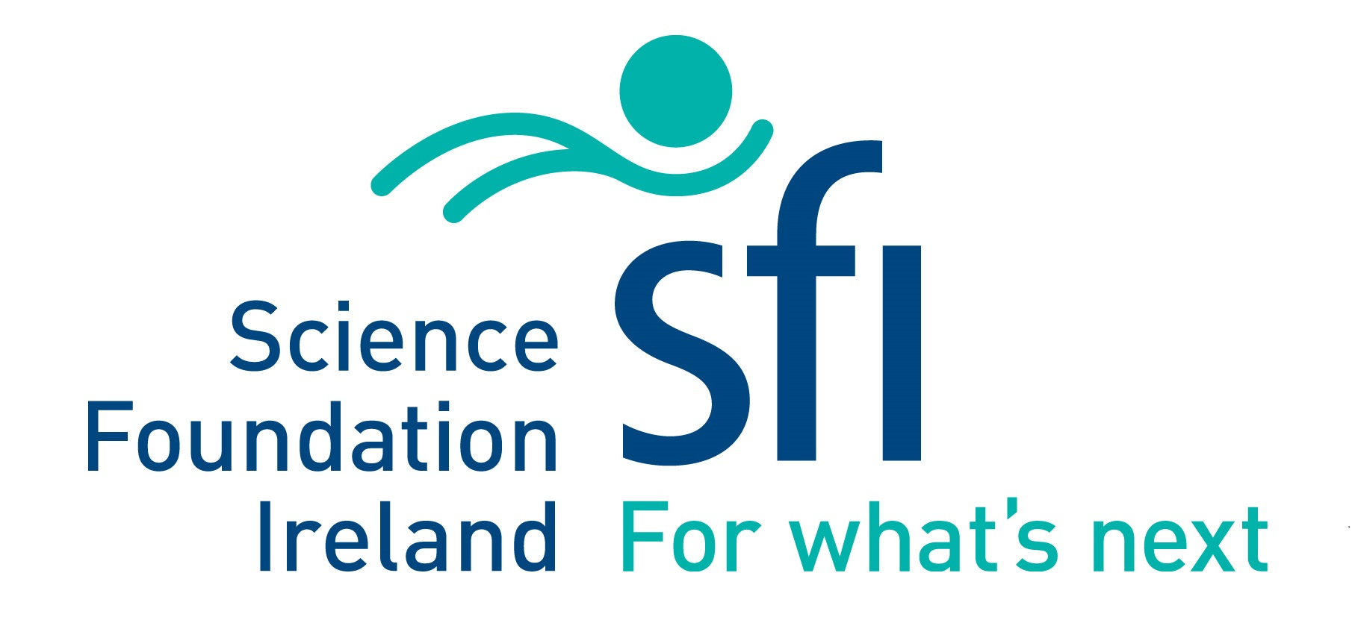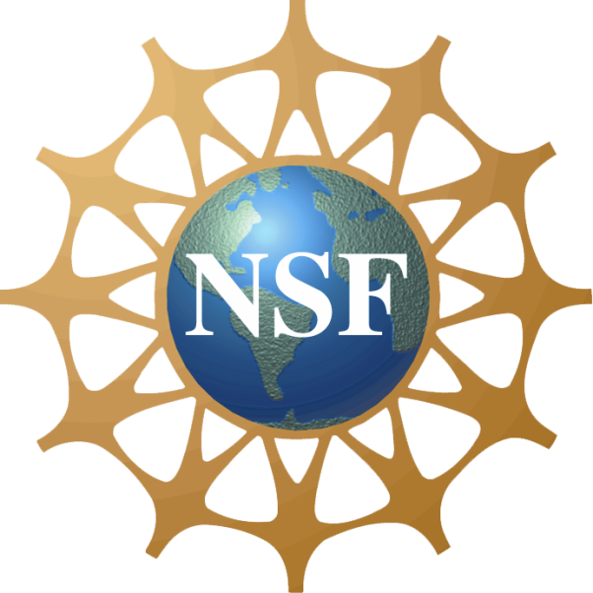

US-Ireland R&D Partnership Programme

Centre-to-Centre Mechanism
______________________________________________________________________________________

Guidance for Republic of Ireland (RoI) and Northern Ireland (NI) applicants for Submission of Tri-Partite Centre-to-Centre (C2C) Proposals to the
National Science Foundation (NSF)

Version: 23 April 2021

Key dates
Mandatory Expression of Interest (EoI) is required to be submitted to Science Foundation Ireland (SFI), Department for the Economy (DfE) and NSF at least 18 weeks in advance of the full submission deadline at NSF (23 weeks in advance of the ERC site review)
Draft Tri-Partite Proposal SFI and DfE DEADLINE - 6 weeks in advance of NSF deadline or, if applicable, the deadline at the US University’s Research Office in advance of the NSF submission deadline (11 weeks in advance of the ERC site visit)
NSF full proposal deadline is 5 weeks in advance of the ERC site visit

Contents
1. Background and Objectives 3
2. How the Centre-to-Centre Mechanism Operates 3
2.1 Expression of Interest 4
2.2 Draft “tri-partite” Centre-to -Centre proposal submission 4
2.3 Submission Steps Timelines 5
3. Eligibility Criteria 5
4. Funding 5
5. Submission of Draft Tri-Partite Proposal to Irish Funding Agencies 6
5.1 SFI Requirements to the draft proposal submission 6
5.2 DfE Requirements 7
6. Tri-Partite Draft Proposal – Review Process and Criteria 7
7. Submission of Final Tri-Partite Proposal to NSF 8
8. Post-Award Review 8
9. General Data Protection Regulation Statements 9
9.1 SFI Statement 9
9.2 DfE Statement 9
APPENDIX 1: FULL PROPOSAL OUTLINE AND EVALUATION CRITERIA 10
APPENDIX 2: COVER SHEET FOR US-IRELAND PROPOSAL, ROI APPLICANTS 13
APPENDIX 3: BUDGET TEMPLATE FOR ROI APPLICANTS 14
APPENDIX 4: COVER SHEET FOR US-IRELAND PROPOSAL, FOR NI APPLICANTS 15
APPENDIX 5: BUDGET TEMPLATE FOR NI APPLICANTS 16

1. Background and Objectives
The US-Ireland Research and Development Partnership, launched in July 2006, is a unique initiative involving funding agencies across three jurisdictions: United States of America (US), Republic of Ireland (RoI) and Northern Ireland (NI).
The overall goal of the Partnership is to increase the level of collaborative R&D amongst researchers and industry across the three jurisdictions. This collaboration aims to generate valuable discoveries and innovations which are transferable to the marketplace, or will lead to enhancements in health, disease prevention or healthcare.
The Partnership achieves its goals through tri-partite research projects in which the funding agencies fund the elements of research undertaken in their own jurisdiction. Importantly, the Partnership must add significant value to each research programme above that achievable by the PI in each jurisdiction working alone.
Under the US-Ireland R&D Partnership Programme, the National Science Foundation (NSF) (US), together with Science Foundation Ireland (SFI) (RoI) and the Department for the Economy (DfE) (NI) have expanded existing opportunities for individual investigator-driven collaborations to include Research Centre-based collaborations between researchers in the three jurisdictions.
This guidance document outlines the objectives, eligibility, funding available, review process, and application procedures for submission of a US-Ireland R&D Partnership Centre-to-Centre (C2C) proposal to the National Science Foundation (NSF) in the Sensors & Sensor Networks, Nanoscale Science & Engineering, Telecommunications, Energy & Sustainability, and Cybersecurity themes.

2. How the Centre-to-Centre Mechanism Operates
The Centre-to-Centre mechanism is currently open to existing SFI-funded Research Centres, NSF-funded Engineering Research Centers (ERC) and researchers in Centres in Northern Ireland.
Each US-Ireland R&D Partnership proposal must have a minimum of one applicant from each jurisdiction and significant research participation by all three jurisdictions. The work proposed for each jurisdiction must add significant value, so that the overall programme of research goes beyond what might be achieved by any one PI working alone supported by national funding only.
The mechanism is a two-step process with Centres being required to submit a two-page Expression of Interest (see Section 2.1), and if successful, the Centres partnership is invited to submit a single tri-jurisdictional proposal in the format required by NSF, which undergoes the review at the annual ERC site visit. Proposals are evaluated in accordance with the standard NSF merit review criteria of intellectual merit and broader impacts of the proposed effort, and additional Centre-specific criteria (see Appendix 1) in support of vision, strategic plan, and ongoing activities within each Centre. The funding agencies on the island of Ireland have agreed to accept the decisions of NSF with regard to the suitability for funding of individual proposals.

2.1 Expression of Interest
To gauge whether the proposed collaboration fits within the scope of the US-Ireland C2C agreement, partners are required to submit a short summary of the proposed collaboration to their respective funding agency. This summary should be composed of two sections, each approximately one-page in length. The first section should address the intellectual merit and broader impacts of the proposed collaboration – focusing on the proposed research, the value of international collaboration, role of each participant, anticipated industry engagement, and the anticipated budget scale (detailed information on the budget is not necessary). The second section should focus on how the proposed project fits within the larger scope of the Research centre and include a statement on how intellectual property issues will be addressed. As a part of this submission, brief information (e.g., names and affiliations) on all of the PIs and co-PIs involved should be provided.
The EoIs from each Centre must be submitted by the applicants to their respective funding agencies no later than 18 weeks in advance of the NSF deadline (23 weeks in advance of the ERC annual site visit).
For RoI applicants, please submit to USIreland@sfi.ie
For NI applicants, please submit to USIreland@economy-ni.gov.uk
The EoIs are shared amongst partner agencies and assessed by them at a joint meeting. If approved, the applicants are invited to submit a full proposal.

2.2 Draft “tri-partite” Centre-to -Centre proposal submission
The peer review of the full proposal is undertaken by the NSF ERC annual site visit panel. The deadline for submission of the full proposal is determined by the date of the ERC’s annual site visit. The joint proposal must be submitted to the NSF at least 5 weeks in advance of the annual site visit along with the ERC’s annual report.
A draft of the “tri-partite” Centre-to-Centre proposal must be simultaneously submitted to the SFI, DfE, and NSF at least 6 weeks in advance of the NSF deadline (11 weeks in advance of the ERC annual site visit) or, if applicable, the deadline at the US University’s Research Office in advance of the NSF submission deadline.
Following submission of the draft proposal, the SFI and DfE will assess the proposal in order to
- determine if there is evidence of significant participation by all partners,
- to pre-approve the budget for the project and, if supportive
- to inform the relevant personnel at the NSF of the RoI/NI support for the proposal should it be approved for funding, and
- to provide a funding commitment letter to the applicant for inclusion in the full proposal submission to NSF.

2.3 Submission Steps Timelines
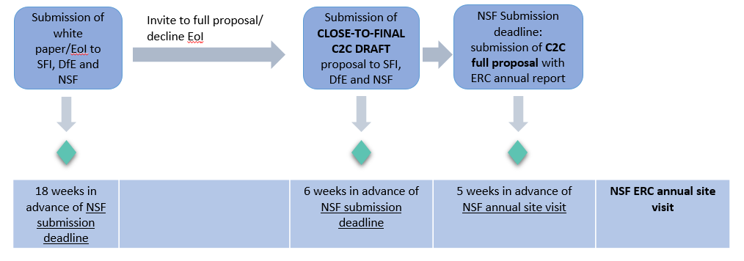
Please note that the above timelines are the latest dates for submission of forms/proposals.

3. Eligibility Criteria
For Research Body and applicant eligibility criteria please refer to US-Ireland R&D Partnership Programme Guidance for RoI and NI applicants for Submission of Tri-Partite Proposals to the National Science Foundation (NSF).

4. Funding
The partner funding agencies have their own specific funding streams available for researchers in the US, NI and RoI applying to the US-Ireland R&D Partnership programme C2C mechanism.
National Science Foundation
US applicants can request up to $800,000 (direct and indirect costs) for up to a 4 year duration, including the no-cost extension period.
Department for Economy Northern Ireland
NI applicants can apply to DfE for total (direct and overhead) costs of up to £300k for a 3-4 -year duration.
DfE eligible costs are staff, equipment, materials, and travel. DfE will also consider other specified costs if demonstrated to be essential for the project to proceed. However, the programme will not meet costs related to new premises, refurbishment, or major items of equipment (costing more than £20,000). An overhead allowance can be included at a rate of up to 40% of the staff costs.
Science Foundation Ireland
RoI applicants can apply to SFI for up to a max of 50% of the total direct cost of the project for a 3-4 years duration. In addition to the direct costs, SFI also makes an indirect, or overhead, contribution to the host Research Body, which is reflected as a percentage of the direct costs (excluding equipment). The overhead should not be included by the applicant in the budget request. See SFI Grant Budget Policy for further details.

5. Submission of Draft Tri-Partite Proposal to Funding Agencies

Please note that for projects that are less than four years in duration requests for SFI contributions towards PhD stipends and fees are not permitted

In advance of submission of the final tri-partite proposal to the NSF, SFI and DfE will evaluate the draft proposal and either approve or decline support. Therefore, a draft of the “tri-partite” proposal for submission to the NSF must be submitted to the NI, RoI, and US funding agencies as outlined in Section 2.2.
Draft proposals will only be accepted from applicants who have submitted an Expression of Interest as outlined in Section 2.1 and have been invited to submit a full proposal.
It is expected that all partners will contribute to designing the research programme and to writing tri-jurisdictional proposal. Equitable participation of all partners is critical to achieving a truly collaborative programme of scientifically excellent, impactful research that takes advantage of the scope, scale, synergy, multi-disciplinarity, equipment and facilities that centres can provide.
The outline of the full proposal composition as per NSF requirements and evaluation criteria that should be taken into account when preparing application, can be found in Appendix 1.

5.1 SFI Requirements
SFI will accept a draft version of the tri-partite proposal in NSF format (Appendix 1); however, the following documents must be included in order for SFI to accurately and fairly assess the level of support required:
- A detailed overview of the research programme including a breakdown of the work packages and tasks to be undertaken by partners in each jurisdiction.
- A standard SFI coversheet signed by the applicant and approved by the appropriate signatory from their institution; for template, please refer to Appendix 2.
- CVs of each applicant in each jurisdiction in NSF format.
- Copies of the requested budget in each jurisdiction. RoI applicants should use the budget template provided in Appendix 3.
- Budget justification for the funding requested (max. 3 pages).
- An ‘added value’ appendix (1 page) which includes an outline of how the work proposed for each jurisdiction adds significant value so that the overall programme of research goes beyond what might be achieved by any one PI working alone supported only by national funding.
- If a Gantt chart or equivalent has not been included in the draft of the research programme, it should be included in the appendix.
- Multi-applicant Management and Communication Plan - please include a section where it is clearly outlined how the multi-applicant team will manage the programme. It is advisable that you refer to regular conference calls or annual team meetings, for example, or other methods of communication that you expect to use to enable the efficient management and a successful outcome of the proposed partnership project.

5.2 DfE Requirements
All documents must be converted into a single Adobe pdf document and emailed to USIreland@sfi.ie for RoI applicants seeking funding from SFI. Please note only the signature page should be scanned, electronic signatures are also acceptable.
DfE will accept a draft version of the tri-partite proposal in NSF format; however, the following documents must be included in order for DfE to accurately and fairly assess the level of support required:
- A standard DfE coversheet signed by the applicant and approved by the appropriate signatories; for template, please refer to Appendix 4.
- Details of the requested NI budget, NI applicants should use the budget template provided in Appendix 5.
- Completed DfE requirements template (max. 6 pages), to include the following information:
- An overview of the research programme including a breakdown of the work packages and tasks to be undertaken by partners in each jurisdiction. The goal of the research programme should be set out clearly in layman’s terms.
- Gantt chart or equivalent.
- Details of the requested NI budget and the requested partner budgets in RoI and US.
- Budget justification for the NI funding requested (max. 2 pages).
- An ‘added value’ section (1 page). This should include an outline of how the work proposed for each jurisdiction adds significant value, so that the overall programme of research goes beyond what might be achieved by any one PI working alone supported only by national funding. The commercial potential / potential route to market of the project should also be included in this section.
Please refer to DfE website for further details, and for copies of the cover sheet, DfE requirements template and budget template.
All documents must be collated and sent as a single email to usireland@economy-ni.gov.uk for NI applicants seeking funding from DfE. Please note the DfE requirements template should be submitted in MS Word format.

6. Tri-Partite Draft Proposal – Review Process and Criteria
Each agency will review the draft tri-partite proposal based on the following criteria:
- Evidence of significant participation by all partners
- The budget is well-justified and represents value for money.
- The work proposed for each jurisdiction adds significant value so that the overall programme of research goes beyond what might be achieved by any one PI working alone supported by national funding only.
- The proposed research fits within one of the five NSF thematic areas.
- The alignment of the research with the strategic focus of the relevant centre(s)
- Assessment of broader impacts.
- The overall quality of the proposal (e.g., structure, clarity, completeness, etc.).
Scientific merit of the proposal is not evaluated. The final decision on the scientific merit of the tri-partite proposal lies with the NSF peer review process.

7. Submission of Final Tri-Partite Proposal to NSF
Once eligibility of the proposal has been confirmed by the RoI and NI funding agencies and the draft tri-partite proposal has been approved, the RoI and NI PIs are permitted to submit the tri-partite proposal to the NSF via their US partner. It is the responsibility of the relevant participating ERC to submit the joint proposal to NSF.
Each of the RoI and NI funding agencies will write a Funding Commitment Letter outlining their level of budget commitment, subject to NSF approval, to the tri-jurisdictional proposal. Funding Commitment Letters are sent to the applicants by their funding agency and must be included in the final NSF submission.
A copy of the final NSF-submitted proposal along with NSF Fastlane submission code must be sent to the relevant funding agencies by the applicants within two weeks of the NSF submission deadline.

8. Post-Award Review
For reporting guidelines please refer to US-Ireland R&D Partnership Programme Guidance for RoI and NI applicants for Submission of Tri-Partite Proposals to the National Science Foundation (NSF) ⁷ and SFI Research Centres Award Management
For further information, RoI applicants should contact SFI at USIreland@sfi.ie and NI applicants should contact DfE at NI contact USIreland@economy-ni.gov.uk.
PLEASE NOTE: Applicants must adhere to and comply with the Terms and Conditions of the relevant funding agency who will govern the administration of the award.

9. General Data Protection Regulation Statements

9.1 SFI Statement
The General Data Protection Regulation is a legal framework that sets out guidelines for the collection and processing of personal information of individuals within the European Union. Applicants are advised that they must be compliant with this regulation if they collect or process personal data.
SFI may collect, use and disclose personal data provided in the application and/or otherwise obtained under, or in connection with, the application for processing the submission, for the performance of its statutory powers and functions, and for the general activities of SFI. Further details regarding SFI’s collection, use and disclosure of personal data, and the rights of individuals with respect to any personal data held by SFI, are available in the SFI Privacy Statement.
During peer-review procedures, information may be sent to external experts in countries outside of the European Economic Area, including countries that are not recognised by the European Commission as having adequate data protection laws. By submitting an application to SFI, the Research Body and members of the Research Team are agreeing that they consent to the processing and transfer of personal information in this way.
During the application process or at any time thereafter, SFI may contact the Research Body, the Principal Investigator, or any member of the Research Team with regard to funding opportunities, activities or events organised by SFI or other relevant bodies, or for the purposes of monitoring and evaluation (including, but not limited to, the collection of scientific data or data relating to the application process). SFI may choose to authorise a third party to contact the Research Body, the Principal Investigator or any member of the Research Team on its behalf.

9.2 DfE Statement
DfE will collect and process personal data to manage and administer the relationship between researchers, the Higher Education Institution (HEI) and Department for the Economy (DfE) in respect of the US-Ireland Research & Development (R&D) Partnership programme. Personal data are required to fulfil our statutory functions, to comply with our statutory obligations and to evaluate and improve DfE performance. DfE will only use personal data for the purpose it was collected.

By submitting an application to DfE, the HEI and members of the Research Team are agreeing that they consent to the processing and transfer of personal information.
Further details regarding DfE’s collection, use and disclosure of personal data, and the rights of individuals with respect to any personal data held by DfE, are available in the DfE Privacy Notice and the US Ireland R&D Partnership Privacy Notice.

APPENDIX 1: FULL PROPOSAL OUTLINE AND EVALUATION CRITERIA
CENTRE-TO-CENTRE PARTNERSHIPS WITHIN THE US-IRELAND R&D PARTNERSHIP PROGRAMME

Under the US-Ireland R&D Partnership Programme, the National Science Foundation (US) together with Science Foundation Ireland (RoI) and the Department for the Economy (Northern Ireland) in addition to the existing opportunities for individual investigator-driven collaborations also includes Research Centre-based collaborations between the United States, the Republic of Ireland and Northern Ireland. Funding decisions will be based upon a combination of the standard NSF Review Criteria and additional Centre-specific criteria in support of the vision, strategic plan, and ongoing activities within each Centre. Criteria to be used in eliciting reviewer feedback on the proposed research programme are specified below.

It is expected that all partners will contribute to designing the research programme and to writing the tri-jurisdictional proposal. Equitable participation of all partners is critical to achieving a truly collaborative programme of scientifically excellent, impactful research that takes advantage of the scope, scale, synergy, multi-disciplinarity, equipment, and facilities that centres can provide.
The relevant participating ERC will be responsible for submitting the joint proposal to NSF. This will undergo external peer review at the annual site visit of the respective Engineering Research Center.
The proposal should comprise the following elements:
RESEARCH PROGRAMME (15 pages max. CVs, Budget, and Letters of Support not included in this limit):

- Details of what is proposed i.e. the specific aims and objectives of the project, how it advances the current state of the art, how it is expected to have impact and how it fits with the objectives of each Centre involved
- An outline of the tasks to be undertaken by each partner and how the work proposed requires participation by the three partners.
- Outline of the added value of the partnership outlining the strategic importance of the collaboration to all partners involved, including industry engagement.
CVs:
- CVs of the applicants for each jurisdiction – (two-page CV)

BUDGET:

- Separate budget request required for each partner along with full justification of the budget. Please use the template provided by your home funding agency.
- Budget templates for RoI and NI partners will be submitted as supplemental information.

LETTERS of SUPPORT:

- Letters of support from industry and/or practitioner partners from each jurisdiction who may intend to participate in trilateral industrial/practitioner advisory board that will be coordinated to the project.
- Letters of support from the funding bodies in Ireland and Northern Ireland, outlining their commitment to fund should the proposal be deemed fundable by the NSF peer review process.
- If the Centre Director is not the applicant/co-applicant, a letter of support from the Centre Director outlining their support for the partnership.

CRITERIA FOR FEEDBACK/ANALYSIS OF CENTE-TO-CENTRE (C2C) PLAN
1. INTELLECTUAL MERIT: The Intellectual Merit criterion encompasses the potential to advance knowledge.
a) Significance: What progress is envisioned in the proposed C2C project?
Additional Guiding Questions:
- What is the anticipated impact of the proposed C2C project and what strengths/capacities of respective participants are leveraged to achieve the defined outcomes?
- How does the proposed C2C project relate to the research Centres’ system vision?
- What advances proposed in the project are benchmarked vs. state-of-the-art?
b) Complementarity: How is the proposed C2C project mutually beneficial for participating Centres?
Additional Guiding Questions:
- Does the proposed C2C collaboration reflect an equal and mutually beneficial partnership between all Centres involved?
- How will the proposed C2C project go beyond the current activities of the individual Centres?
- What are the potential barriers to a successful collaboration?
- What is the risk mitigation strategy?
2. BROADER IMPACTS: The Broader Impacts criterion encompasses the potential to benefit society and contribute to the achievement of specific, desired societal outcomes.
a) Extended Team Diversity: How will existing relationships and plans for new connections be maintained to support a productive C2C collaboration?
Additional Guiding Questions:
- Who will be involved in the proposed C2C collaboration (specify: faculty, post docs, students, industry, etc.)?
- Does the proposed C2C team seem cohesive?
- What will support seamless/cohesive interactions (for example, plans for teleconferences, face-to-face meetings, information exchange)?
- Are there mechanisms in place to support diverse participants and/or students who are adjusting to being abroad for the first time?
b) Innovation: What real, tangible innovative outcomes will result from this collaboration?
Additional Guiding Questions:
- Does this proposed C2C have the potential to impact (discuss all that apply)
- Industry innovation
- Societal infrastructure
- Global sustainability issues?
- Is the route for achieving any of the above clearly described? Is it feasible and realistic?
- How will participants engage with industry or other outside organizations in the proposed C2C?
- Are agreements in place to manage intellectual property and address conflicts of interest/ related issues?
- Are there strategies in place to support technology transfer related to the C2C collaboration?
c) Infrastructure: What resources will support the realization of the proposed C2C interactions within projected timelines?
Additional Guiding Questions:
- What policies and personnel are in place to support all dimensions of this proposed C2C (for example, interactions of faculty and students, mentoring, diversity, innovation)?
- What are indications that participating institutions are committed to the success of the proposed C2C?
- Are there arrangements in place to ensure access to necessary facilities and resources on all sides?

APPENDIX 2: COVER SHEET FOR US-IRELAND PROPOSAL, ROI APPLICANTS

PROGRAMME NAME  US-Ireland R&D Partnership Programme | NSF PROGRAMME NAME  CLOSING DATE FOR APPLICATIONS  (for NSF calls with no fixed deadline indicate intended date of submission) |  | THEMATIC AREA  (tick as relevant)  Sensors & Sensor Networks  Nanoscale Science & Engineering  Telecommunications  Energy & Sustainability  Cybersecurity
TITLE OF PROPOSAL (up to 30 words)
NAME OF HOST INSTITUTION |  | TITLE & FULL NAME OF LEAD REPUBLIC OF IRELAND CONTACT
SFI REQUESTED BUDGET DIRECT COSTS

Signatures below confirm acceptance and agreement with the SFI grants and awards Terms and Conditions, and that the institution ensures the applicant meets eligibility requirements, and that the project is in full agreement with all legal and regulatory matters governing research in Ireland, and no aspect of this project is already being funded from another source and all details provided are correct.
RoI INSTITUTIONAL SIGNATORY AUTHORITY  Name (print):  Position:  Email:  Correspondence Address:  Signed:  Date: |  | LEAD Republic of Ireland CONTACT  Signed:  Date:

APPENDIX 3: BUDGET TEMPLATE FOR ROI APPLICANTS
US-Ireland R&D Partnership Programme
Budget Template for Republic of Ireland applications
RoI Budget Request
Total Proposed budget (in Euro)
Description | Year 1 | Year 2 | Year3 | Year 4 | Year 5 | Total
Staff
Equipment
Materials & Consumables
Travel & Dissemination
TOTAL
Proposed staff costs (in Euro) (Please include salary scale used and point on scale)
Description | Year 1 | Year 2 | Year3 | Year 4 | Year 5 | Total
TOTAL
Proposed Equipment costs (in Euro)
Description | Year 1 | Year 2 | Year3 | Year 4 | Year 5 | Total
TOTAL
Proposed Materials and Consumables costs (in Euro)
Description | Year 1 | Year 2 | Year3 | Year 4 | Year 5 | Total
TOTAL
Proposed Travel and Dissemination costs (in Euro)
Description | Year 1 | Year 2 | Year3 | Year 4 | Year 5 | Total
TOTAL

APPENDIX 4: COVER SHEET FOR US-IRELAND PROPOSAL, FOR NI APPLICANTS

US-Ireland R&D Partnership
Cover Sheet for Full Application to DfE NI

PROGRAMME THEME  (please mark one box below) |  |  | CLOSING DATE FOR APPLICATIONS (STRICTLY 6 WEEKS BEFORE NSF SUBMISSION DEADLINE)
NANO | SENSORS
TELECOMS | ENERGY/SUSTAINABILITY |  | NSF CALL DEADLINE (NORMALLY FIVE WEEKS BEFORE ERC SITE VISIT)
CYBERSECURITY

TITLE OF PROPOSAL (up to 30 words)

NAME OF UNIVERSITY |  | NAME OF NI PRINCIPAL INVESTIGATOR
NAME OF REPUBLIC OF IRELAND PARTNER |  | REQUESTED BUDGET (£s) – NORTHERN IRELAND ONLY (MAX £300K)
NAME OF UNITED STATES PARTNER

Signatures from two university senior officials and stamps below confirm acceptance and agreement with the DfE Terms and Conditions, and that the University ensures that the applicant meets eligibility requirements; that the project is in full agreement with all legal and regulatory matters governing research in the UK; that no aspect of this project is already being funded from another source; that the science proposed is of a high standard, and that all details provided are correct.
Name (print):  Email:  Correspondence Address:  Signed:  Date: |  | Name (print)  Email:  Correspondence Address  Signed:  Date:
Electronic version of cover sheet for NI applicants is available at
US-ireland centre to centre partnership downloadable forms

APPENDIX 5: BUDGET TEMPLATE FOR NI APPLICANTS
US-Ireland R&D Partnership Programme
Budget Template
Proposed university budget (in £ sterling)
Description | Year 1 | Year 2 | Year3 | Year 4 | Year 5 | Total
Staff
Equipment
Materials
Travel
Other (specified)
TOTALS
Proposed staff costs (in £ sterling)
Description | Year 1 | Year 2 | Year3 | Year 4 | Year 5 | Total
Total staff costs
*Existing members of staff will not be supported, unless their posts are being back-filled with additional staff to cover their existing duties.
(In other words, as is the case for all cost categories, the staff costs must represent a truly additional cost to the University).
* Insert PhD costs in the 'Other Cost' table.
Proposed Equipment costs (in £ sterling)
Description | Year 1 | Year 2 | Year3 | Year 4 | Year 5 | Total
Total equipment costs
*Up to £20k per item *Excluding new premises (capital) or refurbishment
Proposed Materials costs (in £ sterling)
Description | Year 1 | Year 2 | Year3 | Year 4 | Year 5 | Total
Total materials costs
Proposed Travel costs (in £ sterling)
Description | Year 1 | Year 2 | Year3 | Year 4 | Year 5 | Total
Total travel costs
Proposed Other costs (in £ sterling)
Description |  | Year 1 | Year 2 | Year3 | Year 4 | Year 5 | Total
Overheads at 40% of staff costs
Total other costs
 | *Publication costs up to £2.5k p.a.

Electronic MS Excel version of budget template for NI applicants is available at US-Ireland centre to centre partnership downloadable forms

Trilateral partnership for supporting research and relationships
National Science Foundation
Science Foundation Ireland
Department for the Economy
SFI Research Centres
Engineering Research Centres
US Ireland Call NSF DFE
SfI Budget Finance-related Policies
https://www.economy-ni.gov.uk/articles/higher-education-international-research-0#toc-3
SFI Research Centres Award Management
Data Protection Ireland
EU GDPR
SFI Privacy
DfE Privacy Notice

