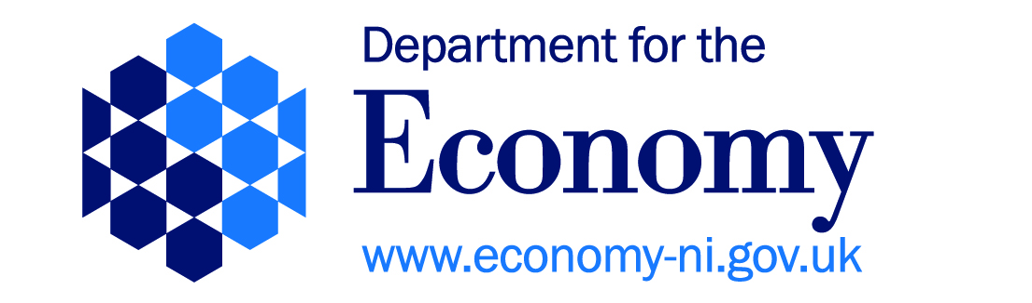

US-IRELAND R&D PARTNERSHIP

COVER SHEET FOR FULL APPLICATION TO DfE

PROGRAMME THEME  (please mark one box below) |  |  | CLOSING DATE FOR APPLICATIONS (STRICTLY 6 WEEKS BEFORE NSF DEADLINE)
NANO | SENSORS
TELECOMS | ENERGY/SUSTAINABILITY |  | NSF CALL DEADLINE
TITLE OF PROPOSAL (up to 30 words)

NAME OF UNIVERSITY |  | NAME OF NI PRINCIPAL INVESTIGATOR
NAME OF REPUBLIC OF IRELAND PARTNER |  | REQUESTED BUDGET (£s) – NORTHERN IRELAND ONLY (MAX £300K)
NAME OF UNITED STATES PARTNER

Signatures from two university senior officials and stamps below confirm acceptance and agreement with the DfE NI Terms and Conditions, and that the University ensures that the applicant meets eligibility requirements; that the project is in full agreement with all legal and regulatory matters governing research in the UK; that no aspect of this project is already being funded from another source; that the science proposed is of a high standard, and that all details provided are correct.
Name (print):  Email:  Correspondence Address:  Signed:  Date: |  | Name (print)  Email:  Correspondence Address  Signed:  Date:

