

DfE
Public Appointments Portal

Applicant Guidance

Version 1.2 (Sept. 2026)

Table of Contents
Click on the page links below to jump to that page:
- Creating an account
- Viewing current vacancies & beginning your application
- Entering Your Personal Details
- Market Research
- Positions Available
- Application Guidance Page
- Completing Criteria Questions
- Declaring Public Appointments Currently Held in Northern Ireland
- Declaring Conflicts of interest or Reputational damage
- Additional Information
- Time Commitment / Availability for Interview
- Guaranteed Interview Scheme (GIS)
- Summary Page
- Declaration & submitting your application
- Viewing & editing your applications
- Contact DfE Public Appointments Unit

Important
NI Direct and this portal use the same platform. If you already have an NI Direct account, your device may be recognised and you may be signed in automatically without entering a password.
If this happens, click ‘Register’ to apply the correct permissions and settings to your account. Otherwise, you will not be able to view available vacancies.

Please be aware: it's best to avoid clicking the ‘Back’ button in your browser while navigating the online portal, as this can cause problems.
On a PC or laptop, the ‘Back’ button is typically a left-pointing arrow at the top left of your screen; on mobile devices, it’s usually found as a left-facing arrow at the bottom.
If you wish to revisit a previous page, use the grey ‘Previous’ buttons where available, and remember to click the save buttons to avoid losing any progress.

Creating an account
DfE Public Appointments are advertised in the following places:
- Local printed press – Belfast Telegraph, Irish News & Newsletter
- Recruitment websites – nijobs.com & nijobfinder.com
- Local Government websites - DfE Webpage, NI Direct
- CPANI Website
- Social media – Facebook, X (formerly Twitter), LinkedIn, Instagram & YouTube (Search for Dept. for the Economy NI)
- Mailshots are issued to organisations who have previously registered an interest in DfE Public Appointments
- The Executive Office’s ‘All Aboard’ newssheet
When you see a DfE Public Appointment advertisement that you wish to apply for, you will be advised to visit the DfE Public Appointments website. Please follow the steps below to create your DfE Public Appointments Portal Account.
- To apply for a Department for the Economy (DfE) Public Appointment opportunity you must first create an account on the DfE Public Appointment’s portal.
- When you have created an account, your personal details will be saved securely, making it quicker and easier for you to apply for future Public Appointment opportunities in DfE.
- Your account will be password protected using ‘2-Factor Authentication’.
- To create an account, you will need access to an email address. This should be an email address that only you have access to.
- 2-Factor Authentication means you will need to keep your mobile phone handy as you will receive a unique code via SMS text message each time you log in with your email address and password. This is to protect your account and keep your personal information safe.
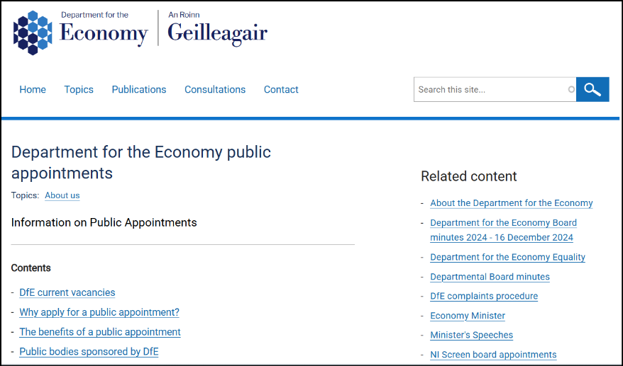
Click on the DfE current vacancies link, then click the ‘apply here’ button next to the relevant opportunity. You will be taken to the DfE Public Appointments Portal Home Page. (See Below)
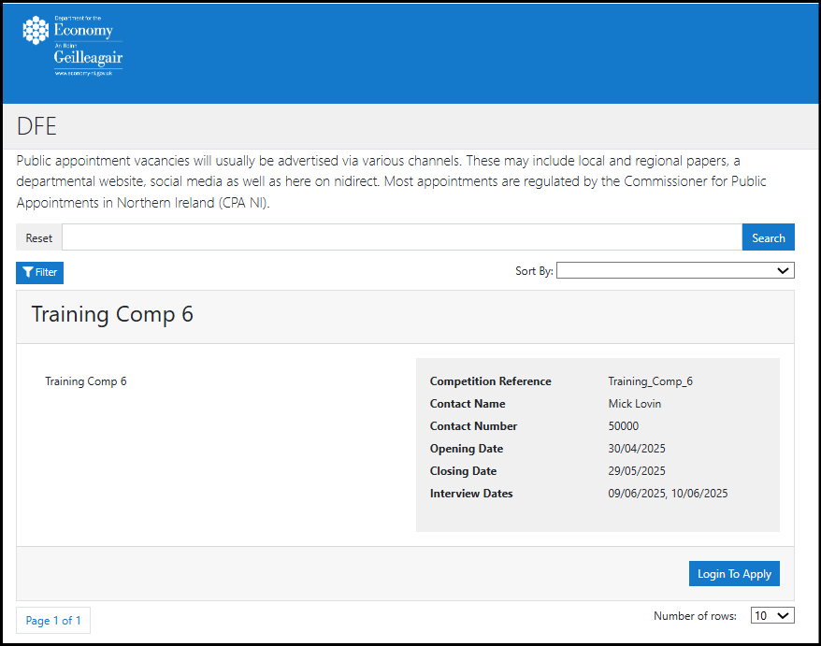

Click the ‘Login to Apply’ button under the competition you wish to enter.
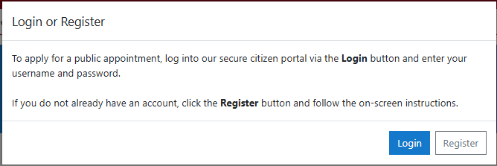
A pop-up box will appear:

If this is your first time entering a competition click Register to begin creating an account.
(If you have previously created an account, click Login and follow the on-screen instructions.)

Enter your Email address on the next page, confirm your email address and click the verify button.
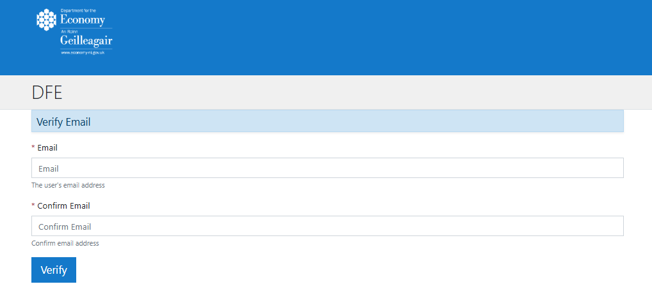
Note: If you get an error message, please re-type your email address in the two boxes, and ensure they match.

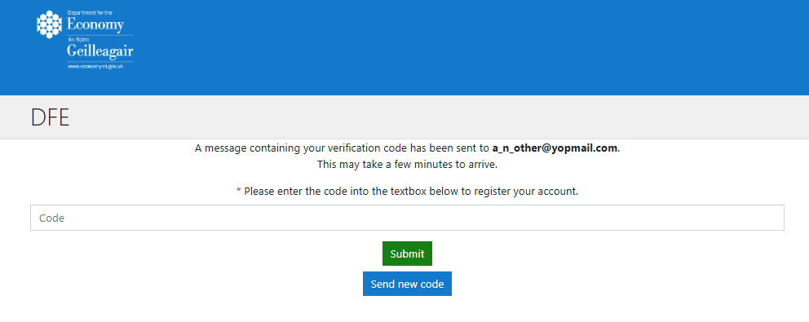
If the email addresses match you will see the following screen:

The system has now sent a code to your email address, enter this code in the box and click ‘Submit’.
Note: your code will expire after 5 minutes, if you get timed out click the ‘Send new code’ button and try again.

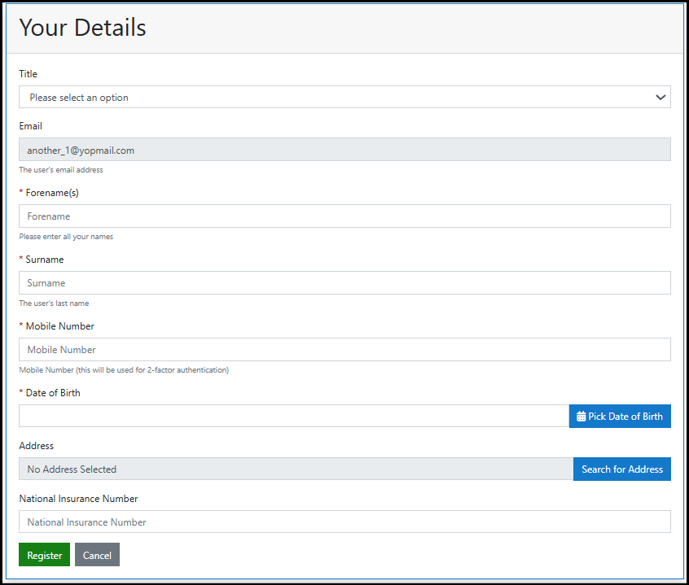
If successful you will be presented with the following box:

Complete the text boxes with your personal details.
Note: You must use the ‘Pick date of birth’ and ‘Search for address’ buttons to enter your date of birth and address. By clicking these buttons text boxes will pop-up to assist you with entering these details.
National Insurance numbers must be entered in the following format:
two letters followed by six numbers followed by a single letter (A,B,C or D) i.e. AB123456C, anything different from this will cause an error message to appear.
When you have completed this page click the ‘submit’ button, if everything has been entered correctly you will see the following message:
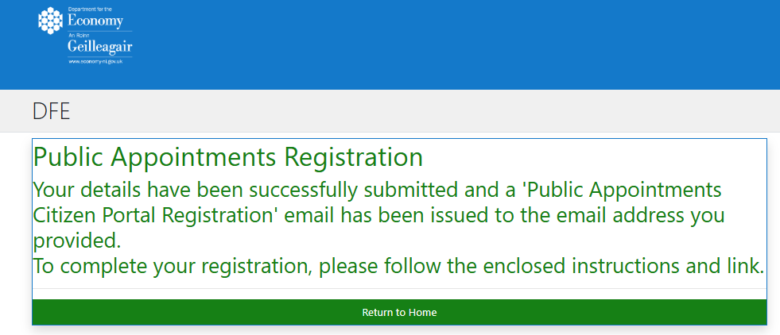

You will receive the following email message to your email account:
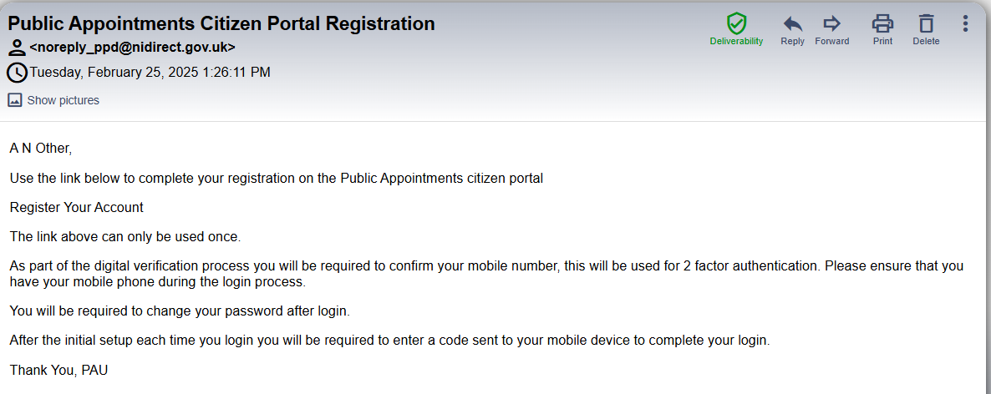

On your Email, click on the ‘Register Your Account’ link (marked with the arrow above). You will be brought to the following screen:
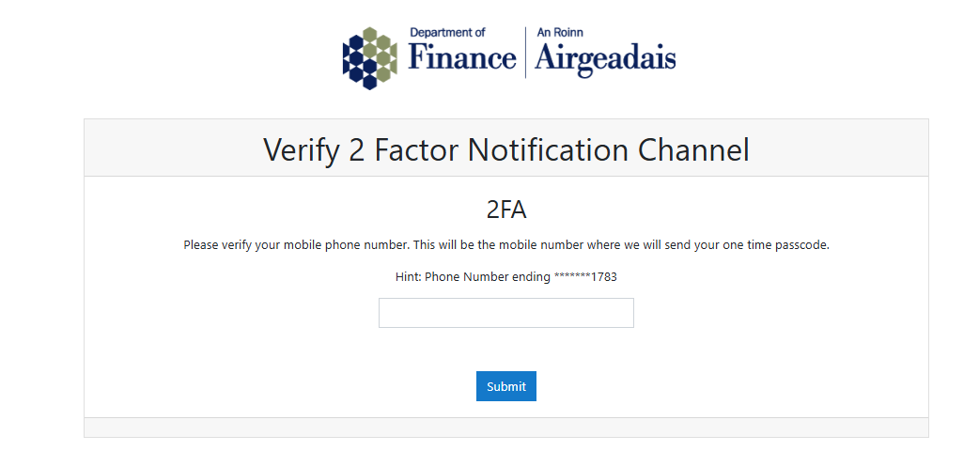
To setup 2 Factor Authentication, enter your mobile phone number in the text box for verification.
Note: This must be the same phone number you used previously when you entered your personal details.
Click on the ‘Submit’ button.

When your phone number has been successfully verified you will receive an SMS Text Message containing a unique six-digit code. The following box will appear:
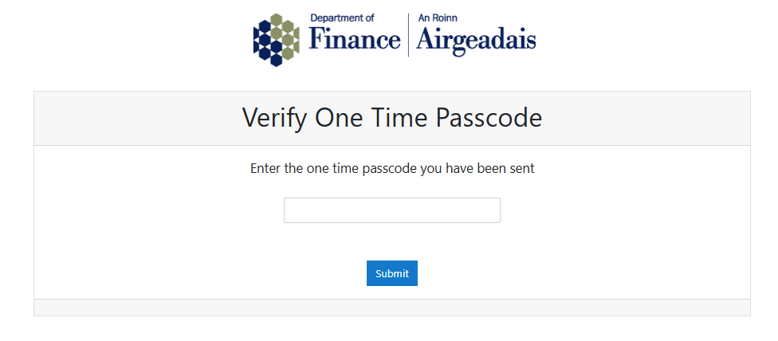
Enter this code in the box and press ‘Submit’.
Note: SMS Text messages are normally received within a few seconds; however this will depend on your mobile phone signal and several other factors so this may take a few minutes to come through. You have 5 minutes to enter the code after it has been received on your phone.

Enter the six-digit code in the box (marked with an arrow above) and click submit.
Note: your code will expire after 5 minutes. If you enter this code after 5 minutes have elapsed a new code will sent via SMS Text and the box above will reset.

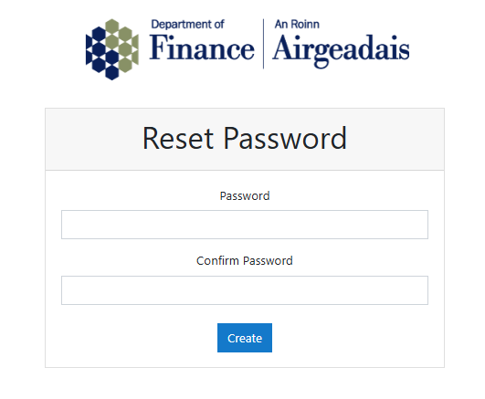
If you have entered the code correctly you will be prompted to enter a new password.

Enter a password in the first box. Please note:
- Passwords must be at least 6 characters.
- Passwords must contain at least one number (e.g. 0 – 9)
- Passwords must contain at least one uppercase letter (e.g. A – Z)
- Passwords must contain at least one symbol (e.g. !”£$%^&*@#<>)
Re-enter your password in the confirm password box.
Click the Create button.
You have now successfully created your account and should be taken to the home page showing the latest vacancies as shown below.
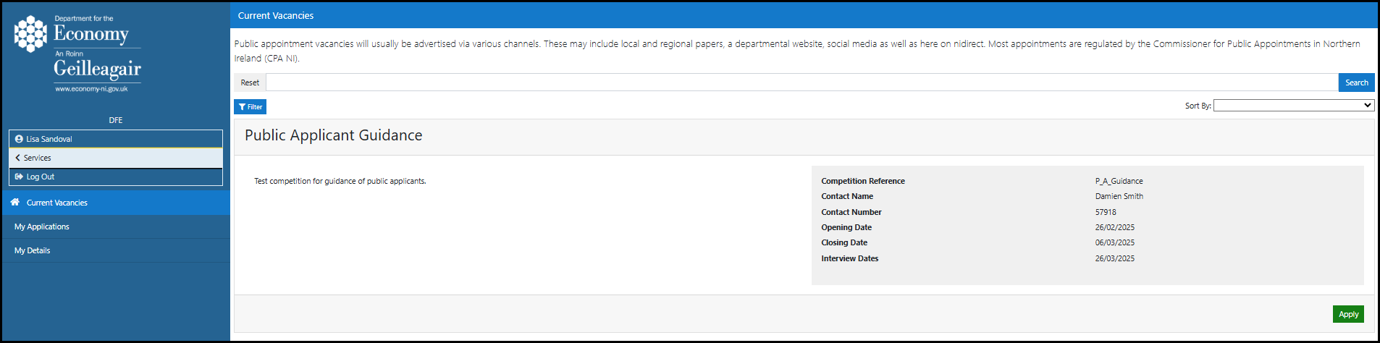

Viewing current vacancies & beginning your application
On this page you can view all current vacancies in DfE. This page will show only open competitions which will disappear when the closing date(s) have been reached.
From the Current Vacancies home page click the green Apply button in the bottom right of the vacancy information panel (marked with an arrow below).
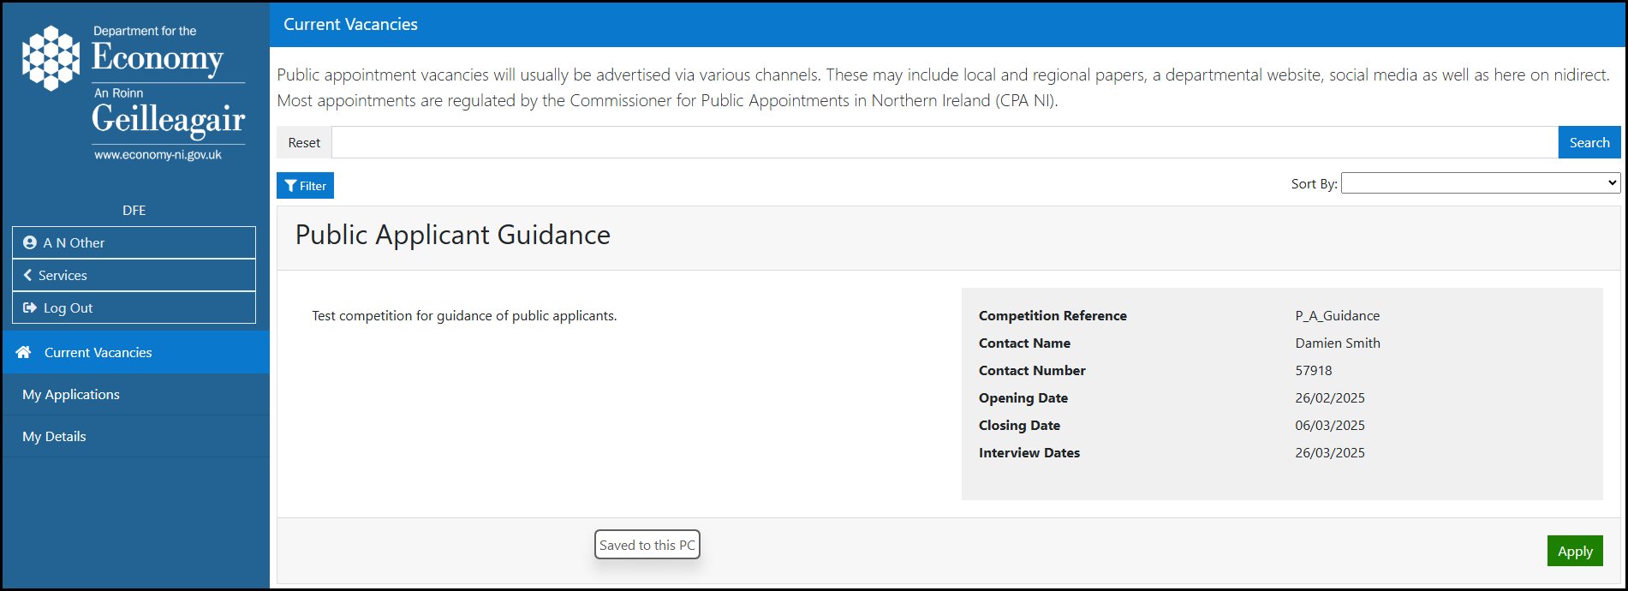

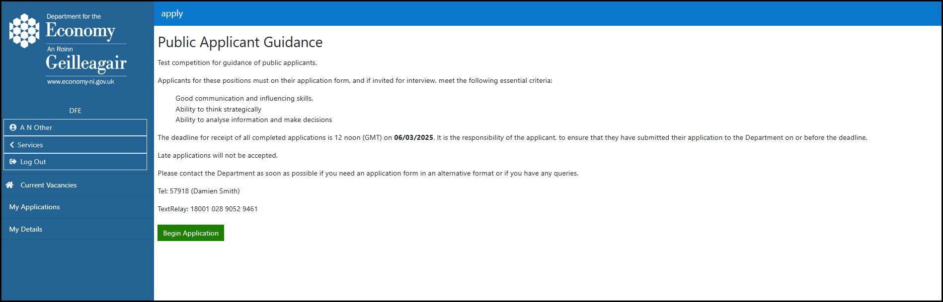
When you have read the notes for applicants click the Begin Application button.

Entering your personal details
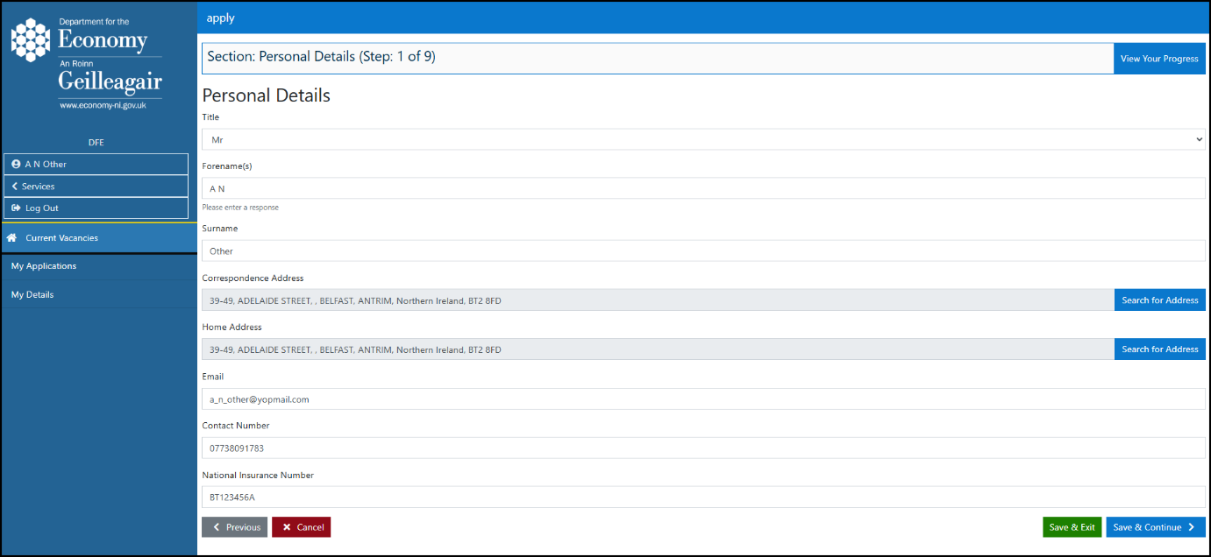
Your personal details should already appear on this page, using the information you provided when you created your account. If you need to update any details for this application only, such as using a different correspondence address or email address, you can make those changes here.
When you have finished click Save & Continue.
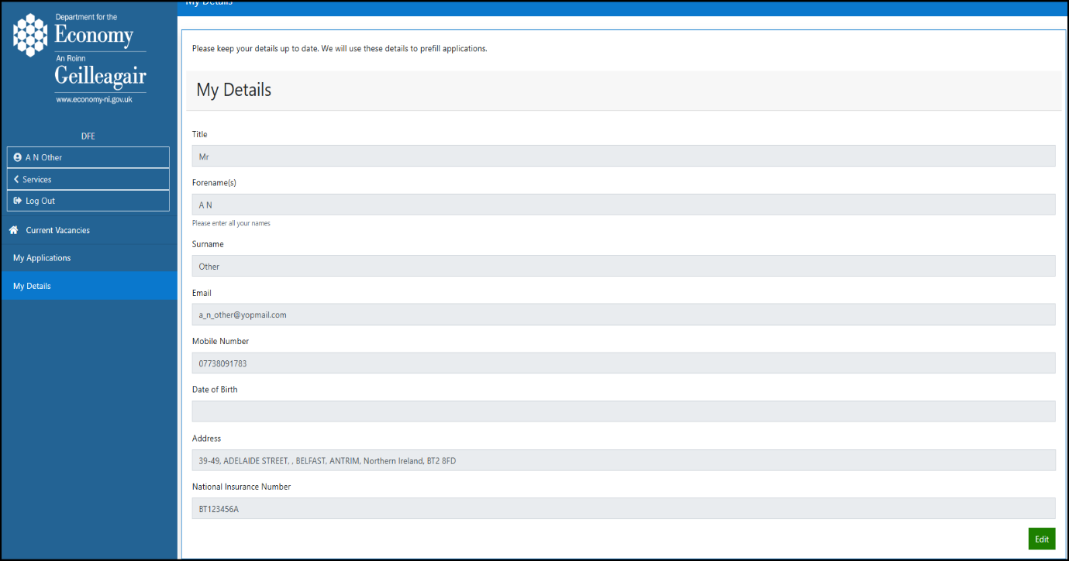
Note: Any changes you make on the screen above will only apply to this application. If you want to update your personal details for future applications as well, please go to the My Details section in the left-hand menu and update them there.

To update your personal details for future applications, click ‘My Details’ in the left-hand menu, then click the ‘Edit’ button.
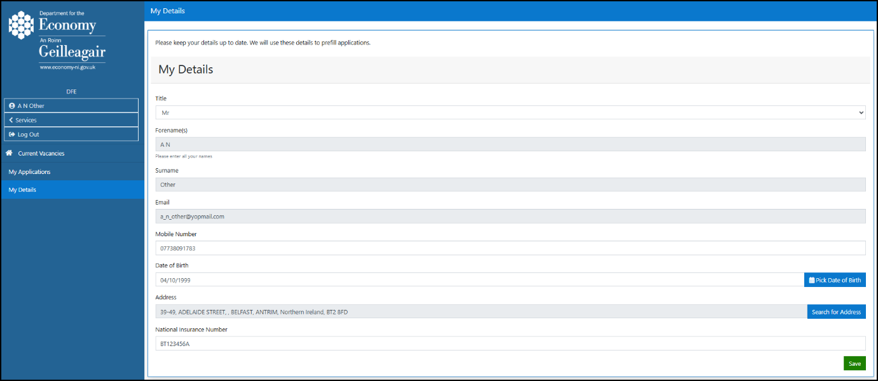
Update the relevant text boxes with your new details. If you need to change your address, please use the ‘Search for Address’ button. When you have finished making your changes, click ‘Save’.

Market Research
On the market research page, please select all the options that apply to you. Each box will turn blue when it has been selected. When you have chosen your options, click Save & Continue to move to the next step.
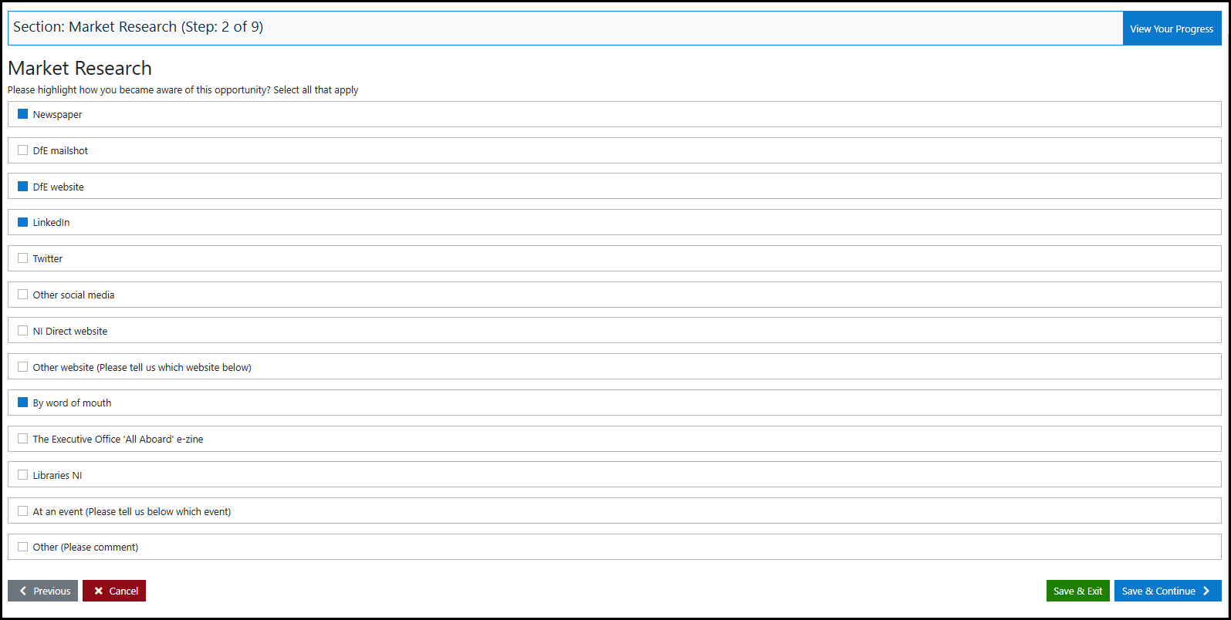
Note: At least one box must be selected, or an error message will pop up on the screen when you click Save & Continue.

Save & Exit / Save & Continue buttons
From this point onwards, you will see the Save & Exit and Save & Continue buttons at the bottom of each screen. These are highlighted above with a blue arrow.
Both buttons will save the information you have entered so far. They do not submit your application.
Save & Exit – click this if you want to save your progress and come back to your application later.
Save & Continue – click this to save your progress and move to the next screen.
View Your Progress Button
From this point onwards, you will also see the View Your Progress button. This is highlighted above with a red arrow. Click it to check the progress of each section of your application. Each section will show as Completed, In Progress, or Cannot Start Yet.
You can open any section marked In Progress or Completed. These sections will appear in blue text. Sections marked Cannot Start Yet cannot be opened until the previous section has been completed.

Positions Available
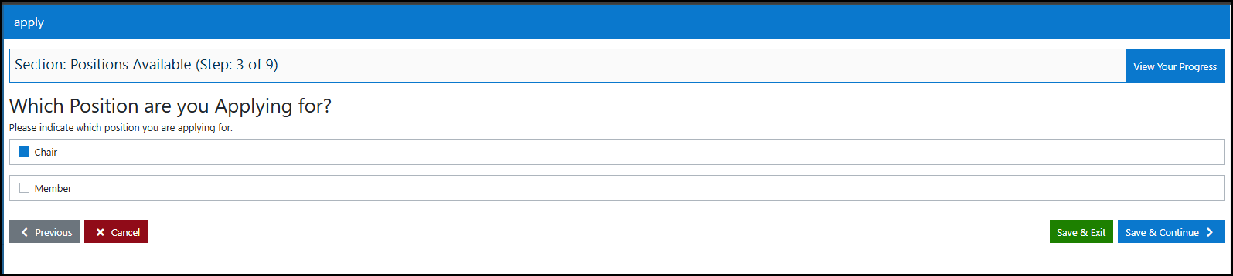
Select the position you want to apply for. The box will turn blue once it has been selected. When you are ready, click Save & Continue to move to the next stage. This is highlighted below with a blue arrow.

Note: Some Public Appointment competitions may include more than one post. Where this applies, you may be able to apply for more than one post by selecting each one you are interested in. Please check the Candidate Information Booklet for full details. If the system only lets you select one option, this means you can only apply for one of the posts available.

Application Guidance Page
This page provides guidance on criteria-based selection. Please read the information carefully, then click Save & Continue when you are ready to move to the next step.
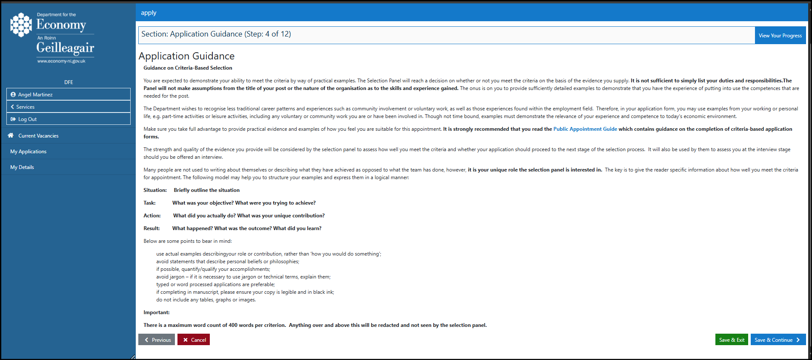

During your application, you may see light blue text. This means the text is a link to an external web page, such as the Public Appointments Guide. Clicking the link will open that web page.
Note: Links may open in the same browser tab as your application. If this happens, you could lose any unsaved progress. To avoid this, open links in a new tab where possible. On a PC or laptop, right-click the link and select ‘Open link in new tab’. On a mobile device, press and hold the link until the option to open it in a new tab appears.
You can return to your application by selecting the application tab in your browser.

Completing Criteria Questions
Type your answer to each criteria question in the text box provided. Each text box has a maximum limit of 2,800 characters, which is around 400 words. The counter below the text box will count down as you type, so you can see how many characters you have left.
When you have finished, click Save & Continue to move to the next page. This button is highlighted below with a blue arrow.
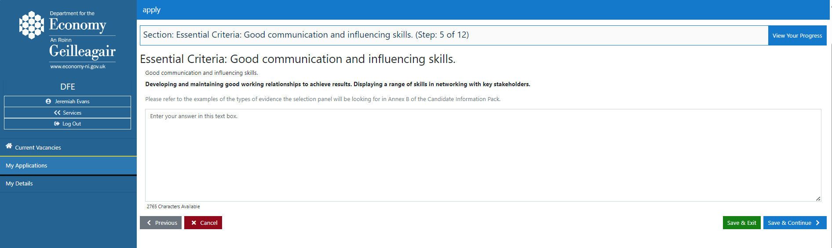

Note: The same process applies to all Essential Criteria, Desirable Criteria and Eligibility Criteria questions. Please make sure you complete all questions that apply to the post, or posts, you are applying for.

Declaring Public Appointments Currently Held in Northern Ireland
Click the green button to add details of any Public Appointments you currently hold, or have previously held, in Northern Ireland. You do not need to include appointments held in the Republic of Ireland or Great Britain.
If you have never held a Public Appointment in Northern Ireland, click Save & Continue to move to the next section.
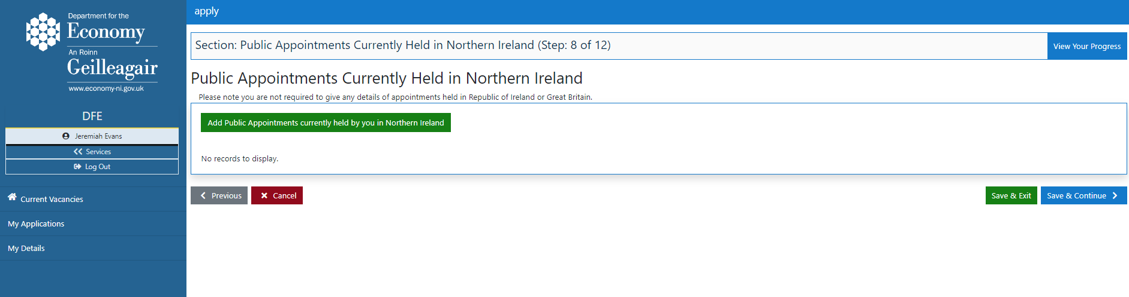

When you click the green button, a text box will appear. Please complete the details requested, then click ‘Add Entry’.
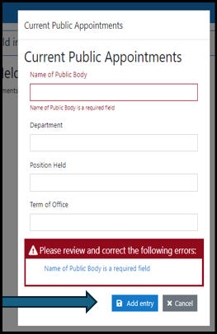

Conflicts of Interest / Reputational Damage
Answer these questions by selecting Yes or No from the drop-down menus, which are marked below with red arrows. If you select Yes for either question, please provide more details in the text box that appears below.
If you answer No to both questions, click Save & Continue to move to the next section. This button is marked below with a blue arrow.
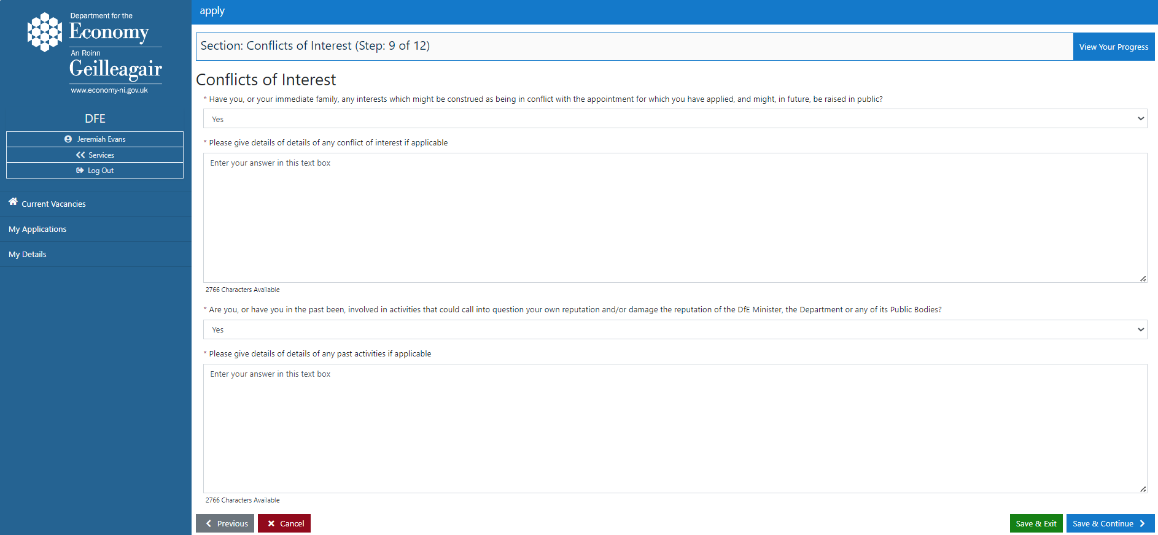

Additional Information
Please answer the additional information questions by ticking the checkbox beside any question that applies to you. The checkbox will turn blue when it has been selected.
If none of the questions apply to you, please select N/A.
If you select N/A, click Save & Continue to move to the next section. This button is marked below with a blue arrow.
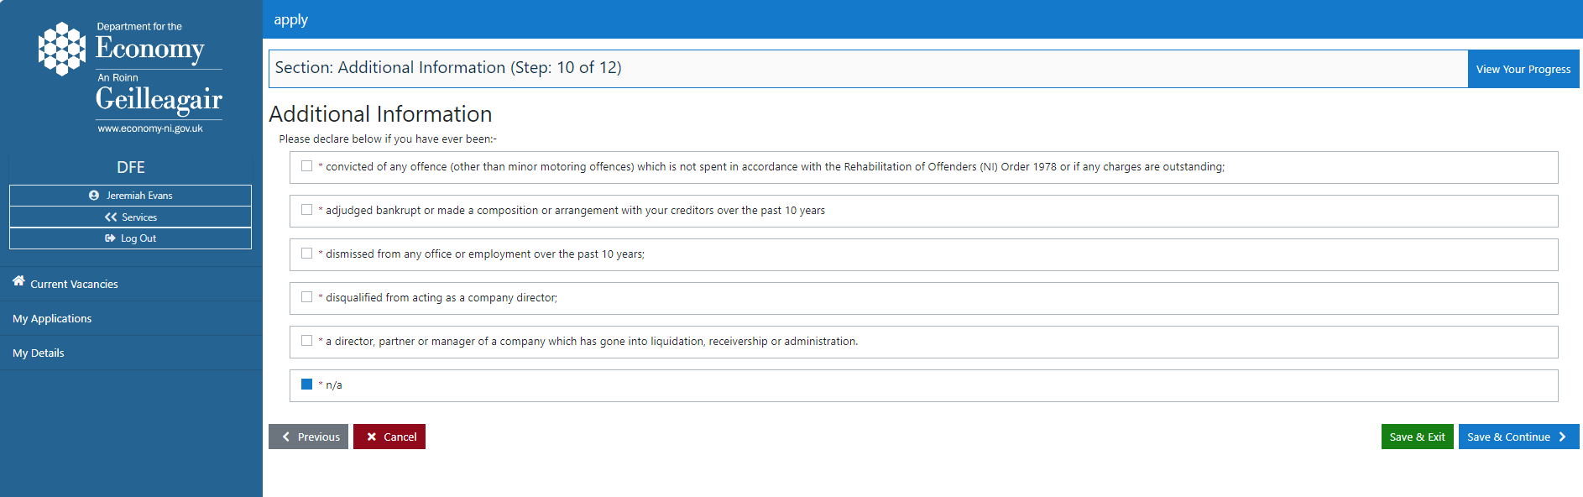

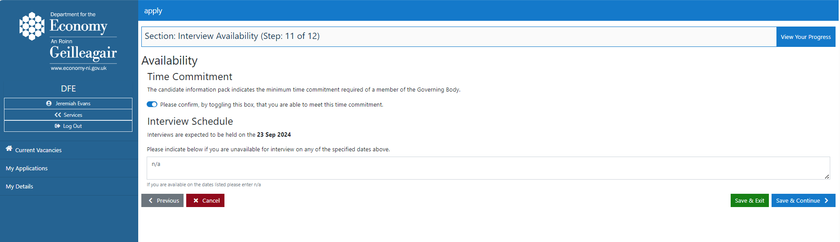
Time Commitment & Availability for Interview

Time Commitment
Please confirm that you can meet the time commitment required for the role by selecting the button. The button will turn blue when it has been selected.
Interview Schedule
The expected interview dates will be listed here. If you are available for interview on any of these dates, type N/A in the text box. If you are not available on one or more of the dates, please use the text box to tell us when you are available.
Note: Please do not leave the text box empty. If it is left blank, a red error message will appear and you will not be able to move to the next section. Please either tell us your availability or type N/A.
Interview dates may change. If this happens, the Public Appointments Team will try to let applicants know as soon as possible.

Guaranteed Interview Scheme (GIS)
Please read the information on this page about the Guaranteed Interview Scheme (GIS). If you meet the disability definition provided and would like to apply under the GIS, please tick the checkbox. The box will turn blue once it has been selected.
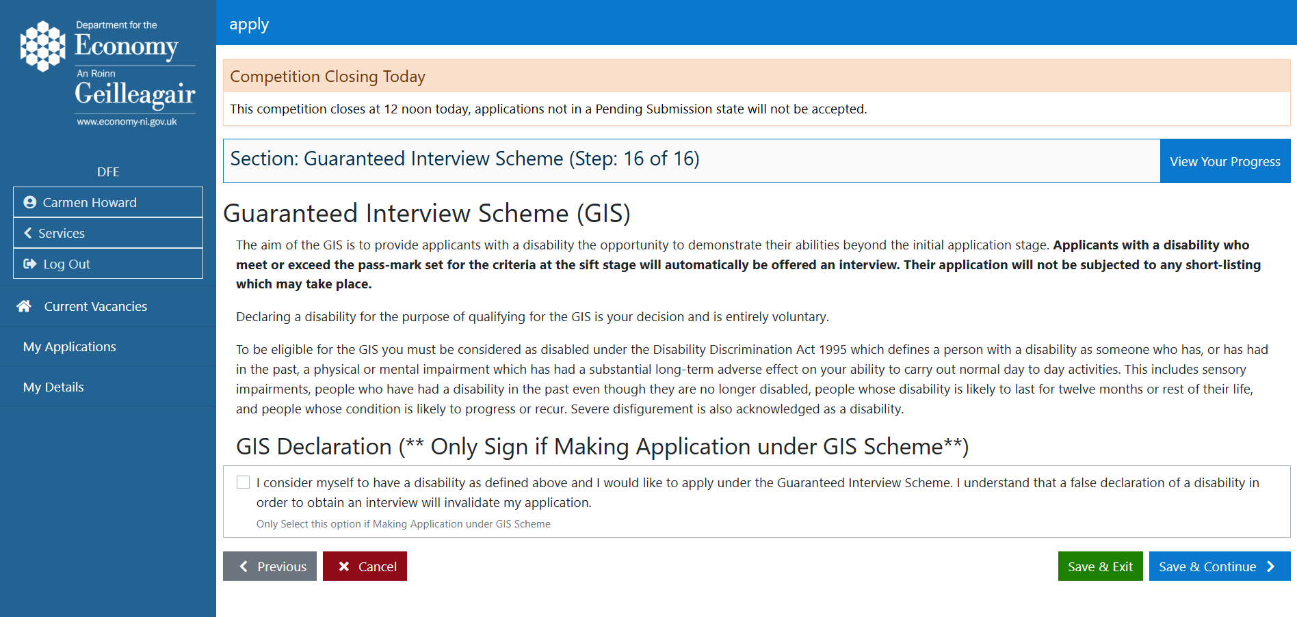
When you are ready, click Save & Continue to move to the summary page. This button is marked below with a blue arrow.

Summary Page
The summary page lets you review all your answers in one place. To see your responses for each section, click the blue drop-down arrow beside that section. This is shown below with a red arrow. If you have missed anything, or need to make a change, use the View Your Progress button to go back to the relevant section. Please remember to save any changes you make.
When you are satisfied that all sections are complete, click Save & Continue to go to the Declaration page. This button is shown below with a blue arrow.
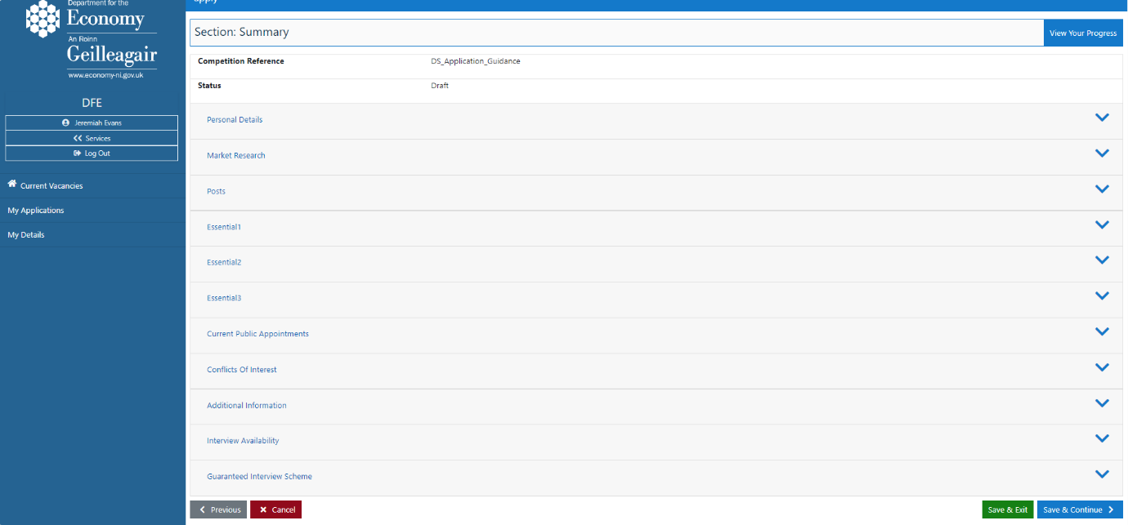

Declaration & Submitting Your Application.
Please read the declaration page carefully, along with the CPANI leaflet ‘Complaints and Conflicts of Interest Information Guidance’. The words ‘CPANI Leaflet’ will appear in blue text. Click this link to open the guidance on the CPANI website.
When you have read the declaration and guidance, tick the checkbox to confirm. The box will turn blue once selected. Then click the green Submit button to submit your application. These are highlighted below with a red arrow and a blue arrow.
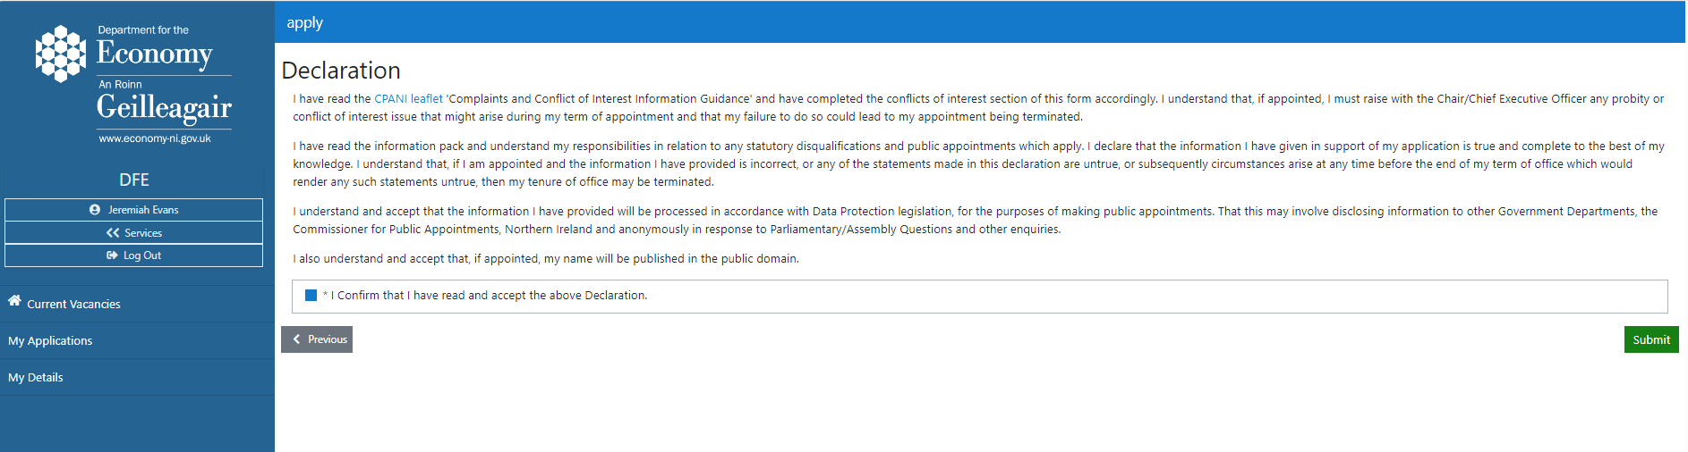
By clicking Submit, you are confirming that you have read and accepted the declaration. This acts as your digital signature and is treated in the same way as signing a paper application form.

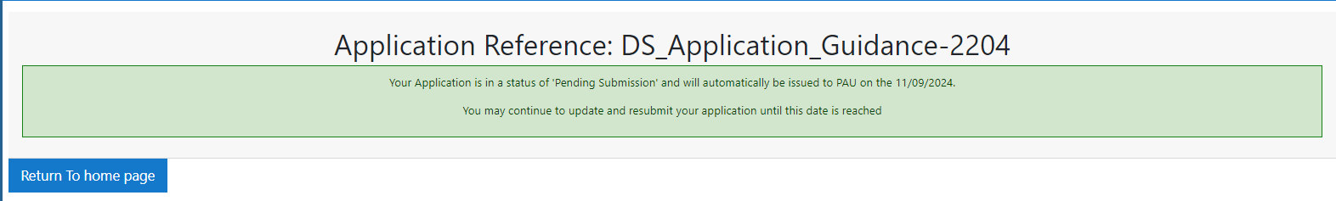
When you click submit this message will appear, your application is now ‘pending submission’.

Please note: Once you have completed your application and clicked the green Submit button, its status will show as ‘Pending Submission’. Applications with this status will automatically be sent to the Public Appointments Unit (PAU) when the competition closing date is reached.
If you finish your application before the closing date, please remember to click the green Submit button. This ensures your application is ready to be automatically forwarded to PAU at the closing date.
You can still make changes while your application is marked as ‘Pending Submission’. To do this, use the Edit option in ‘My Applications’. This is explained in the next section.

Viewing & Editing Your Applications
You can view and edit your applications from the ‘My Applications’ page. The ‘Application States’ box at the top of the page shows the current status of each application. To review the answers you have entered for each step, click the green View button.
Editing your application
You can edit your application at any time before the competition closing date. Click the blue Edit button to return to the furthest point you have completed in the form. You can then use View Your Progress to go to any other section of the form.
This means you can complete your application in smaller sections at a time that suits you. Remember to save your progress as you go, so you can exit the form and come back to it later.
When you have completed the final part of the form, including the declaration, please click the Submit button. Your application status should then show as ‘Pending Submission’. See Part 14 for more information.
Note: You can still edit and resubmit your application while it is marked as ‘Pending Submission’, up until the competition closing date. This status means your application is ready to be automatically forwarded to PAU for assessment when the competition closes.

Contact DfE Public Appointments Unit
If you have any questions or issues that have not been discussed in this booklet, please contact: pau@economy-ni.gov.uk
If your query is regarding a submitted application, please include your application reference number.

