Participant User Guide: for completing your RHI Annual Declaration

Here you will find useful information on how to complete the form required to receive payment for Renewable Heat Incentive (RHI) Scheme Closure.

Contents Page

What is an Annual Declaration 3
Why do I need to complete an Annual Declaration 3
When do I need to complete my Annual Declaration? 3
What information should I have ready before I start? 3
How do I access the Annual Declaration on the RHI Register? 4
What should I check before submitting? 5
What happens after I submit the Annual Declaration? 5
What if I make a mistake or need help? 5
Completing the Annual Declaration 6
Step 1: Sign in to the RHI Register 6
Step 2: Opening the Annual Declaration 7
Step 3: Review the information shown 8
Step 4: Complete the declaration questions 10
Step 5: Review and submit 15

What is an Annual Declaration?
An Annual Declaration is a form that participants must complete through the RHI Register each year. The declaration is used to confirm that the information held in relation to your installation and participation in the Renewable Heat Incentive (RHI) Scheme Closure remains accurate and up to date. Completing the declaration helps ensure that the Department has the information required to assess and process any payments due to you under the Scheme Closure arrangements.
It is important that you read each section carefully and ensure all responses are accurate before you submit the form.
Failure to complete the Annual Declaration, or providing incorrect or incomplete information, may result in delays to the processing of payments or may affect your entitlement under the Scheme Closure arrangements.
Why do I need to complete an Annual Declaration?
The Annual Declaration is required to ensure that the information held on the RHI Register remains accurate, complete and up to date. By completing the declaration, you confirm that the details relating to your participation in the RHI Scheme are correct and that any relevant changes have been declared.
The information provided through the Annual Declaration is used to verify your continued eligibility and to support the assessment and processing of any payments due under the RHI Scheme Closure arrangements. It is therefore important that all questions are answered accurately and that the information submitted reflects your current circumstances.
When do I need to complete my Annual Declaration?
Your Annual Declaration will become available on the anniversary of your accreditation date. When it becomes available, you should log in to the RHI Register and complete the declaration as soon as possible.
You must ensure that your Annual Declaration is submitted before the deadline specified on the RHI Register. Completing the declaration promptly helps ensure that your information remains up to date and that there are no unnecessary delays in the processing of payments due under the RHI Scheme Closure arrangements. It is your responsibility to ensure that the declaration is completed and submitted on time.
What information should I have ready before I start?
Before starting your Annual Declaration, you should ensure that you have access to your RHI Register account and that you have all relevant information available to help you complete the declaration accurately.
As part of the Annual Declaration process, you will be required to upload the following evidence:
- A photograph of your biomass boiler.
- A photograph of the boiler nameplate, clearly showing the manufacturer, model and serial number details.
- A photograph of the biomass boiler within its surrounding installation or boiler house, taken from a wider distance to show the full installation.
Providing clear, up-to-date photographs will help ensure that your declaration can be processed without unnecessary delays. Before beginning the declaration, it is recommended that you take these photographs and save them in an easily accessible location on your computer or device so that they are ready to upload when required.
How do I access the Annual Declaration on the RHI Register?
To access your Annual Declaration, you must first sign in to the RHI Register using your NIDA account. Once signed in, select the relevant installation and navigate to the Annual Declaration section.
If an Annual Declaration is due, it will be available from the anniversary of your accreditation date and will be displayed on the installation record. You can then open the declaration, review the information provided and complete the required questions before submitting the form.
What should I check before submitting?
Before submitting your Annual Declaration, check that all information is accurate, all required questions are completed, and the correct clear and legible supporting files and images have been uploaded.
Providing accurate information and the required evidence will help prevent delays in the assessment of your declaration and any payments due under the RHI Scheme Closure arrangements
What happens after I submit the Annual Declaration?
Once you have submitted your Annual Declaration, a confirmation message will be displayed on the RHI Register to confirm that your declaration has been received. You should retain any confirmation reference provided for your records.
Your Annual Declaration and supporting evidence will then be reviewed as part of the RHI Scheme Closure process. This includes checking that all required information has been provided and that the supporting photographs submitted are clear and meet the declaration requirements.
Provided that all required information has been submitted, and no further clarification is required, payments are normally issued within six weeks of the Annual Declaration being successfully submitted. If additional information is required, you may be contacted and this could affect the payment timescale.
To help avoid delays, ensure that all questions have been answered accurately and that the required photographs have been uploaded before submitting your declaration
What if I make a mistake or need help?
For assistance, please contact the RHI Management Team using the contact details provided in your correspondence. If you would like to include specific contact information in this guide, you can add:
Email: rhimanagement@economy-ni.gov.uk
Telephone: 02890 257571
The RHI team will be able to provide guidance on completing your Annual Declaration and help resolve any issues that may prevent you from submitting your declaration successfully.

Completing the Annual Declaration

Step 1: Sign in to the RHI Register
Follow the instructions shown on the screen. Check the information carefully before moving to the next page.
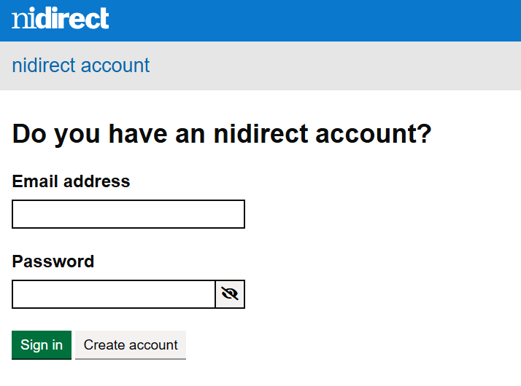

- Input your email address
- Type in your password
- Click Sign In

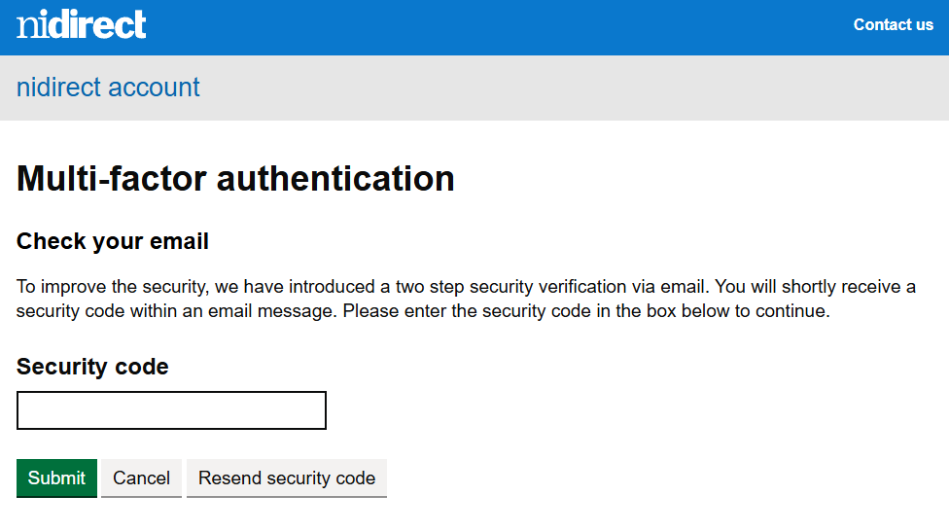

- Follow on screen instructions to check your email for the security code
- Input the security code from your email and click Submit

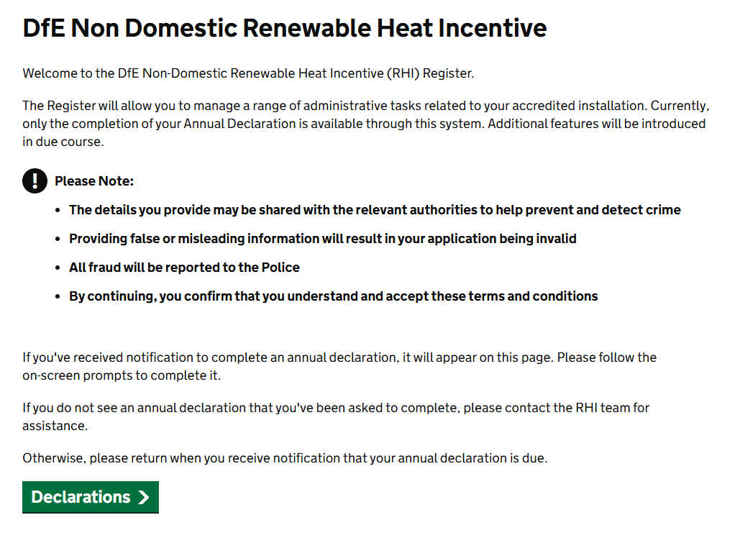

- After reviewing the above screen, click on Declarations to continue

Step 2: Opening the Annual Declaration
Follow the instructions shown on the screen. Check the information carefully before moving to the next page.

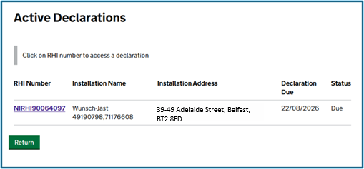
- Click on the underlined RHI number to open the Annual Declaration.
- If you have more than one installation, there could be more than one Declaration listed to complete but this is dependent on the anniversary of the accreditation date.

Step 3: Review the information shown
Follow the instructions shown on the screen. Check the information carefully before moving to the next page.

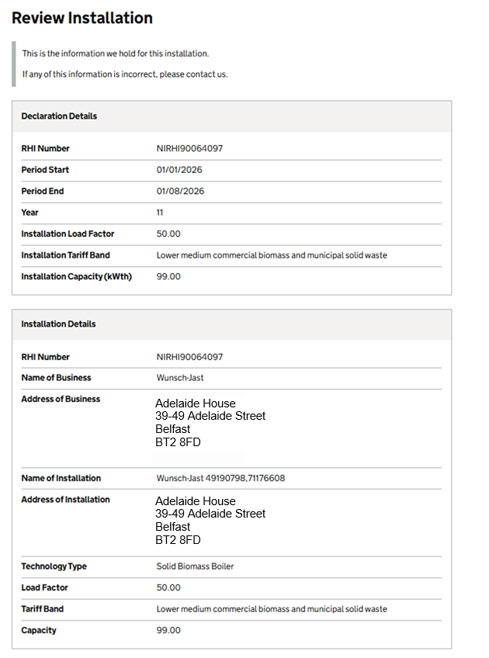
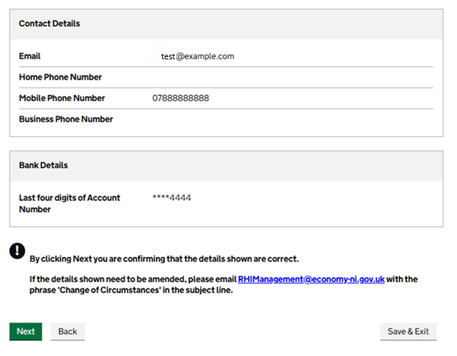

- When you are satisfied that the above details on your Annual Declaration are correct, click next.

Step 4: Complete the declaration questions
Follow the instructions shown on the screen. Check the information carefully before moving to the next page.
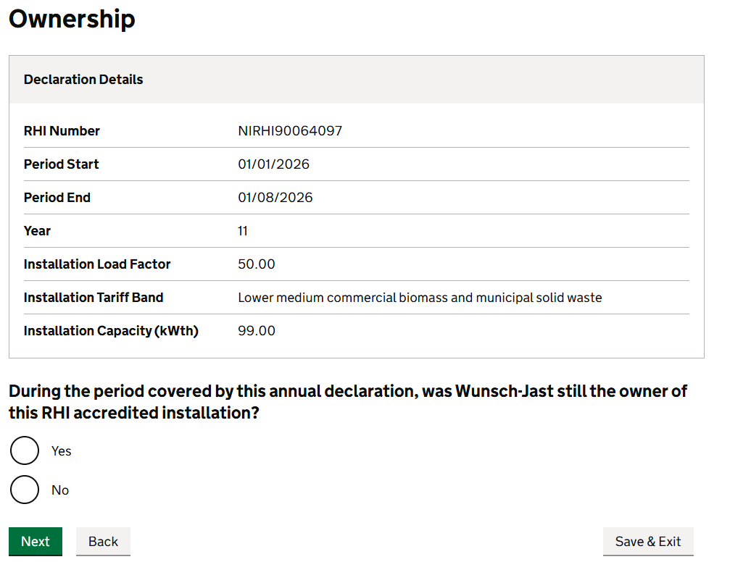

- Confirm Ownership by selecting Yes or No
- Click Next

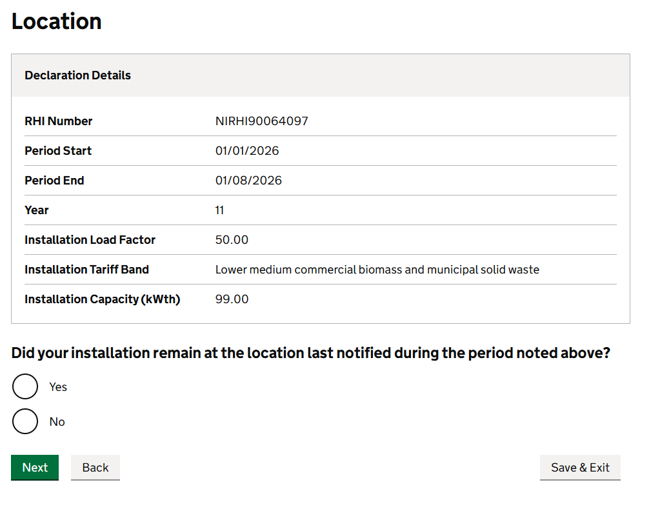

- Confirm Location by selecting Yes or No
- Click Next

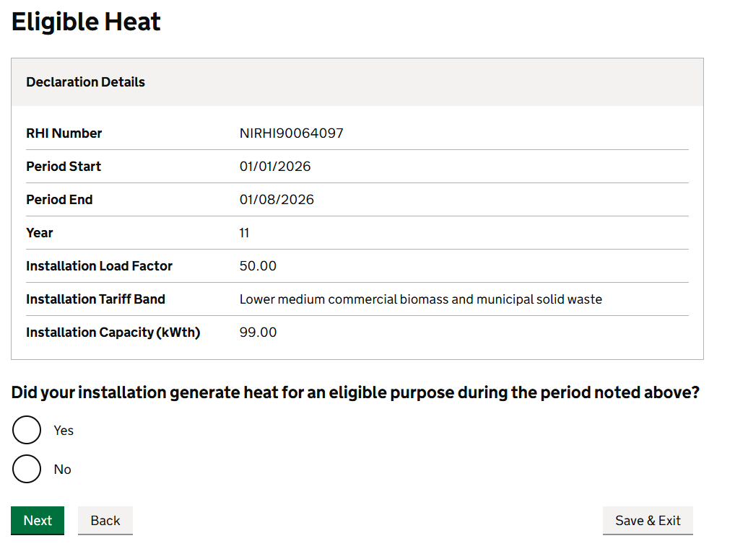

- To confirm if your installation generated heat by selecting Yes or No
- Click Next

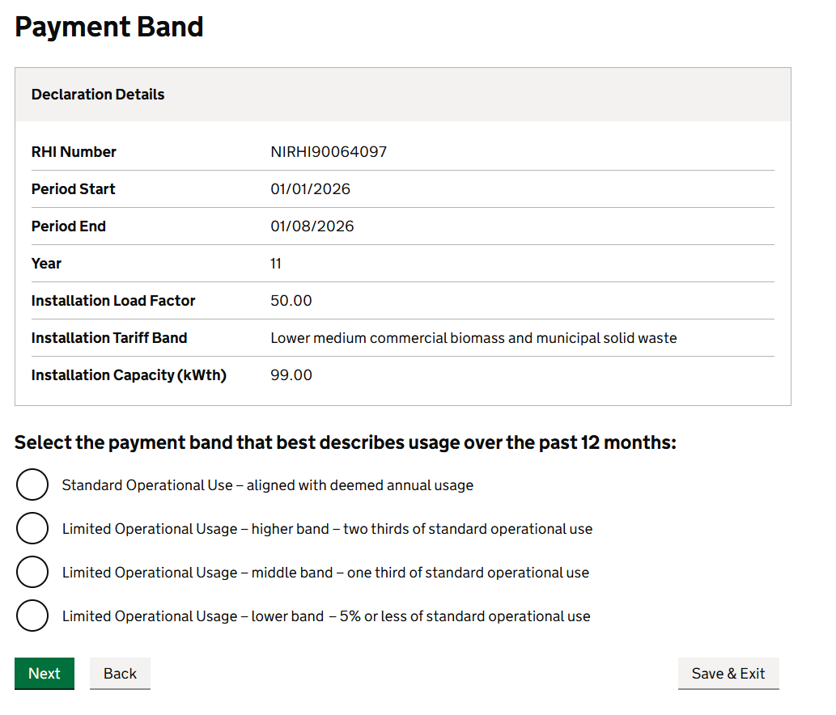

- Confirm your Operational Use; there are 4 payment bands to choose from.
- If the installation has been used more than 66.7% (or more than 2/3rds) when compared to the 2017-2019 period, then choose this option. If you are eligible to receive payment, you will receive the full amount.
- If the installation was used less than two thirds but more than one third in the period (i.e., if you used it less than 66.7% but more than 33.3%) when compared to the usage that was established as normal in the 2017-2019 period, then choose this option. If you are eligible to receive payment, the load factor will be adjusted to reflect 2/3rd usage.
- If the installation is used less than 33.3% but more than 5% when compared to the 2017-2019 period which established normal use, then choose this option. If you are eligible to receive payment, the load factor will be adjusted to reflect 1/3rd of that which was used in the 2017-2019 period.
- If the installation was used 5% or less when compared to what was considered the normal usage established in the 2017-2019 period, then choose this option. If you are eligible to receive payment, the load factor will be adjusted to 5% of that which was used in the 2017-2019 period.
- Click Next

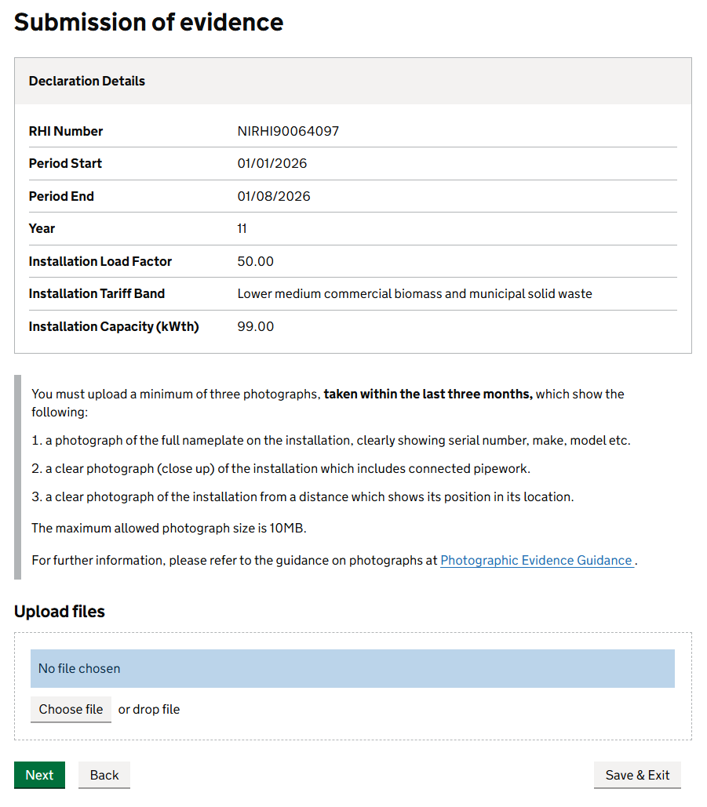

Uploading Photographs to the RHI Database
Participants are required to upload photographs as part of the Annual Declaration submission on the RHI Closure Register. These photographs will be used as supporting evidence to verify eligibility for the Annual Closure Payment and must meet the requirements outlined below.

Before You Start

- You should only begin this process once you have received instructions from the Department to complete your Annual Declaration.
- Photographs must be clear, legible and relevant to the information requested.
- Files should be saved in a common image format, such as JPG or PNG.

Photograph Submission for an Annual Declaration

Photograph Requirements
For an Annual Declaration submission, a minimum of three photographs must be provided. Each photograph must show a different view of the installation and meet the requirements below.

Photograph 1: Installation Nameplate
- Provide a clear close-up photograph of the installation's nameplate.
- The photograph must clearly show the serial number of the installation.
- The serial number of the installation is required, not the serial number of any associated meter.

Photograph 2: Installation in Situ
- Provide a photograph taken from further away that shows the installation in its operating location.
- As much of the installation as is reasonably practicable should be visible within the photograph.

Photograph 3: Installation Context
- Provide a wider-angle photograph showing the installation within its surrounding environment.
- This image should show the installation in context, for example within a warehouse, factory, shed, workshop, plant room or similar premises.

General Photograph Standards

All photographs must:
- Be in focus and clearly show the relevant details.
- Be taken in sufficient lighting.
- Be free from glare, shadows or obstructions.
- Clearly show the information requested.
- Not be blurred, cropped or incomplete.

How to Upload Photographs
- Access the Annual Declaration using the link provided in your correspondence.
- When prompted, select the option to upload supporting evidence.
- Click Upload File and select the required photographs from your device.
- Confirm that the correct photographs have been selected and uploaded successfully.
- You will not be able to submit the Annual Declaration until a minimum of 3 photographs have been uploaded.
- You may upload more than 3 photographs of the installation if you believe this will be helpful
- Submit the form once all required information and supporting evidence have been provided.

After Submission
Once submitted, your photographs and Annual declaration will be reviewed by the RHI Management Team. You may be contacted if further information is required.

To upload your files
- Click Choose file. This will open a new window for you to select the file from your computer.
- Select the file required
- Repeat this for the remaining files you wish to upload
- There is a minimum of 3 files required to be uploaded, but you may upload more if you wish.

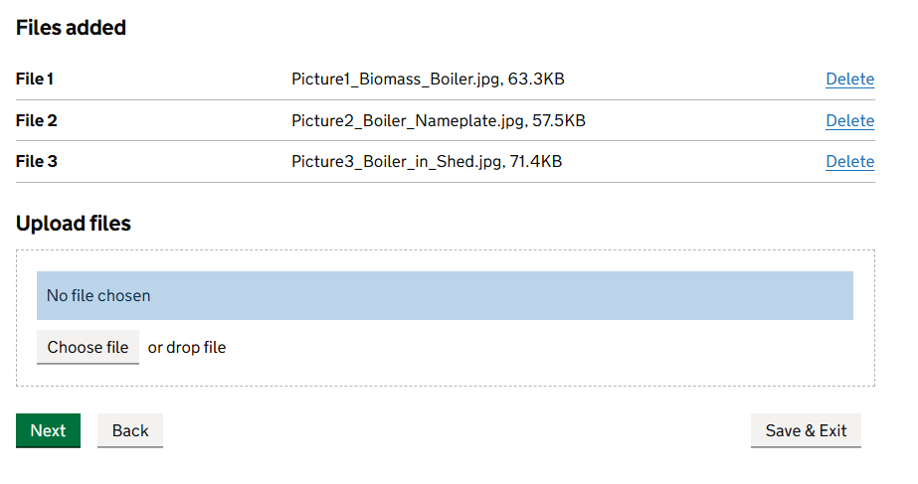

- Click next to continue

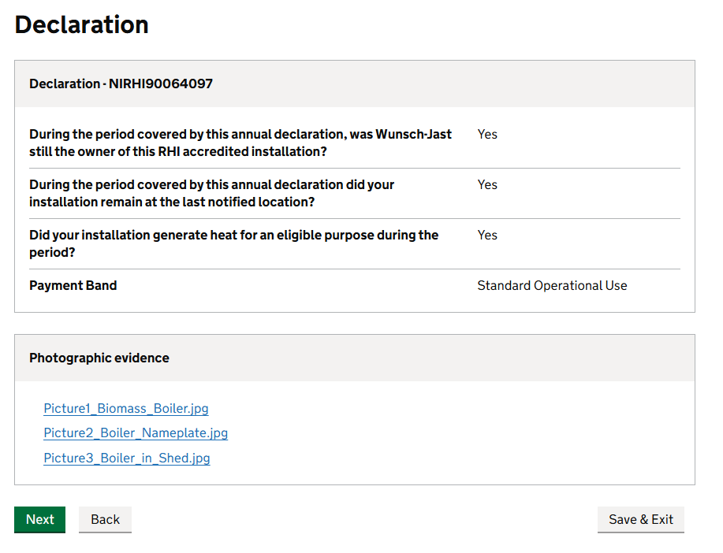

- This screen above is an overview of your questions answered.
- When you are satisfied with the information on the declaration page, click Next.

Step 5: Review and submit

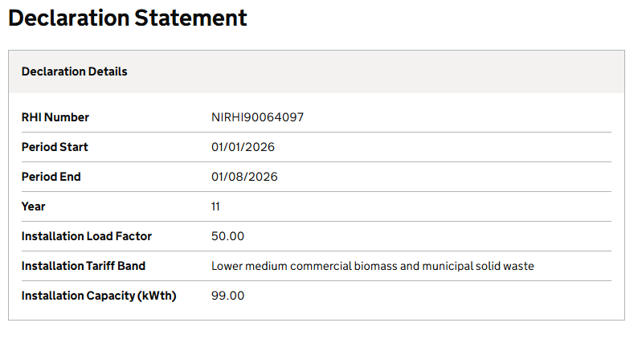
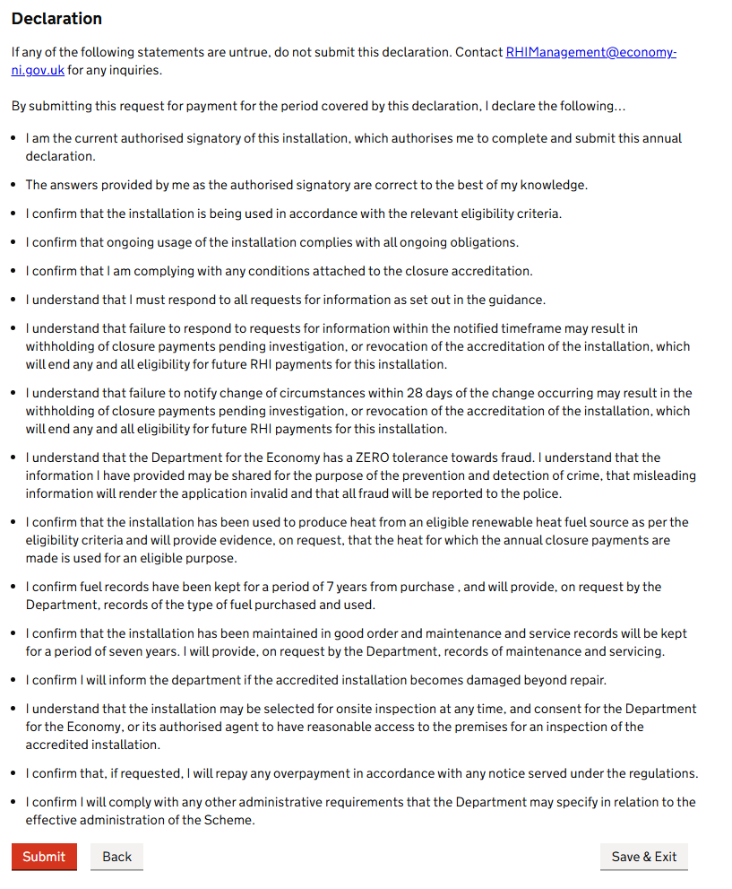

- Read and understand all the statements on this page and click Submit

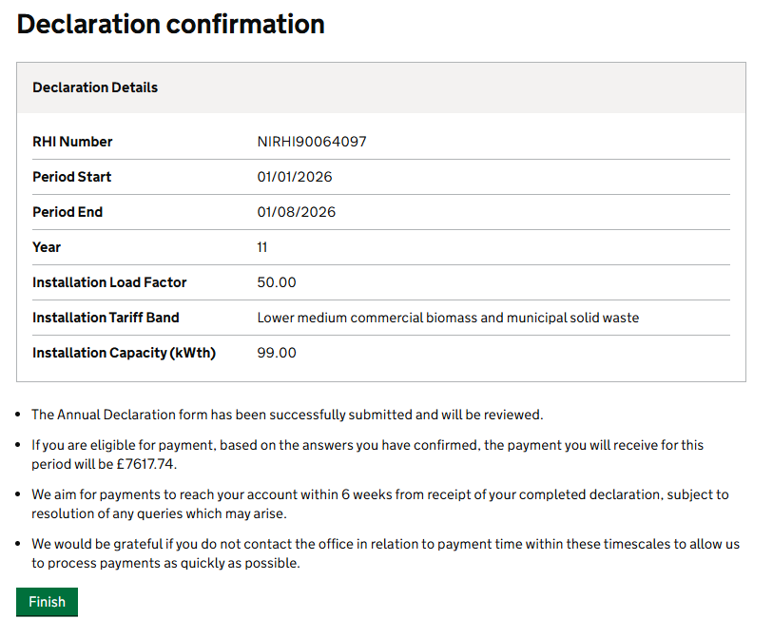

- This page confirms that you have successfully completed your Annual Declaration and confirms the payment amount at point 2.
- Click Finish



- This page will show you that no further Declarations are to be completed.
- If you have more than one installation, further Annual Declarations will be listed here for completion.
- You can now close your browser window.

