Circular Number: FE 01/22 Date of Issue: 3rd March 2022
Subject: Capital Development Payment Procedures
Target Audience:
- Principals of Further Education
- FE College Finance Officers
Summary of Contents:
This circular clarifies the procedures for Colleges claiming for approved Capital Expenditure.
Enquiries:
Any enquiries about the contents of this circular should be addressed to:
Susan Bolas

Further Education Capital Projects Team Department for the Economy susan.bolas@economy-ni.gov.uk

Related Documents: N/A

Superseded Documents: FE 18/01 issued 9 August 2001 FE 18/01 issued 9 March 2012
FE 18/01 issued 1 February 2016
FE 19/01 issued 18 April 2019

Expiry Date: N/A
Website: www.economy-ni.gov.uk
E-Mail: susan.bolas@economy-ni.gov.uk

1. INTRODUCTION
1.1
The purpose of this circular is to clarify the documentation required in order to enable the Department to make payment of claims against Capital Projects funding. Procedures have been updated in line with public health guidelines.

2. PAYMENT OF CAPITAL GRANT
2.1 The Department will only pay grant on receipt of the following documentation:

- Proof of payment of invoices must be supplied by submitting all of the documents as follows:

- A BACS Authorisation Report – showing the claimed invoice amount included in the total amount of the payments processed in that particular "batch", and signed as approved by appropriate college staff.

- A copy bank statement should also be supplied showing the "batch" amount as debited from the college bank account.

- Copies of the college BACS remittance advice should also be supplied which shows the payee name/address, the invoice date and amount paid.

- Architect’s / Consulting Engineer’s Interim or Full Certificates – claims as above, must also be accompanied by an original interim or full certificate, where applicable.

- Invoices relating to Integrated Supply & Consultancy Team contracts must be approved, signed and dated by the Project Director/Estates Manager.

3. CAPITAL CLAIM PRO-FORMA
3.1 To ensure that all of the necessary information regarding a claim is included, a proforma, has been developed (See Appendix A). When completing the proforma
the following guidance applies:
- All invoices relating to the project must be listed on the pro-forma.

- The completed form must be signed by or accompanied by an authorising email from the Principal (or the College Nominated Signatory – See Appendix
B) and emailed along with the invoices to Further Education Capital Projects Team for processing.
- Please use the attached claim form, as required and enter the year as
appropriate.

4. APPENDIX A


20 /20 CAPITAL CLAIM

Web: www.economy-ni.gov.uk

Please E-mail To: susan.bolas@economy-ni.gov.uk and fecapitalprojects@economy-ni.gov.uk

As Accounting Officer (or the College Nominated Signatory) for the
_______College, I am requesting payment of £____________as detailed below.

Original invoices and proof of payment must be attached. Where there is more than one project please record relevant invoices together.

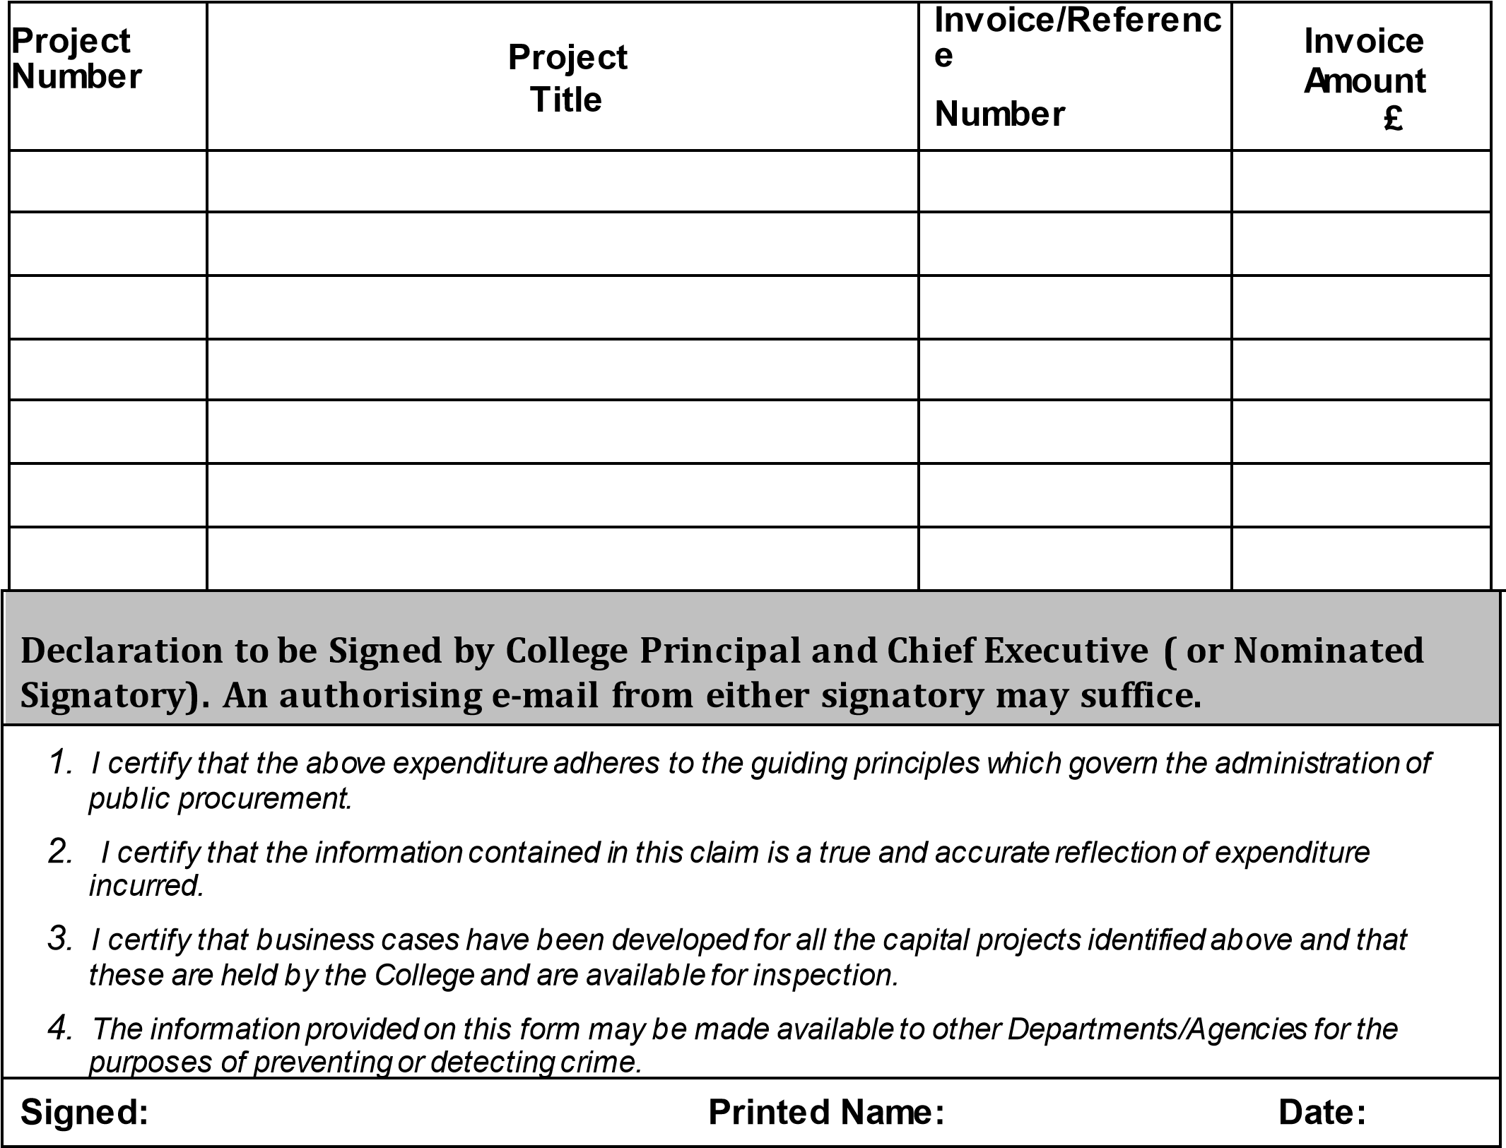

5. APPENDIX B

NOMINATED SIGNATORIES (CAPITAL CLAIMS)

July 2025
Belfast Metropolitan College:
Aidan Sloane
Damian Duffy

Northern Regional College:
Sean Laverty
Mel Higgins

North West Regional College:
Patrick McKeown
Leo Murphy

South Eastern Regional College:
Tommy Martin
David McCullough

Southern Regional College:
Lee Campbell
Gerard Byrne

South West College:
Sean O’Donnell
Celine McCartan

