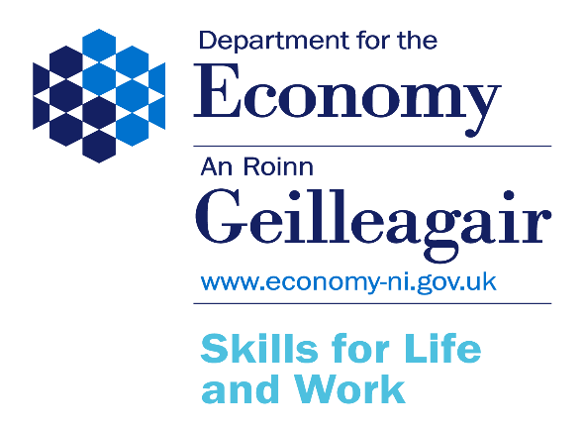

Skills for Life and Work 2025 - Privacy Notice

Data Controller Name: Department for the Economy
Address: Youth Inclusion Branch, Adelaide House,
Belfast, BT2 8FD
Email: Skillsforlifeandwork@economy-ni.gov.uk

Why are you processing my personal information?
Your personal information is being collected for the purposes of the Skills for Life and Work 2025 (SfLW25) programme.

As a SfLW25 participant, we use your personal data to record your participation(s) and achievement(s) on the programme. As you progress through the programme, details of your achievements (qualifications) will be added to your record as well as any change of circumstances which you may inform the Department of (e.g. change of address/status). The information is also required to manage, monitor and report on the SfLW25 programme and evaluation of the success of the programme.

The lawful basis for processing your personal data is to meet a public task function of the Department in relation to the SfLW programme and is in line with Article 6(1)(e) of the UK General Data Protection Regulation (UK GDPR).

Should you provide any information defined as special category data this will be processed in accordance with Article 9(2)(g) of UK GDPR and Schedule 1, Part 2, Para 6 of the Data Protection Act 2018.

This programme operates under the Training and Employment Act NI 1950.

What categories of personal data are you processing?
Contact details, such as name, address, date of birth, national insurance number, bank details, gender and previous educational attainments.

We may also ask for special category data for Equality Monitoring, which is sensitive information, under Section 75 of the Northern Ireland Act 1998, however your provision of this information is voluntary.

Special category data will include such information as:

- racial or ethnic origin
- health
- political opinion
- religious affiliation
- sexual orientation

In addition, we will collect:

- Information about your initial assessment and induction on the programme.
- Information about your time on the programme, including your progress/achievements.
- Information required to support and evidence the payment of any expenses and other allowances you have claimed under the programme.
- Information about any additional support that you may avail of to fully benefit your participation in the programme, including information on disability support.
- Once you have completed training, we may contact you to seek your views in relation to your training experience, via a Leavers’ Survey, however, this is voluntary.

Where do you get my personal data from?

You will supply your personal data when you request a Training Credit from the Department’s Careers Service to join the SfLW25 programme. Additional data will also be supplied by you to your chosen Training Contractor when you enrol/register on the programme using your Training Credit. Your Training Contractor is obliged to ask for Section 75 information from you to assist the Department in meeting its statutory requirement to promote and report on equality of opportunity, however your provision of this information is voluntary.

Do you share my personal data with anyone else?

We may need to share your data internally with other branches within the Department, for example those who have a role in the administration, reporting, compliance monitoring, payment processing and statistical analysis of the SfLW25 programme. The data may also be shared with the Northern Ireland Statistics and Research Agency for the purposes of statistics and research; however, this data will be anonymised before being sent.

Your data may also be shared with Training Contractors in response to queries relating to you, on issues such as eligibility and training entitlement, or Awarding Organisations with regards to qualification certificates.

We will only ever share your personal data with organisations who have a legal right to the data, or whom the Department contract to process the data on our behalf. DfE will satisfy itself that it has a lawful basis on which to share the information and document its decision-making.

Do you transfer my personal data to other countries?

Your data will be located on cloud hosted services with servers within the UK. Any processing of your personal data beyond storage, will only occur within the UK.

How long do you keep my personal data?

The Department will ensure that personal data is kept no longer than necessary, that it manages records effectively from when they are created, including how they are stored and used, through to their destruction or archiving. Client records will be destroyed 7 years from the date of last payment/contact with the Department.

Do you use my personal data to make an automated decision about me or for profiling?

Youth Inclusion Branch does not use automated decision making or profiling in the management of its training programmes.

What rights do I have?

You have the following rights in relation to how the Department uses your personal data:

- You have the right to obtain confirmation that your data is being processed, and access to your personal data
- You are entitled to have personal data rectified if it is inaccurate or incomplete.
- You have a right to have personal data erased, in specific circumstances
- You have the right to ‘block’ or suppress processing of personal data, in specific circumstances
- You have the right to data portability, in specific circumstances
- You have the right to object to the processing, in specific circumstances
- You have rights in relation to automated decision making and profiling

How do I complain if I am not happy?
If you are unhappy with how any aspect of this privacy notice, or how your personal information is being processed, please contact the Department’s Data Protection Officer at DPO@economy-ni.gov.uk
If you are still not happy, you have the right to lodge a complaint with the Information Commissioner’s Office (ICO).
Contact details of the ICO are available at https://ico.org.uk/global/contact-us/

The Department for the Economy’s Corporate Privacy Notice is available at: https://www.economy-ni.gov.uk/dfe-privacy-notice-

