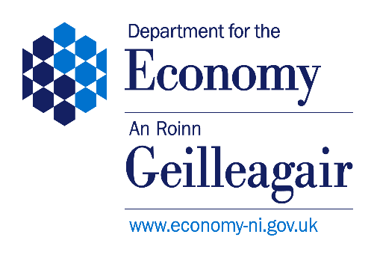
US-Ireland R&D Partnership Checklist for NI applicants
1. Intention to Submit Notification
For NSF programmes with a fixed call deadline
☐Complete ‘Intention to Submit’ notification form and submit via the University Research Office to usireland@economy-ni.gov.uk at least 10 weeks in advance of the full proposal deadline at NSF.
For NSF programmes without a fixed call deadline
☐Complete ‘Intention to Submit’ notification form and submit via the University Research Office to usireland@economy-ni.gov.uk by one of the following deadlines: 1st of February, 1st of June and 1st of October.

2. Draft “Tri-Partite” proposal submission
For NSF programmes with a fixed call deadline
☐Complete Draft “Tri-Partite” proposal submission documentation listed below and submit via the University Research Office to usireland@economy-ni.gov.uk at least 6 weeks in advance of the full proposal deadline at NSF.
For NSF programmes without a fixed call deadline
☐Complete Draft “Tri-Partite” proposal submission documentation must be submitted no later than four weeks after submitting an Intention to Submit form to one of the deadlines specified above.

The following must be included in the Draft “Tri-Partite” proposal submission:
☐A draft version of the tri‐partite proposal in NSF format.
☐A standard DfE coversheet, signed by the applicant and approved by (i) the designated Finance Business Partner (QUB) or Research Development Manager (UU) and (ii) the Head of School or Faculty (or staff members holding higher positions, if applicable).
Please ensure when using electronic signatures for the designated signatories that the cover sheet is sent from their own individual email accounts to USIreland@economy-ni.gov.uk or that they have been copied into the e-mail sent to the Department. This is required by the Department for audit purposes.

☐A US Ireland R&D Partnership Application – Pre-Submission Template. This requests the applicant to provide the following information:
- An overview of the research programme including a breakdown of the work packages and tasks to be undertaken by partners in each jurisdiction.
- The goal of the research programme set out clearly, in layman’s terms where possible.
- A budget justification for the funding requested by the NI Partner.
- Details of the requested partner budgets in RoI and US (an overall figure for each is acceptable).
- An ‘added value’ appendix (1 page). This should include an outline of how the work proposed for each jurisdiction adds significant value, so that the overall programme of research goes beyond what might be achieved by any one PI working alone, supported only by national funding.
- The commercial potential / potential route to market of the project should also be included in the ‘added value’ appendix section. (We appreciate that the proposal is likely to be highly pre-competitive in nature, so would not expect you to be definitive on the potential exploitation route(s) and possible economic benefits to Northern Ireland. However, we will need to have a clear understanding of the potential for commercial benefit).
☐A Gantt chart or equivalent.
☐DfE budget template to provide details of the requested NI budget.
All documents must be collated and sent as a single email to USIreland@economy‐ni.gov.uk.

