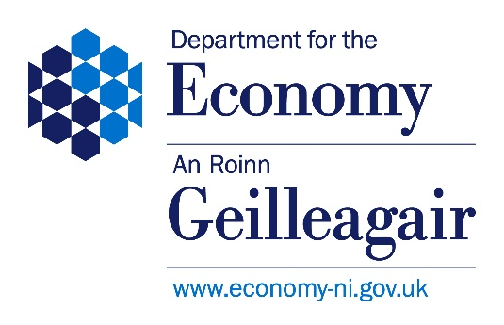

US-IRELAND R&D PARTNERSHIP

COVER SHEET FOR FULL APPLICATION TO DfE
Programme Theme (please mark one box below): Choose an item.
Closing Date for Applications (strictly 6 weeks before NSF target date): Click or tap here to enter text.
NSF Call Target Date: Click or tap here to enter text.
If Open Call – Proposed Submission Date: Click or tap here to enter text.
Title of Proposal (up to 30 words): Click or tap here to enter text.
Name of University: Click or tap here to enter text.
Name of Republic of Ireland Partner: Click or tap here to enter text.
Name of United States Partner: Click or tap here to enter text.
Name of Northern Ireland Principal Investigator: Click or tap here to enter text.
Requested Budget (£s) – NI Only (Max £400k): Click or tap here to enter text.
Signatures from two university senior officials and stamps overleaf confirm acceptance and agreement with the DfE NI Terms and Conditions, and that the University ensures that the applicant meets eligibility requirements; that the project is in full agreement with all legal and regulatory matters governing research in the UK; that no aspect of this project is already being funded from another source; that the science proposed is of a high standard, and that all details provided are correct.

Name (print): Click or tap here to enter text.
Post held: Click or tap here to enter text.
Email: Click or tap here to enter text.
Correspondence Address: Click or tap here to enter text.
Signed: Click or tap here to enter text.
Date: Click or tap here to enter text.

Name (print): Click or tap here to enter text.
Post held: Click or tap here to enter text.
Email: Click or tap here to enter text.
Correspondence Address: Click or tap here to enter text.
Signed: Click or tap here to enter text.
Date: Click or tap here to enter text.

This coversheet must be signed by two designated individuals to proceed with the submission process. The required signatories are: - Finance Business Partner (QUB) / Research Development Manager (UU) - Head of School or Faculty In situations where it's not possible to collect signatures from the individuals specifically designated, the Department will accept signatures from staff members who hold higher positions.

