
IFF Research
November 2025
Employer Skills Survey 2024 –
Northern Ireland
Research report
Contents
1. Introduction 8
1.1 Background 8
1.2 Structure of the report and report coverage 8
1.3 Reporting conventions 8
2. Employer characteristics 10
3. Skill-shortage vacancies 12
3.1 Introduction 12
3.2 Vacancies 12
3.3 Skill-shortage vacancies 14
3.4 Skills lacking in the available labour market 16
3.5 Impact of skill-shortage vacancies on employers 18
4. Recruitment 20
4.1 Introduction 20
4.2 Proportion of employers that recruited over the last 12 months 20
4.3 What employers look for when recruiting 20
4.4 Recruitment directly from education 21
5. The internal skills challenge 23
5.1 Introduction 23
5.2 Incidence, volume and density of skills gaps 23
5.3 Causes of skills gaps 26
5.4 Skills lacking internally 27
5.5 Impact of skills gaps on employers 29
5.6 Under-use of skills and qualifications 30
5.7 Upskilling 31
6. Training and workforce development 35
6.1 Introduction 35
6.2 Incidence of training and workforce development 35
6.3 Number of training days provided 37
6.4 Proportion of staff trained 37
6.5 Types of training provided 39
6.6 Barriers and limits on training 41
6.7 Employer investment in training 43
7. Apprenticeships 45
7.1 Introduction 45
7.2 Offering formal apprenticeships 45
7.3 Future apprenticeships plans 45
8. High Performance Working practices 47
8.1 Introduction 47
8.2 Proportion of employers classed as High Performance Working employers and change over time 47
9. Artificial Intelligence 50
9.1 Introduction 50
9.2 Use of Artificial Intelligence 50
9.3 Future use of Artificial Intelligence 51
10. National Occupation Standards (NOS) 52
10.1 Awareness of NOS in Northern Ireland 52
10.2 The use of NOS in Northern Ireland 52
11. Methodology 54
Annexes 56
Annex A – Definitions 56
Annex B - Grouped codes 57
Key Findings 59

List of tables
Table 1-1: Definitions for key incidence, volume and density measures used in this report 8
Table 4-1: Importance of factors looked for in recruitment, 2022 – 2024 20
Table 6-1: Number and proportion of staff trained, by sector 37
Table 6-2: Level of nationally recognised qualification staff worked towards, 2022 – 2024 40
Table 6-3: Total training expenditure and spend per person trained and per employee (2022 – 2024), in 2024 prices 43
Table 11-1: Interviews achieved in Northern Ireland, per module 53

List of figures
Figure 2-1: Employer and employment profile by site size in Northern Ireland in March 2024 9
Figure 2-2: Employer and employment profile by sector in Northern Ireland in March 2024 10
Figure 3-1 Incidence and density of vacancies, by sector 12
Figure 3-2 Incidence and density of skill-shortage vacancies, by region, 2022 – 2024 13
Figure 3-3 Density of skill-shortage vacancies, by occupation, 2022 - 2024 14
Figure 3-4 Technical and practical skills lacking among applicants to vacancies classed as skill-shortage vacancies among those followed (prompted) 16
Figure 3-5 People and personal skills lacking among applicants to vacancies classed as skill-shortage vacancies among those followed (prompted) 17
Figure 3-6 Impact of skill-shortage vacancies, 2022 – 2024 (prompted) 18
Figure 5-1 Incidence and of skills gaps by sector 23
Figure 5-2 Incidence and density of skills gaps by region, 2022 – 2024 24
Figure 5-3 Prevalence of skills gaps by occupation, 2022 - 2024 25
Figure 5-4 Causes of skills gaps in occupations followed up (prompted) 26
Figure 5-5 Technical and practical skills lacking among staff with skills gaps followed up (prompted) 27
Figure 5-6 People and personal skills lacking among staff with skills gaps followed up (prompted) 28
Figure 5-7 Overall impact of skills gaps and specific implications of skills gaps (prompted), 2022 – 2024 29
Figure 5-8 Overall proportion of employers with a need for upskilling and the reasons for needing to upskill, 2022 – 2024 31
Figure 5-9 Occupations most affected by the need for upskilling 32
Figure 6-1: Incidence of any training, off-the-job training and on-the-job training, 2011 – 2024 34
Figure 6-2: Incidence of training by sector, 2022 – 2024 35
Figure 6-3: Proportion of staff trained over the last 12 months by occupation, 2022 – 2024 38
Figure 6-4: Types of training provided for employees over the last 12 months, 2022 – 2024 39
Figure 6-5: Reasons for not providing training among non-training employers (unprompted), 2022 – 2024 41
Figure 6-6: Training equilibrium status of employers 42
Figure 7-1 Proportion of employers offering apprenticeships in the future, by site size 45
Figure 8-1 Prevalence of High Performance Working practices 46
Figure 8-2 Prevalence of High Performance Working practices, by site size 47
Figure 8-3 Prevalence of High Performance Working practices, by sector 48
Figure 9-1 Use of AI, by sector 49
Figure 9-2 Whether sites are planning to adopt AI and timeframe for adoption (non-users) 50
Figure 10-1 Proportion of sites in each sector using National Occupational Standards 52

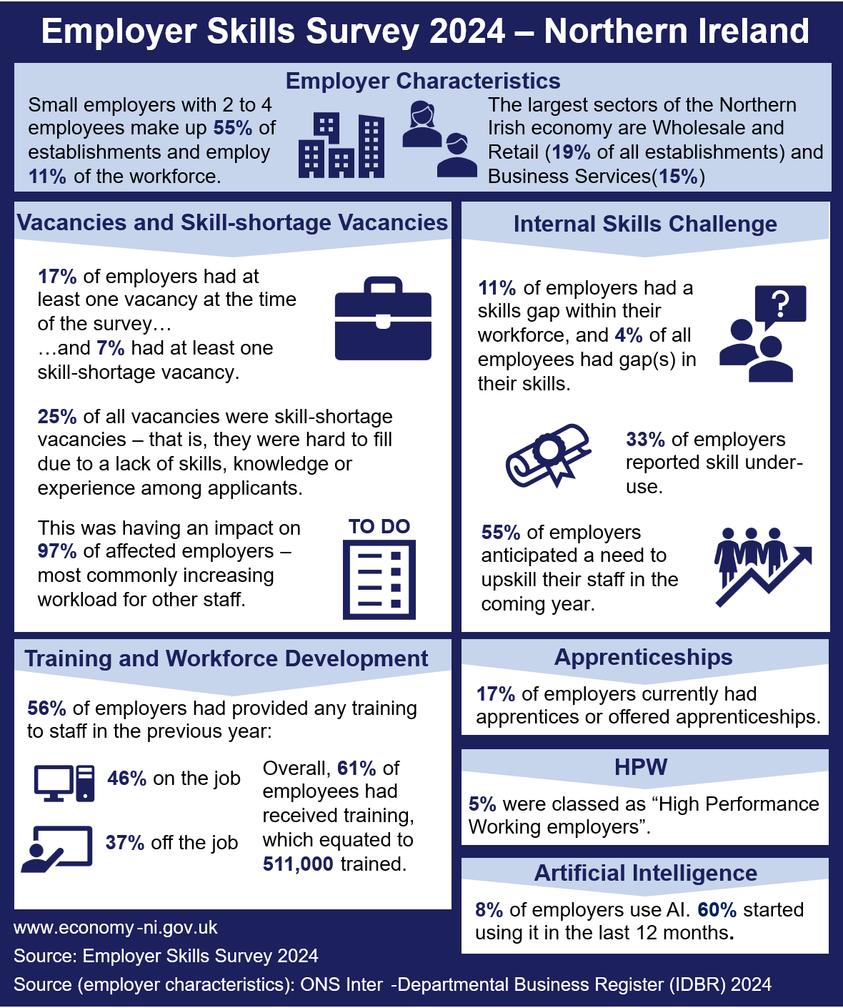

Introduction

Background
The Employer Skills Survey 2024 (ESS 2024) is a large-scale survey among employers across the UK, designed to understand the skills challenges faced by employers, including their extent, nature and impact within both their existing workforce, and when recruiting. The survey also provides insights into how employers respond to these challenges through investment in training and workforce development. This report focuses on the findings from employers in Northern Ireland, capturing the responses of 3,388 sites.
ESS was conducted at the UK level every two years from 2011 to 2017, then again in 2022 and 2024. ESS involves a telephone survey of employers in England, Northern Ireland, Scotland and Wales. The survey ran in 2019 but did not include employers in Scotland. Northern Irish employers have been included in every iteration of the survey since its inception in 2011. The Employer Perspectives Survey (EPS) ran in parallel with ESS from 2010 to 2017, before being combined with ESS in 2019 to produce one survey.
Throughout the report, comparisons are made with England, Scotland and Wales, and within key subgroups of employers in Northern Ireland (e.g., by size, sector and region). Time series comparisons are generally included for up to two waves of data, though for some indicators an extended time series is given. Further information about the ESS method can be found in the Methodology section of this report, and the published full UK technical report.

Structure of the report and report coverage
This report explores the following topics:
- The external skills challenge: skill-shortage vacancies, skills lacking in the available labour market, the impact on employers, analysis of recruitment trends, including recruitment directly from education;
- The internal skills challenge: skills gaps and their impact, their causes and what skills are lacking, alongside under-use of skills and qualifications, and the need for upskilling;
- Training and workforce development, including training expenditure;
- Apprenticeships; the current offering and future plans;
- High Performance Working Practices;
- Artificial Intelligence (AI) in the workplace; and
- National Occupational Standards (NOS): awareness and use in Northern Ireland.

Reporting conventions
The terms ‘site’ and ‘employer’ are used interchangeably throughout this report to avoid excessive repetition. Previous ESS reports have used the word ‘establishment’ in the same context; however, it was decided that for ESS 2024 that ‘site’ better represented the unit being described.
The survey population is UK businesses with two or more employees; this means businesses with at least two people working on the payroll, including working proprietors. When reporting volume and density measures, we typically refer to ‘employees’ throughout the report rather than ‘employment’.
All differences referred to in the report commentary are statistically significant at the 95% level of confidence. This applies to differences between subgroups such as region, size and sector, and also to differences over time.
Throughout the report, unweighted base figures are shown on tables and charts to give an indication of statistical reliability of the figures. These figures are always based on the number of sites answering a question, as this is the information required to determine statistical reliability.
In the tables, ‘zero’ is denoted as a dash (“-“), and an asterisk (“*”) is used if the figure is larger than zero but less than 0.5%.
In the tables and charts, figures with a base size of fewer than 30 sites are not reported (a double asterisk, “**”, is displayed instead), and figures with a base size of 30 to 49 are italicised and should be treated with caution as the error margin for these results is larger, and therefore the results are less statistically reliable.
Throughout the report the terms incidence, volume and density are used regarding vacancies, skill-shortage vacancies and skills gaps. They are defined in Table 1-1.
Table 1-1: Definitions for key incidence, volume and density measures used in this report
 | Vacancies | Skill-shortage vacancies | Skills gaps
Incidence | The number of sites reporting at least one vacancy | The number of sites that reported at least one skill-shortage vacancy | The number of sites that reported any of their staff lacked full proficiency
Volume | The total number of vacancies | The total number of vacancies that are hard to fill as a result of skill shortages | The total number of employees that lack full proficiency
Density | The total number of vacancies as a proportion of all employment | The total number of skill-shortage vacancies as a proportion of all vacancies | The total number of employees that lack full proficiency as a proportion of all employment

Throughout the report, we breakdown results by region using District Council area, which creates five categories. The 11 district councils which make up the five regions are noted below:
- Belfast: Belfast
- East: Ards and North Down, Mid and East Antrim, Antrim and Newtownabbey, Lisburn and Castlereagh
- South: Armagh City Banbridge and Craigavon, Newry Mourne and Down
- North: Causeway Coast and Glens, Derry City and Strabane
- West: Mid Ulster, Fermanagh and Omagh

Employer characteristics
The population of employers for the ESS 2024 included all sites that had at least two people working at them (including owners and working proprietors). A “site” is a single location of an organisation, meaning interviews were carried out with an individual at each local office (rather than a single “head office” location with a respondent answering on behalf of the whole organisation). This reflects the fact that skills issues are felt most acutely at local level, and continues the approach taken by previous UK-wide ESS surveys dating back to 2011.
Figure 2-1 shows the profile of employers and employees in Northern Ireland by site size. The Office for National Statistics (ONS) figures estimate that in March 2024 there were 61,709 sites in Northern Ireland, employing 833,997 people between them.
Nine-in-ten sites (90%) in Northern Ireland are classed as small employers with 56% employing between 2 and 4 staff, and the other 34% employing between 5 and 24 staff. However, these smaller employers employ only 11% and 25% of the workforce respectively. Employers with 100 or more staff employed almost two-fifths (38%) of the workforce, despite only making up 2% of the size profile.
Figure 2-1: Employer and employment profile by site size in Northern Ireland in March 2024
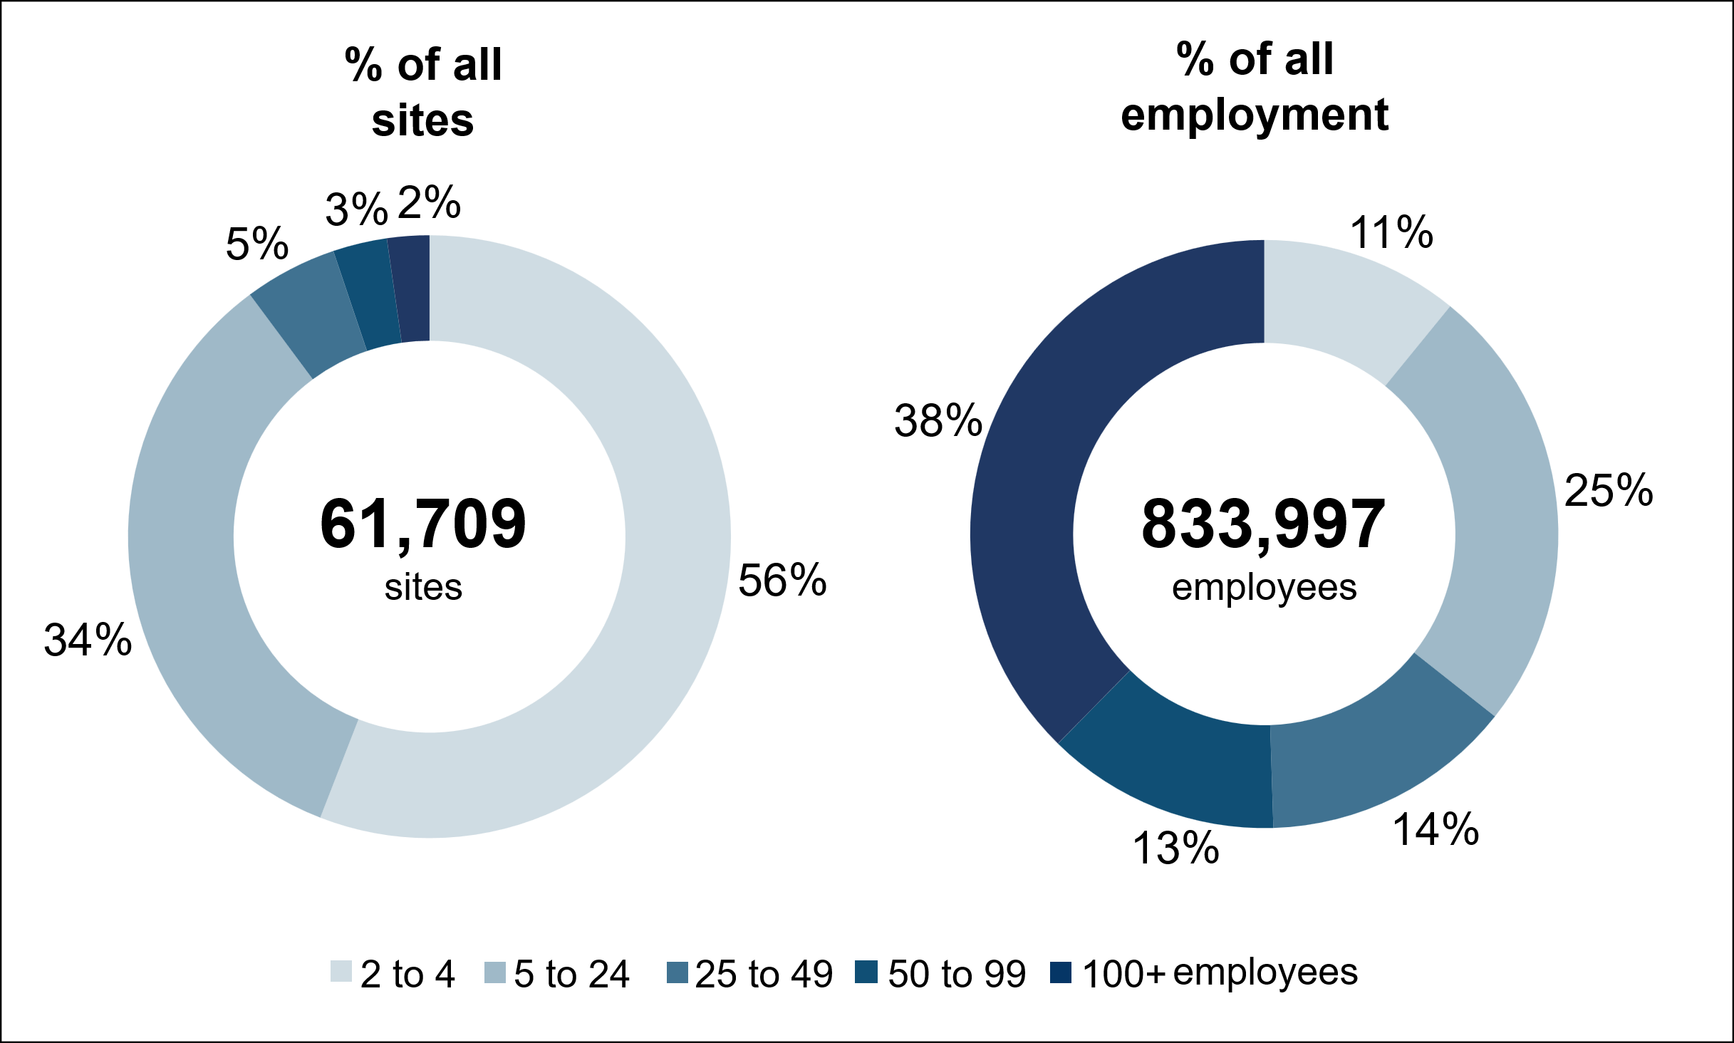
Source: ONS Inter-Departmental Business Register (IDBR) March 2024.
IDBR data indicates that the largest sector by number of sites is the Wholesale and Retail sector (19%), followed by the Primary and Utilities (15%) and Business Services (14%) sectors. The smallest sector is Public Administration which makes up only 1% of sites in Northern Ireland.
By employment, the largest sector is Health and Social work which represents 17% of total employment. This is followed by Wholesale and Retail (16%) and Business Services (13%). The sector making up the smallest level of employment is the Financial Services sector (2% of total employment). Figures for both the spread of sites and employment by sector have remained in line with the proportions in 2022.
Figure 2-2: Employer and employment profile by sector in Northern Ireland in March 2024
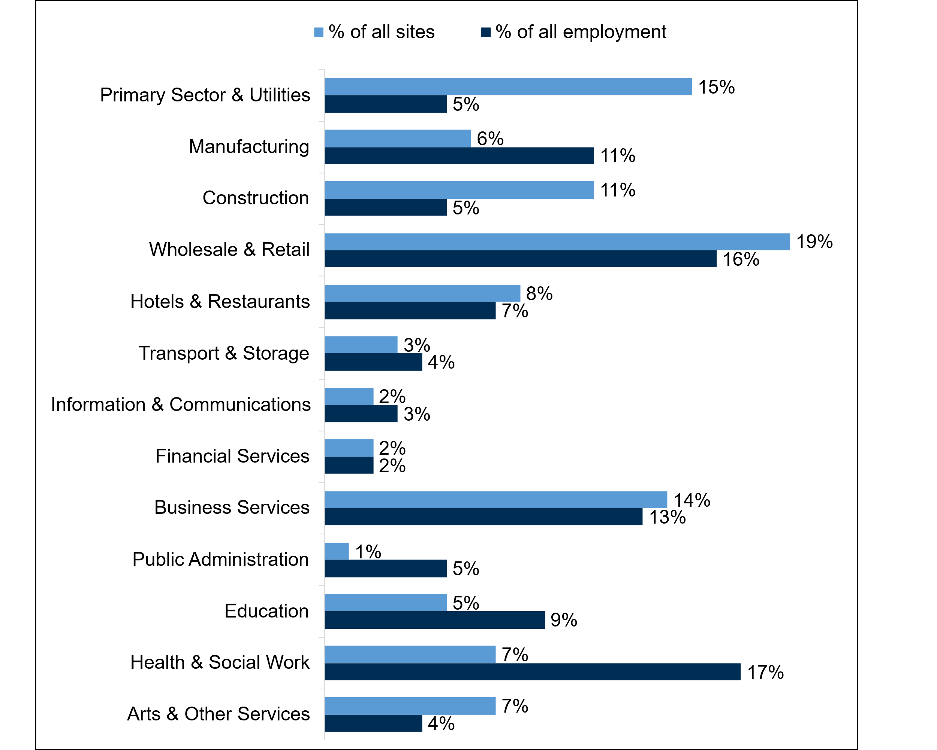
Source: ONS Inter-Departmental Business Register (IDBR) March 2024.

Skill-shortage vacancies

Introduction
This chapter considers the incidence, density and profile of vacancies in Northern Ireland. This includes a specific focus on skill-shortage vacancies (SSVs), which are vacancies that are difficult to fill due to a lack of applicants with the necessary skills, experience or qualifications. The chapter also explores which skills were lacking most among applicants, as well as the impacts of skill-shortage vacancies on employers.
The key measures used in this section are as follows:
- Incidence of vacancies: the proportion of sites reporting at least one vacancy
- Incidence of skill-shortage vacancies: the proportion of sites that had at least one skill-shortage vacancy
- Vacancy density: vacancies as a proportion of all employment
- Skill-shortage vacancy density: skill-shortage vacancies as a proportion of all vacancies

Vacancies
Overall, one-in-six (17%) sites in Northern Ireland had at least one vacancy at the time of the survey. This proportion has decreased since 2022 (21%) but is still somewhat higher than levels seen in 2019 (14%) and 2017 (16%).
In total, there were 29,900 vacancies, equivalent to 3.6% of total employment. The volume and density of vacancies have also decreased since 2022, when there were 39,500 vacancies, equivalent to 5.0% of total employment. However, the density levels are similar to 2019 (24,000 vacancies; 3.1% of total employment) and 2017 (23,200 vacancies; 3.1% of total employment).
When looking at specific regions, as in 2022, Belfast has the highest incidence of vacancies (22%) compared to other regions in Northern Ireland. In other regions, this proportion was between 14% and 18% (14% in the South, 16% in the East and 18% in the North and West). On the other hand, the density of vacancies was highest in the East (5.1%), and lowest in the North (2.6%) and South (2.5%). This contrasts to 2022, when the South had the highest vacancy density, at 5.9%, but shows a return to similar levels seen in this region in 2019 (2.3%). All other regions remained consistent between 2024 and 2022.
The incidence of vacancies grew with site size, ranging from 10% among sites with 2 to 4 employees to 68% among employers with 100 or more employees. However, vacancy density was highest among employers with 2 to 4 employees (4.8%) and lowest among employers with 50 to 99 employees (2.5%). There was no direct correlation between employer size and vacancy density.
Employers in the Health and Social Work, Manufacturing and Education sectors had the highest vacancy incidences, with 31%, 27% and 24%, respectively (compared to 17%, overall). Less than one-in-ten (9%) employers in Construction reported having at least one vacancy, the lowest of all sectors. In terms of vacancy density, Construction (4.4%), Hotels and Restaurants (4.4%) and Business Services (4.1%) had higher levels than overall (3.6%). Vacancy density was lowest in the Financial Services (0.9%) and Information and Communications (1.4%) sectors. A further breakdown of these figures across all sectors is shown in Figure 3-1.

Figure 3-1 Incidence and density of vacancies, by sector
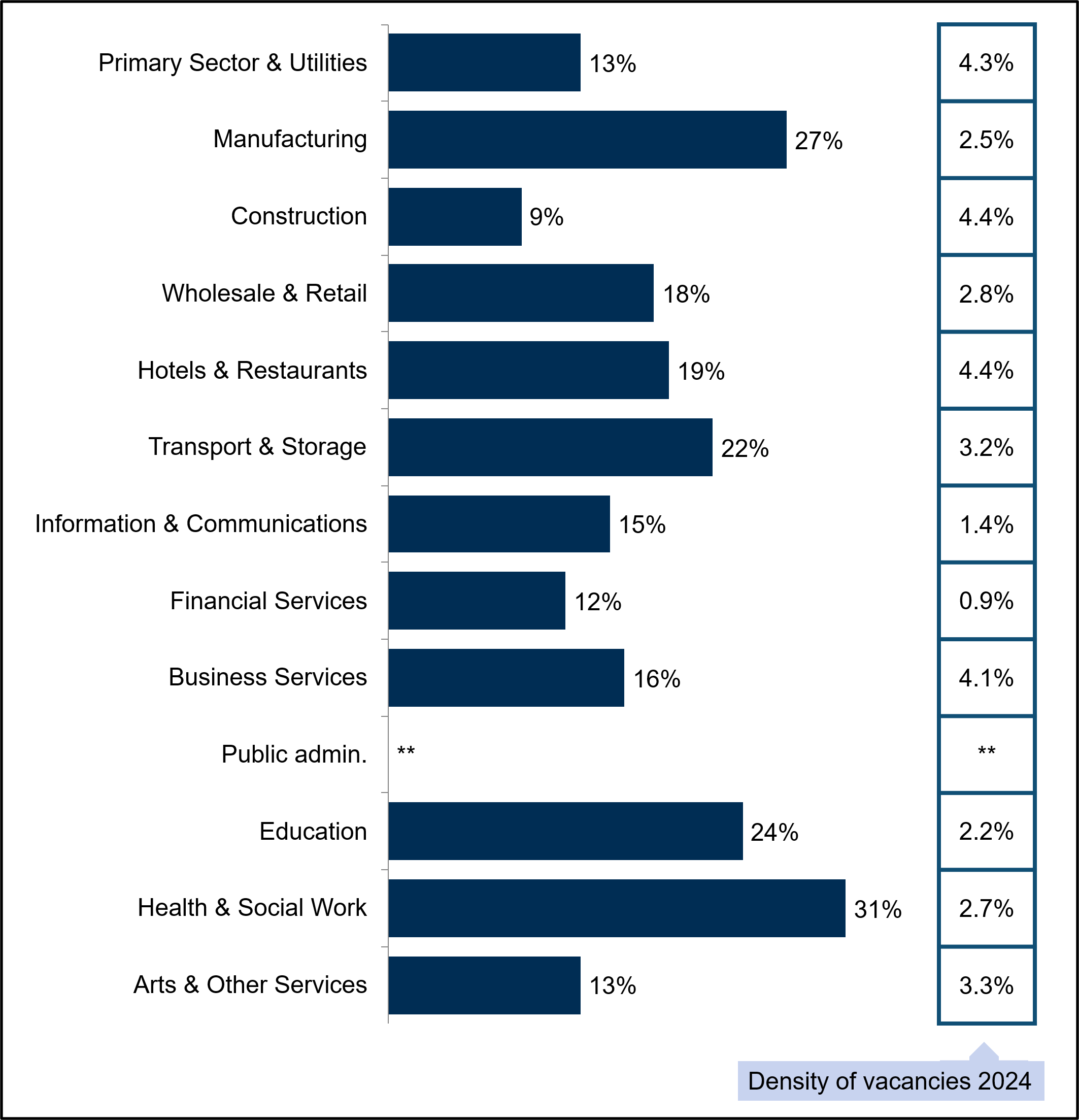
Base: All sites in Northern Ireland (3,388; sector bases range from 61 for Financial Services, to 740 for Wholesale and Retail). Public Administration not charted due to low base size.
Further data on the incidence and density of vacancies can be found in Tables 14 and 16 of the published Northern Ireland Data Tables.

Skill-shortage vacancies
Employers that indicated that they had vacancies at the time of the 2024 survey were asked whether any had proved hard-to-fill. If so, they were asked whether it was due to a lack of skills, experience or qualifications among applicants. The information provided is summarised in the skill-shortage vacancies measure (SSVs).
In total, there were 7,500 skill-shortage vacancies is Northern Ireland in 2024. This is notably lower than the number in 2022 (13,700) but higher than in 2019 (5,400) and 2017 (4,900). Overall, 7% of employers had a skill-shortage vacancy. As with the total number of vacancies, this is a lower proportion than in 2022 (9%), however it is higher than 2019 (4%) and 2017 (5%). Regionally, the proportion of employers with SSVs decreased in Belfast (13% to 8%), but did not significantly decrease elsewhere, as seen in Figure 3-2.
SSVs made up a quarter (25%) of all vacancies in Northern Ireland in 2024 (referred to as SSV density). This has decreased since 2022 (35%) but remains relatively consistent with 2019 (22%) and 2017 (21%). Regionally, SSV density was highest in the West (39%) and South (34%), as also shown in the table within Figure 3-2.
Figure 3-2 Incidence and density of skill-shortage vacancies, by region, 2022 – 2024
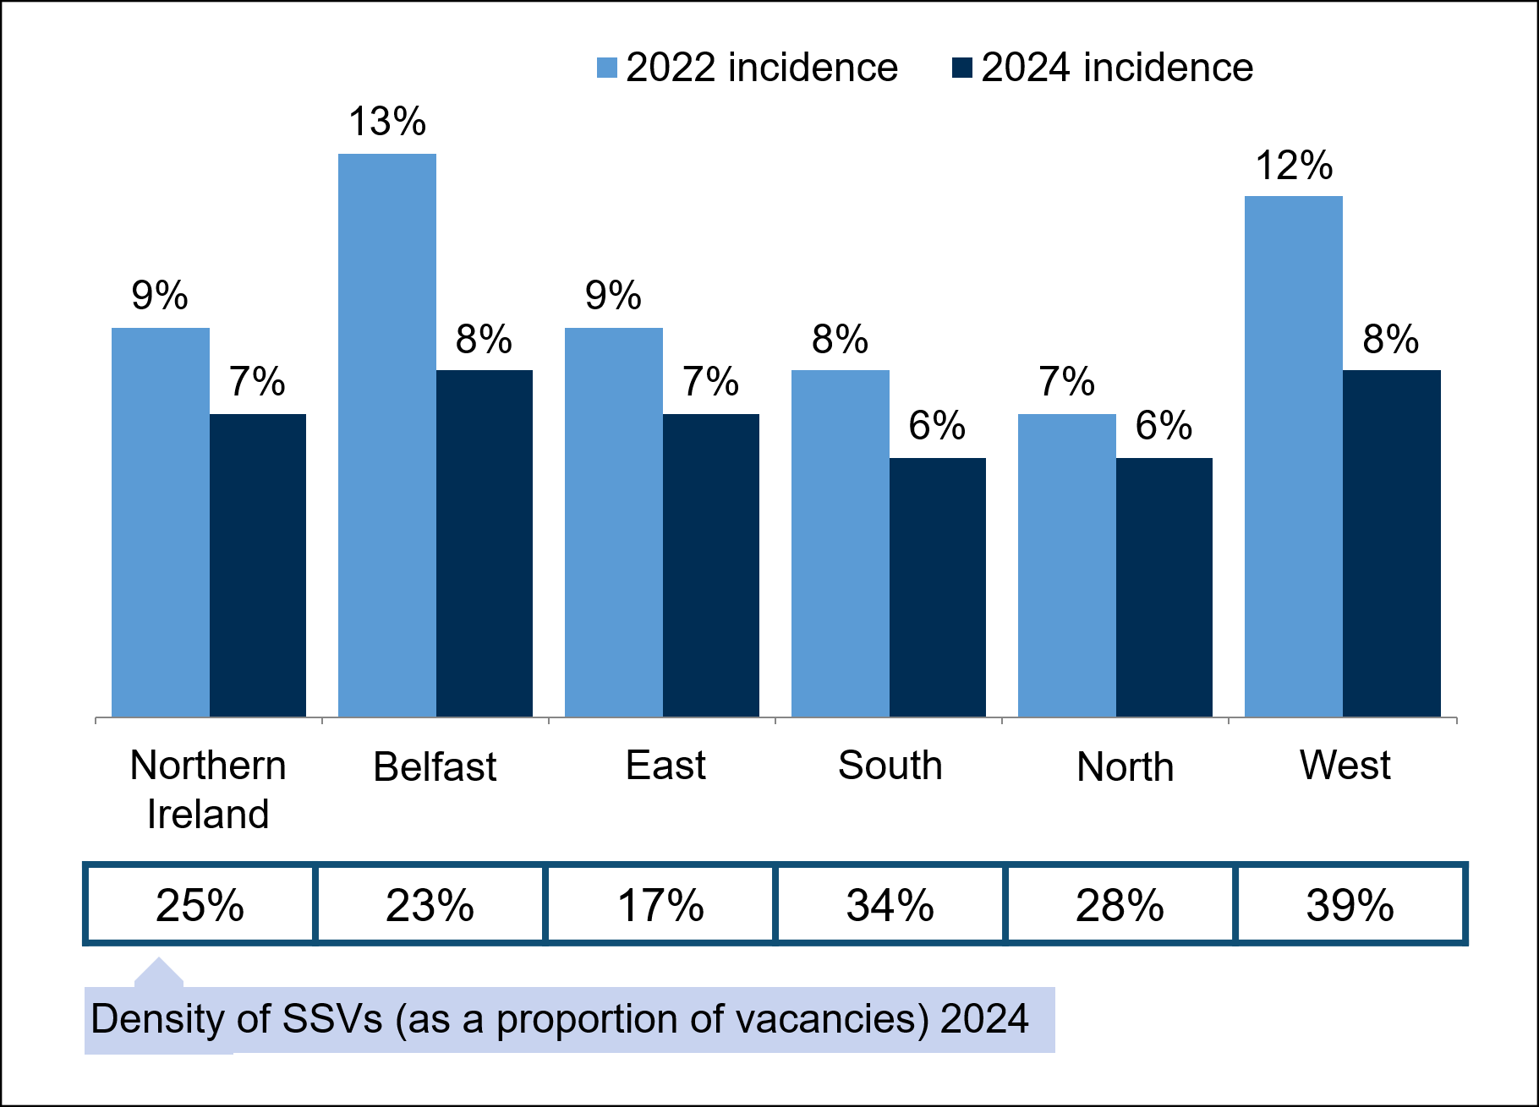
Base: All sites in Northern Ireland (2022: 3,400; regional base sizes range from 503 in the North to 942 in the East, 2024: 3,388; regional bases range from 508 in the North to 955 in the East;). Base for density figures: All sites with vacancies in Northern Ireland (2024: 867: regional bases range from 120 in the North and 229 in the East).
Incidence of SSVs increased with site size. Only 4% of employers with 2 to 4 employees had SSVs compared with 23% of employers with 100 or more employees. Conversely, density of SSVs was lowest among large employers with 100 or more employees. This was also true in 2022, however the SSV density of employers with 100 or more employees has declined from 21% in 2022 to only 7% in 2024. Employers with between 50 and 99 employees had the highest SSV density (40%).
By sector, incidence of SSVs was most common among employers in Manufacturing (14%) and Education (12%) and lowest in Construction (3%). High SSV density were found among employers in the Education (37%) sector.
In terms of occupation, Skilled Trades occupations and Elementary occupations had the highest SSV densities (43% and 40% respectively). The lowest density was among Professionals (13%). Some occupations have seen a decrease in their SSVs between 2022 and 2024, most notably Machine Operatives, Associate Professionals and Professional occupations which have decreased from 52% to 26%, 34% to 23% and 34% to 13%, respectively. Caring, Leisure and Other Services occupations were the only occupation where the density of SSVs notably increased (30% vs. 20% in 2022). A breakdown of SSV density across all occupational groups can be found in Figure 3-3.
Figure 3-3 Density of skill-shortage vacancies, by occupation, 2022 - 2024
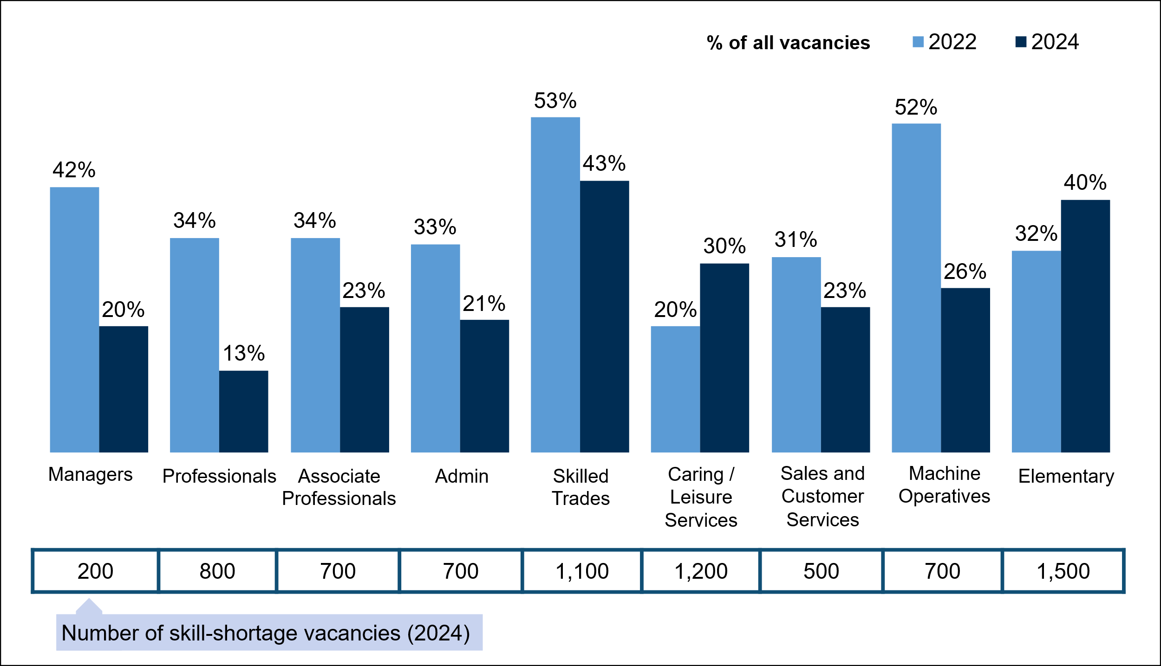
Base: All sites with skill-shortage vacancies in Northern Ireland (2022: 1,030; occupational base sizes range from 65 for Managers to 228 for Caring, Leisure and Other Services, 2024: 867; occupational base sizes range from 59 for Managers to 174 for Caring, Leisure and Other Services). The number of SSVs for each occupation is rounded to the nearest 100.

Skills lacking in the available labour market
Employers with skill-shortage vacancies were asked which skills were lacking among applicants, for each occupation in which they reported skill-shortage vacancies. Those skills lacking among candidates have been grouped into two categories:
Technical and practical skills: specific skills required to perform the specific functions of a job role. Those who mentioned lacking IT skills were also asked (unprompted) which digital skills were lacking.
People and personal skills: ‘softer’, less tangible skills required to manage oneself and interact with others in the workplace.
A lack of technical and practical skills contributed to around nine-in-ten (89%) SSVs. This has slightly increased since 2022 (84%) but is closely aligned with levels seen in 2019 (89%) and 2017 (87%). The most common technical and practical skills lacking were specialist skills or knowledge needed to perform the role (64%), complex problem-solving skills (47%) and creative and innovative thinking (44%).
The skills lacking among candidates can be grouped into broader categories of ‘operational skills’, ‘complex analytical skills’, ‘basic skills’ and ‘digital skills’ (as defined in Annex B). Complex analytical skills were most commonly found to be lacking, with this contributing to more than half of SSVs (54%); an increase from two-fifths (40%) in 2022. This includes, as mentioned earlier, a lack of complex problem-solving skills (47%), and also a lack of complex numerical or statistical skills (31%). The proportion of SSVs affected by a lack of operational skills decreased from 53% in 2019, to 42% in 2024. Most commonly this included a lack of knowledge of products and services offered (35%), closely followed by knowledge of how the organisation works (31%). The proportion of SSV applicants lacking digital and basic skills (35% and 36% respectively) remained relatively consistent with 2022 (32% and 35%, respectively), but lower than 2019 levels (41% and 47%, respectively).
By size, SSVs at small employers with 2 to 4 employees were more likely to be caused by a lack of complex analytical skills (73%) whereas this was far less common when looking at SSVs among employers with 100 or more employees (29%). Among other skills categories, links with employer size were comparatively non-linear. Operational skills were most commonly lacking among applicants for employers with 25 to 49 employees (52%). Digital skills and basic skills deficiencies were more common among applicants to employers with 5 to 24 employees.
Those with SSVs who reported a lack of digital skills among applicants were asked what specific IT skills they felt were lacking. The most common response was a lack of basic Microsoft Office applications skills (37% of SSVs caused by a lack of digital skills). One-in-six (17%) were due to a reported lack of foundational digital skills such as turning on devices, typing, changing passwords or connecting to the internet; around one-in-eight digital SSVs were due to a lack of advanced Microsoft Office skills (12%); around one-in-ten were caused by a lack of EPOS / till systems skills (10%); as similar proportion due to skills lacking relating to specialist software or hardware and internal system (10%); and 8% due to skills lacking when communicating via email (8%). A full breakdown of these lacking skills is shown in Figure 3-4.

Figure 3-4 Technical and practical skills lacking among applicants to vacancies classed as skill-shortage vacancies among those followed (prompted)
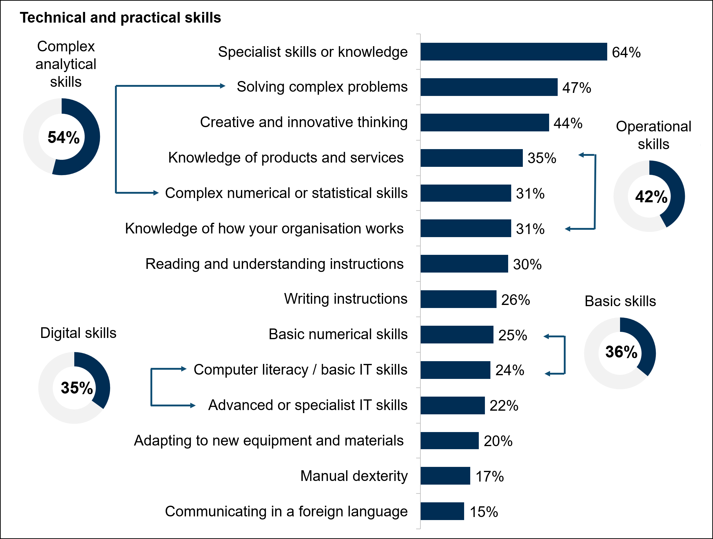
Base: All sites in Northern Ireland with skill-shortage vacancies - up to 2 occupations followed up (348).
Around seven-in-ten (72%) SSVs were caused, at least to some extent, by a lack of people and personal skills. This has increased since 2022 when 64% of SSVs were attributed to a lack of these skills, but remains consistent with 2019 levels (77%). The most common people and personal skills found to be lacking among applicants were time management and task prioritisation (54%), a lack of team working skills (34%) and a lack of ability to manage feelings and handle those of others (32%).
People and personal skills, as with technical and practical skills, were grouped together into broader categories of self-management skills, management and leadership skills, and sales and customer skills (as defined in Annex B). Self-management skills were most commonly lacking among applicants, contributing to around three-fifths of SSVs (61%), representing an increase from 2022 levels (48%). In more than half of cases this was specifically due to, as discussed earlier, a lack of time management skills (54%). There was also an increase in the proportion of SSVs caused, in part, by a lack of management and leadership skills (42% vs. 35% in 2022); most commonly this related to a lack of skills in managing or motivating staff (30%). The proportion of SSVs affected by a lack of sales and customer skills was relatively unchanged from 2022 (34% vs. 31% in 2022).
Considering size differences, SSVs caused by lack of management and leadership skills were more common among employers with 5 to 24 employees (49%), while sales and customer skills were most often lacking among applicants at sites with 25 to 49 employees (42%). Employers with 25 or more employees were least likely to experience SSVs caused by a lack of self-management skills (54%) and sales and customer skills (28%), with ‘sales and customer skills’ being particularly low among employers with 50 to 99 employees (25%).
Figure 3-5 People and personal skills lacking among applicants to vacancies classed as skill-shortage vacancies among those followed (prompted)
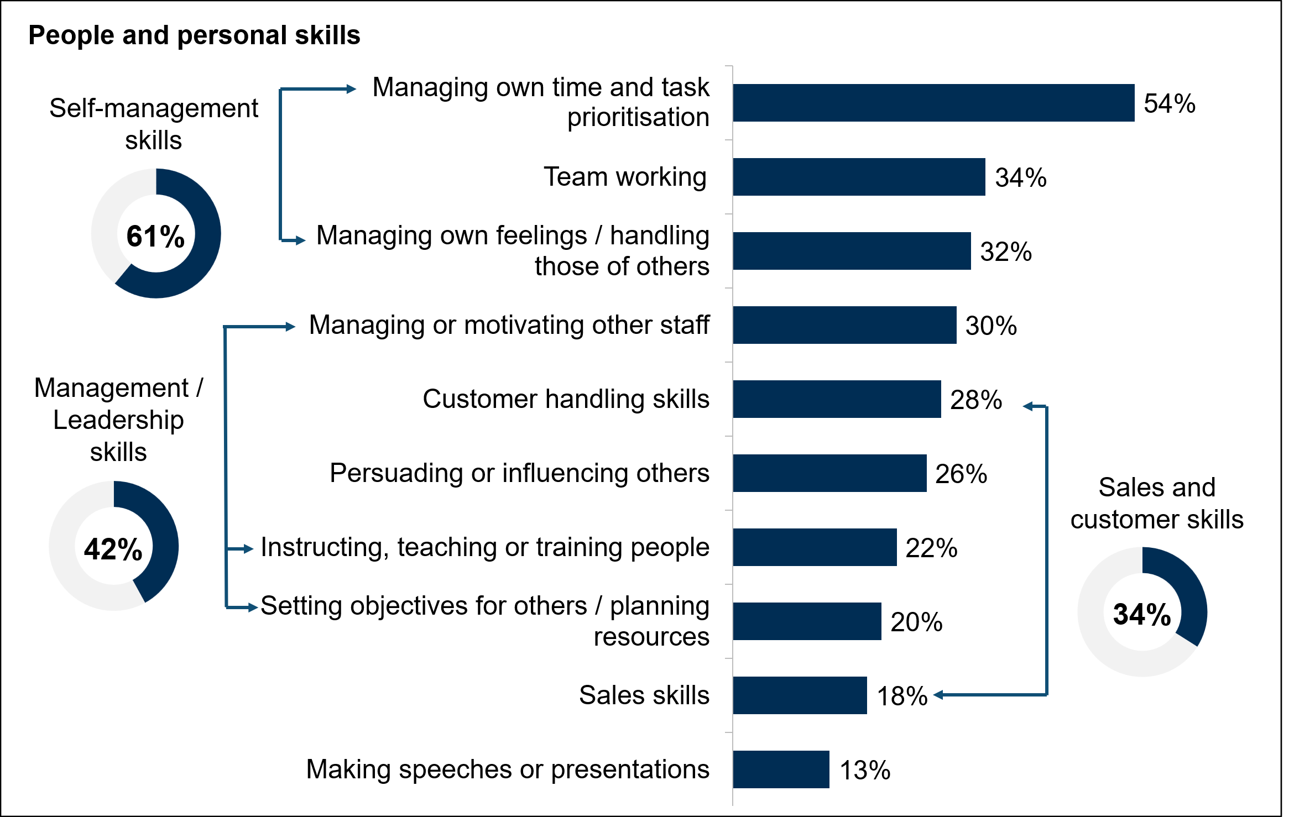
Base: All sites in Northern Ireland with skill-shortage vacancies - up to 2 occupations followed up (348).

Impact of skill-shortage vacancies on employers
Almost all employers (97%) among whom all hard-to-fill vacancies were a result of a skills shortages said SSVs had had some form of impact on their business. This is in line with results from 2022 (96%) but higher than results from 2019 (93%). As in previous waves, increased workloads for other staff were the most common impact of SSVs (89%). Around half reported that SSVs had created difficulties meeting customer service objectives (50%), delayed developing new products or services (48%) and increased operating costs (48%).
There was a decrease in the proportion of employers who reported difficulties meeting customer expectations (50% vs. 62% in 2022) and those who had experienced increased operating costs (48% vs. 59%).

Figure 3-6 Impact of skill-shortage vacancies, 2022 – 2024 (prompted)
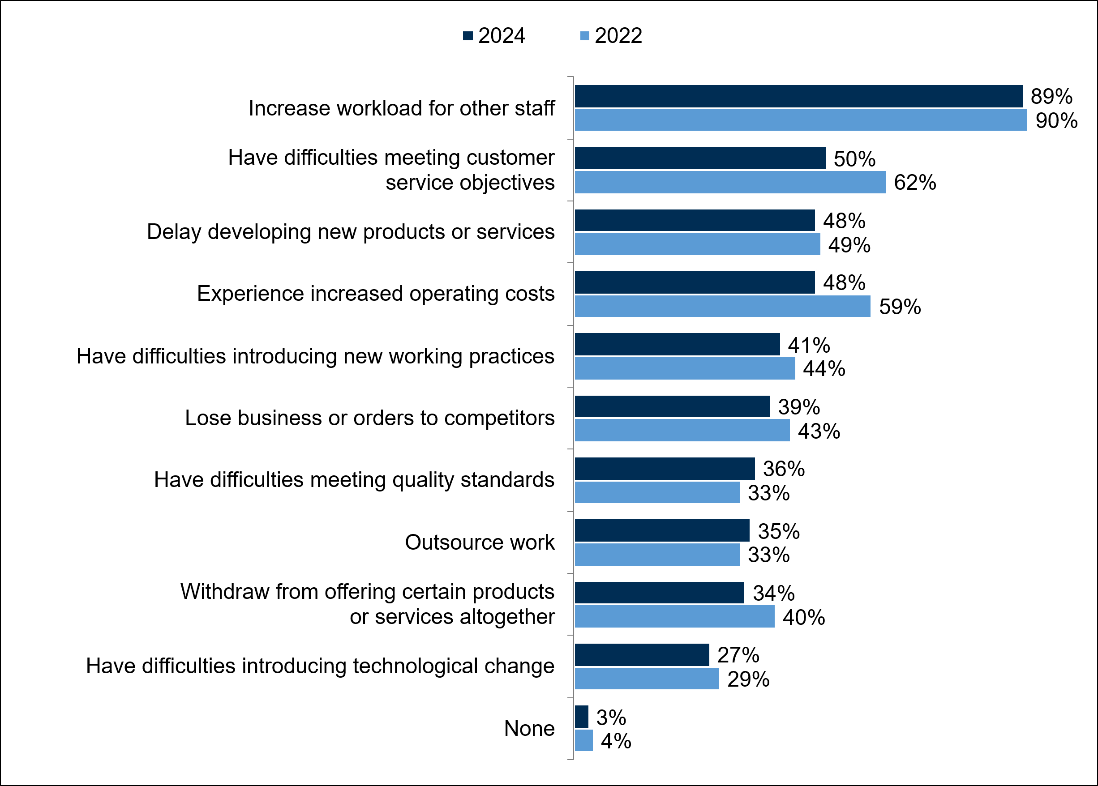
Base: All sites with hard-to-fill vacancies that are all as a result of skill shortages (2024: 308; 2022: 386).

Recruitment

Introduction
This chapter looks at the different recruitment practices used by employers in Northern Ireland, including their methods of recruitment, and the factors they consider when recruiting. It also covers the level of recruitment of new entrants into the labour market, including young people and those who have been recruited directly from education.

Proportion of employers that recruited over the last 12 months
Just over four-in-ten (41%) employers in Northern Ireland had recruited anyone in the past 12 months. This is consistent with 2022 (43%). The likelihood of having recruited increased with site size, from 18% among sites with 2 to 4 employees to 98% among sites with 100 or more employees. By sector, employers in Education (73%) and Health and Social Work (65%) were most likely to have recruited; these were also among the most likely sectors to recruit in 2022. By region, employers in Belfast were more likely than all other regions to have recruited in the past year and the only region where a majority had done so (55%); in other regions the proportion who had recruited ranged from 36% in the West to 41% in the East.

What employers look for when recruiting
Employers were asked to consider the level of importance that their site places on different factors when selecting candidates for recruitment.
Just under two-thirds (65%) of employers considered that a candidate having relevant work experience was of critical or significant importance. While this remained the most highly valued factor of those asked about (listed in Table 4-1 below), this represents a decrease compared to 2022 (71%), although a return to 2019 levels (66%).
Around six-in-ten (60%) employers also considered having Maths and English GCSE to at least level 2 or A*-C to be of critical or significant importance in a candidate, as shown in Table 4-1. Slightly under half valued having particular academic qualifications (e.g. GCSE, A Levels, a degree) (46%) or having a relevant vocational qualification (45%) as significantly or critically important, while just over a-third (36%) said this of completing a relevant apprenticeship. A further quarter (24%) considered having a degree or equivalent to be of significant or critical importance. Compared with 2022, employers were more likely to feel that having Maths and English GCSE was significantly or critically important (60% vs. 54%), while proportions citing other factors remained similar.

Table 4-1: Importance of factors looked for in recruitment, 2022 – 2024
 | Proportion who considered recruitment factor to be ‘Critical’ or ‘Significant’
Factor | 2022 | 2024
Having relevant work experience | 71% | 65%
Having Maths and English GCSE to at least level 2 or A*-C | 54% | 60%
Having a relevant vocational qualification | 49% | 45%
Having particular academic qualifications such as GCSEs, A levels or a degree | 46% | 46%
Having completed a relevant apprenticeship | n/a | 36%
Having a degree or degree-equivalent qualifications | 25% | 24%
Base: All sites in Northern Ireland (Module D 2022: 822; Module C 2024: 804).

Recruitment directly from education
Around a third (34%) of employers had recruited an employee directly upon them leaving education, whether school, college or university, in the last 2-3 years. This is higher than in 2022 and 2019 (both 29%).
As in previous years, larger employers were more likely to recruit directly from education, with 89% of sites with 100 or more staff having done so, compared with 18% of sites with between 2 and 4 staff. This trend broadly follows the general pattern of larger employers being more likely to recruit (see Skill-shortage vacancies).
Employers in the Education (49%), Wholesale and Retail (44%), and Business Services (43%) sectors were more likely than average to have recruited an education leaver, while those in the Primary Sector and Utilities were least likely to have done so (8%).
Overall, one-in-five (21%) had recruited someone directly from school, 14% from an FE college, and 16% had taken someone on their first job from a university or other Higher Education Institution. Compared with 2022, employers were more likely to have recruited a school leaver, or college leaver, when these figures were 16% and 11% respectively.
Education leavers were generally felt to be well prepared for work by the majority of employers. Over four-in-five (83%) employers considered the Higher Education leavers they had recruited to be well prepared, just under seven-in-ten (69%) considered FE college leavers well prepared, and six-in-ten (60%) felt the 17–18-year-old school leavers they had recruited were well prepared for work. The only group considered well prepared by a minority of employers were 16-year-old school leavers (43% of those who had recruited these new entrants). While this result was not significantly different from 2022 (48%), it continues the decrease in perceived preparedness for this group since its peak in 2019 (61%). Preparedness for work remained similar among other education leavers.
The most common reasons given for perceiving new entrants from education to be poorly prepared for work included them having a poor attitude or lacking motivation (cited by 24% of employers in relation to 16-year-old school leavers (where these recruited), 25% in relation to 17-18 year old school leavers, and 15% in relation to FE college leavers), or a lack of experience and maturity (26% for 16-year-olds, 23% for 17-18 year olds, 12% for FE college leavers).

The internal skills challenge

Introduction
This chapter explores the prevalence and impact of current skills gaps within the Northern Irish workforce, i.e., the extent to which employers have staff that are not fully proficient in their job role. Some skills gaps may be temporary by nature, for example where new staff are not yet fully trained or experienced. However, others can be more persistent, usually a result of underinvestment in training, staff turnover or reluctance among employers or staff to develop new skills. These persistent skills gaps can affect a site’s productivity and ability to innovate.
The Employer Skills Survey (ESS) measures the incidence, volume, density of skills gaps, overall and at a national, sectoral and occupational level. Also covered in this chapter are the specific skills that employers identified as lacking among their employees, the causes of these skills gaps, and the impacts of these on performance. This chapter also covers the incidence and density of skills being underutilised, as well as the expected need for upskilling in the next year.
- Skills gap incidence is the proportion of sites judging at least one employee not fully proficient in their role.
- Skills gap density is the number of employees that were judged not fully proficient as a proportion of all employees.
- Skills gap volume is the number of employees that were judged not fully proficient.

Incidence, volume and density of skills gaps
Just over one-in-ten employers (11%) reported having staff with skills gaps, consistent with 2022 levels (also 11%).
As in previous years, the proportion of employers with skills gaps increased with site size, from 4% of employers with 2 to 4 staff to 50% of those with 100 or more staff. By sector, Manufacturing remained the sector with the highest skills gap incidence (20%), alongside Wholesale and Retail (16%). In contrast, employers in the Primary Sector and Utilities were least likely to experience skills gaps (6%), as in 2022. By region, skills gap incidence ranged from 9% in the North to 15% in Belfast. Most regions remained in line with 2022, except for the West, where incidence rose from 9% to 13%.
Employers who had recruited new staff in the previous 12 months were much more likely to report at least one skills gap in their workforce compared to those who had not (22% vs. 4%). Similarly, those who had vacancies at the time of interview were more likely than average to experience skills gaps (23%), particularly those with skills shortage vacancies (27%).
Overall, there were approximately 33,400 skills gaps (i.e. workers not fully proficient at their job), equating to around 4.0% of the workforce (referred to as skills gap density). Skills gap density has remained relatively stable compared to 2022, when it was 4.6%.
Skills gap density was highest among medium-sized sites, with a higher-than-average proportion of staff recorded as not fully proficient among employers with 25 to 49 staff (5.3%) and 50 to 99 staff (4.5%). In comparison, just 2.0% of the workforce among employers with 2 to 4 employees had skills gaps.
The two sectors with the highest skills gap incidence also recorded the highest skills gap density, at 6.6% among Manufacturing employers, and 5.9% for Wholesale and Retail. Skills gap density was also high among the Hotels and Restaurants (5.5%) and Business Services (4.9%) sectors. Skills gaps density was lowest in the Information and Communications (1.2%) and Health and Social Work (1.5%) sectors.
Figure 5-1 Density of skills gaps by sector
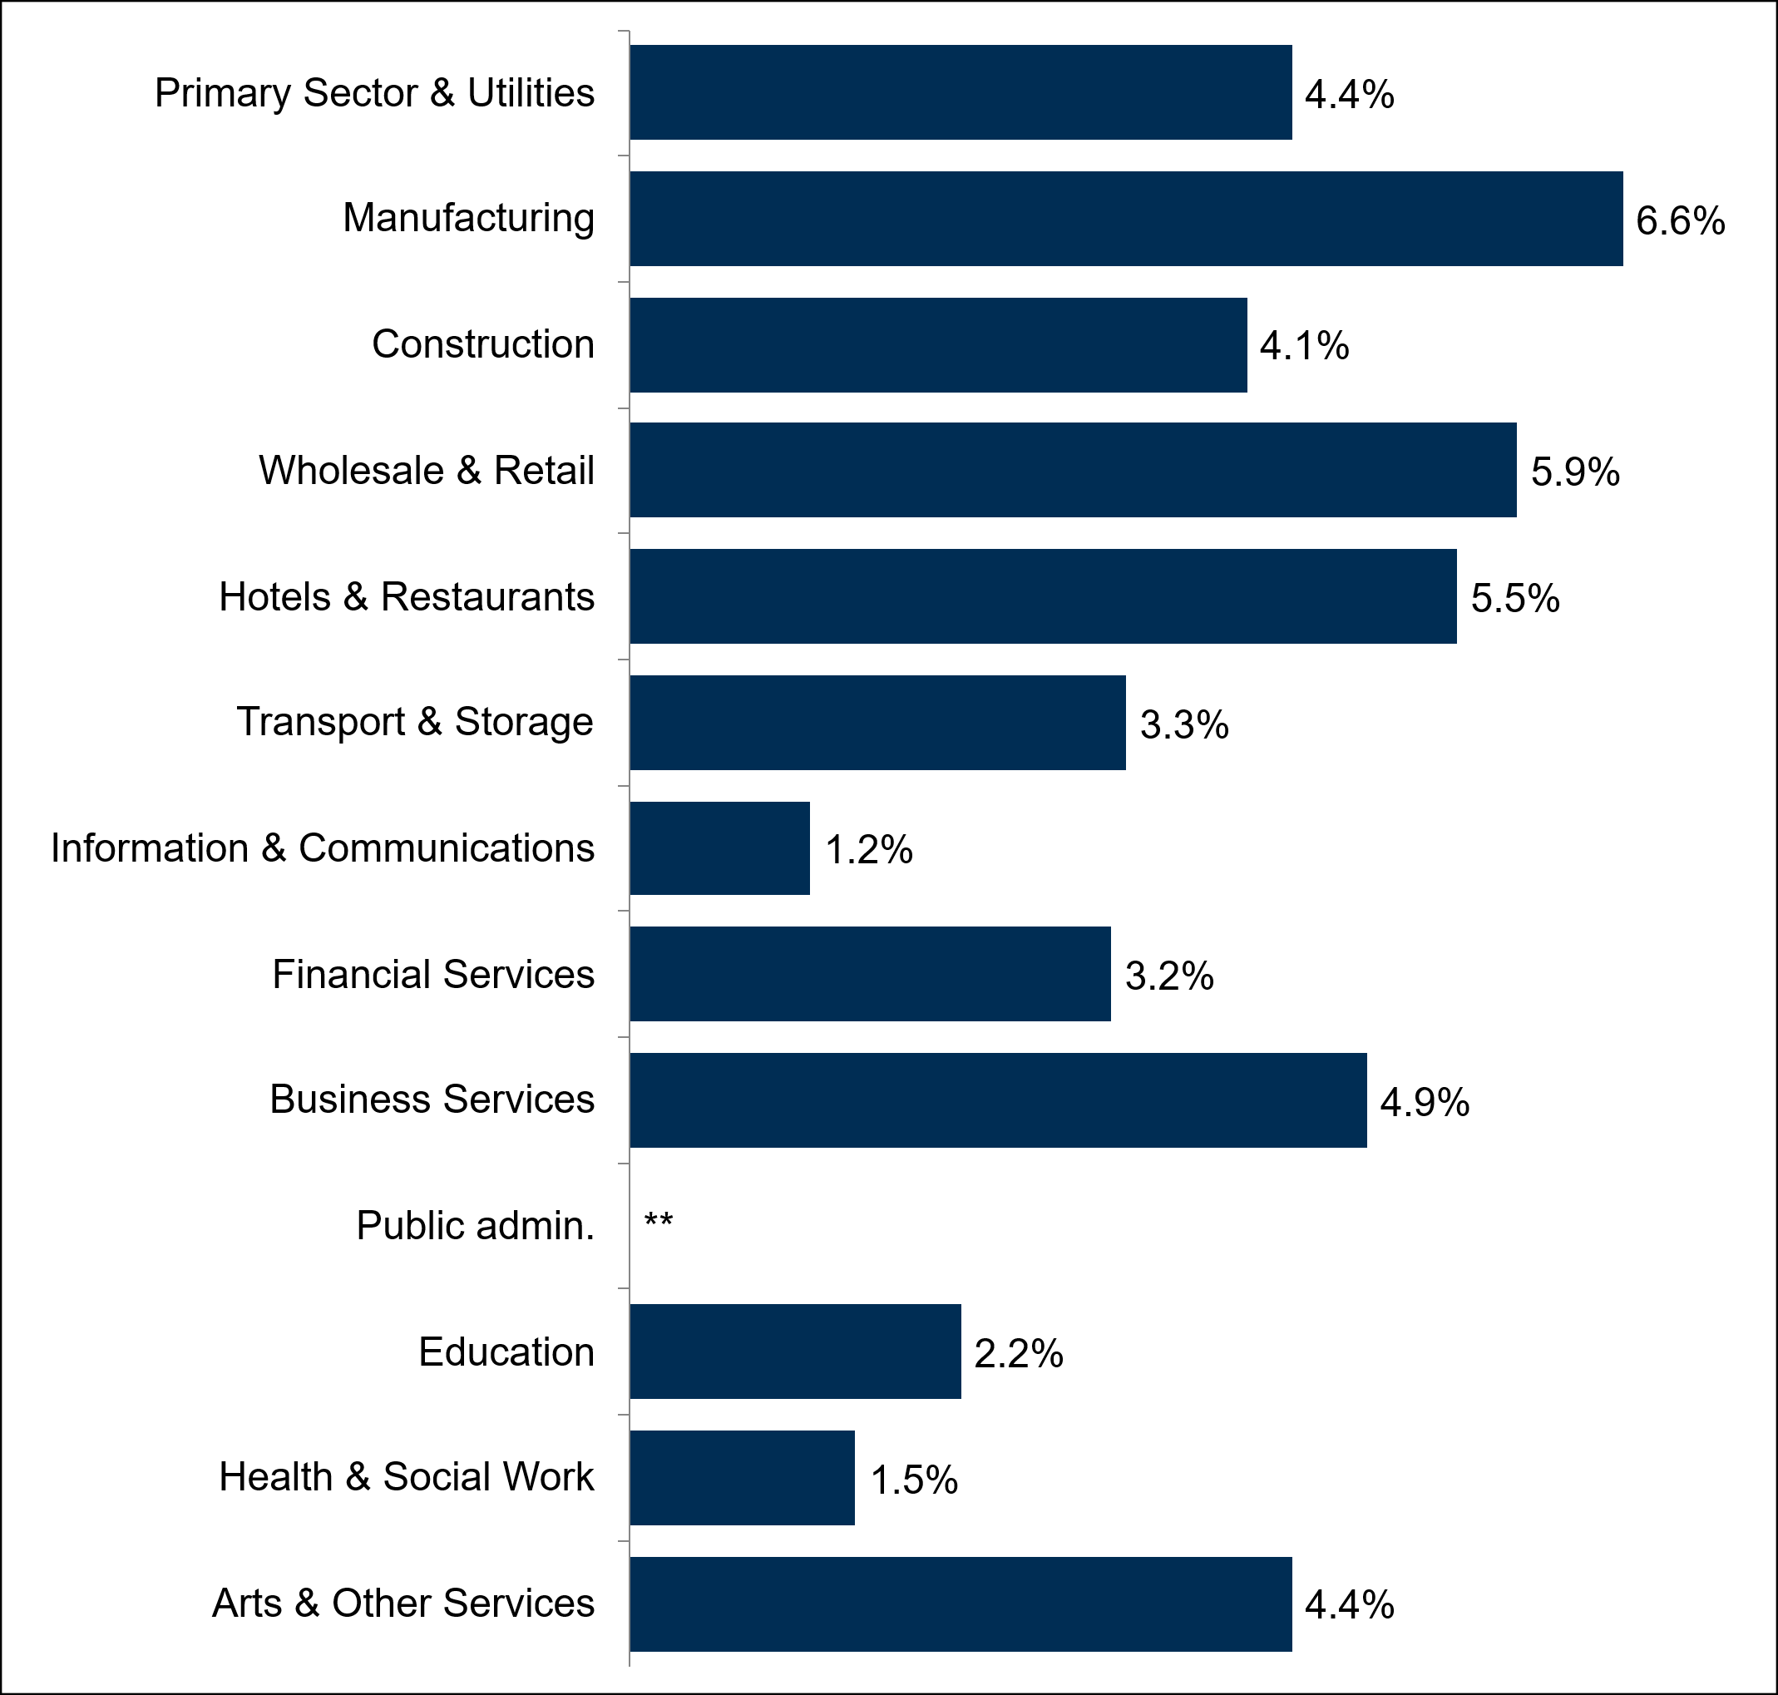
All sites in Northern Ireland (3,388; sector bases range from 61 for Financial Services, to 740 for Wholesale and Retail). Public administration not charted due to low base size.
Skills gap density remained relatively consistent across sectors compared to 2022. The only significant change was within Health and Social Work, where a lower proportion of employees had skills gaps (1.5% vs. 3.9% in 2022).
By region, employees in the West (5.1%) and the North (4.9%) were more likely to be lacking in skills than other regions. Skills gap density was lowest in the South (2.3%). Both the incidence and density of skills gaps by region are shown in Figure 5-2 below, alongside comparisons to 2022 levels.
Figure 5-2 Incidence and density of skills gaps by region, 2022 – 2024
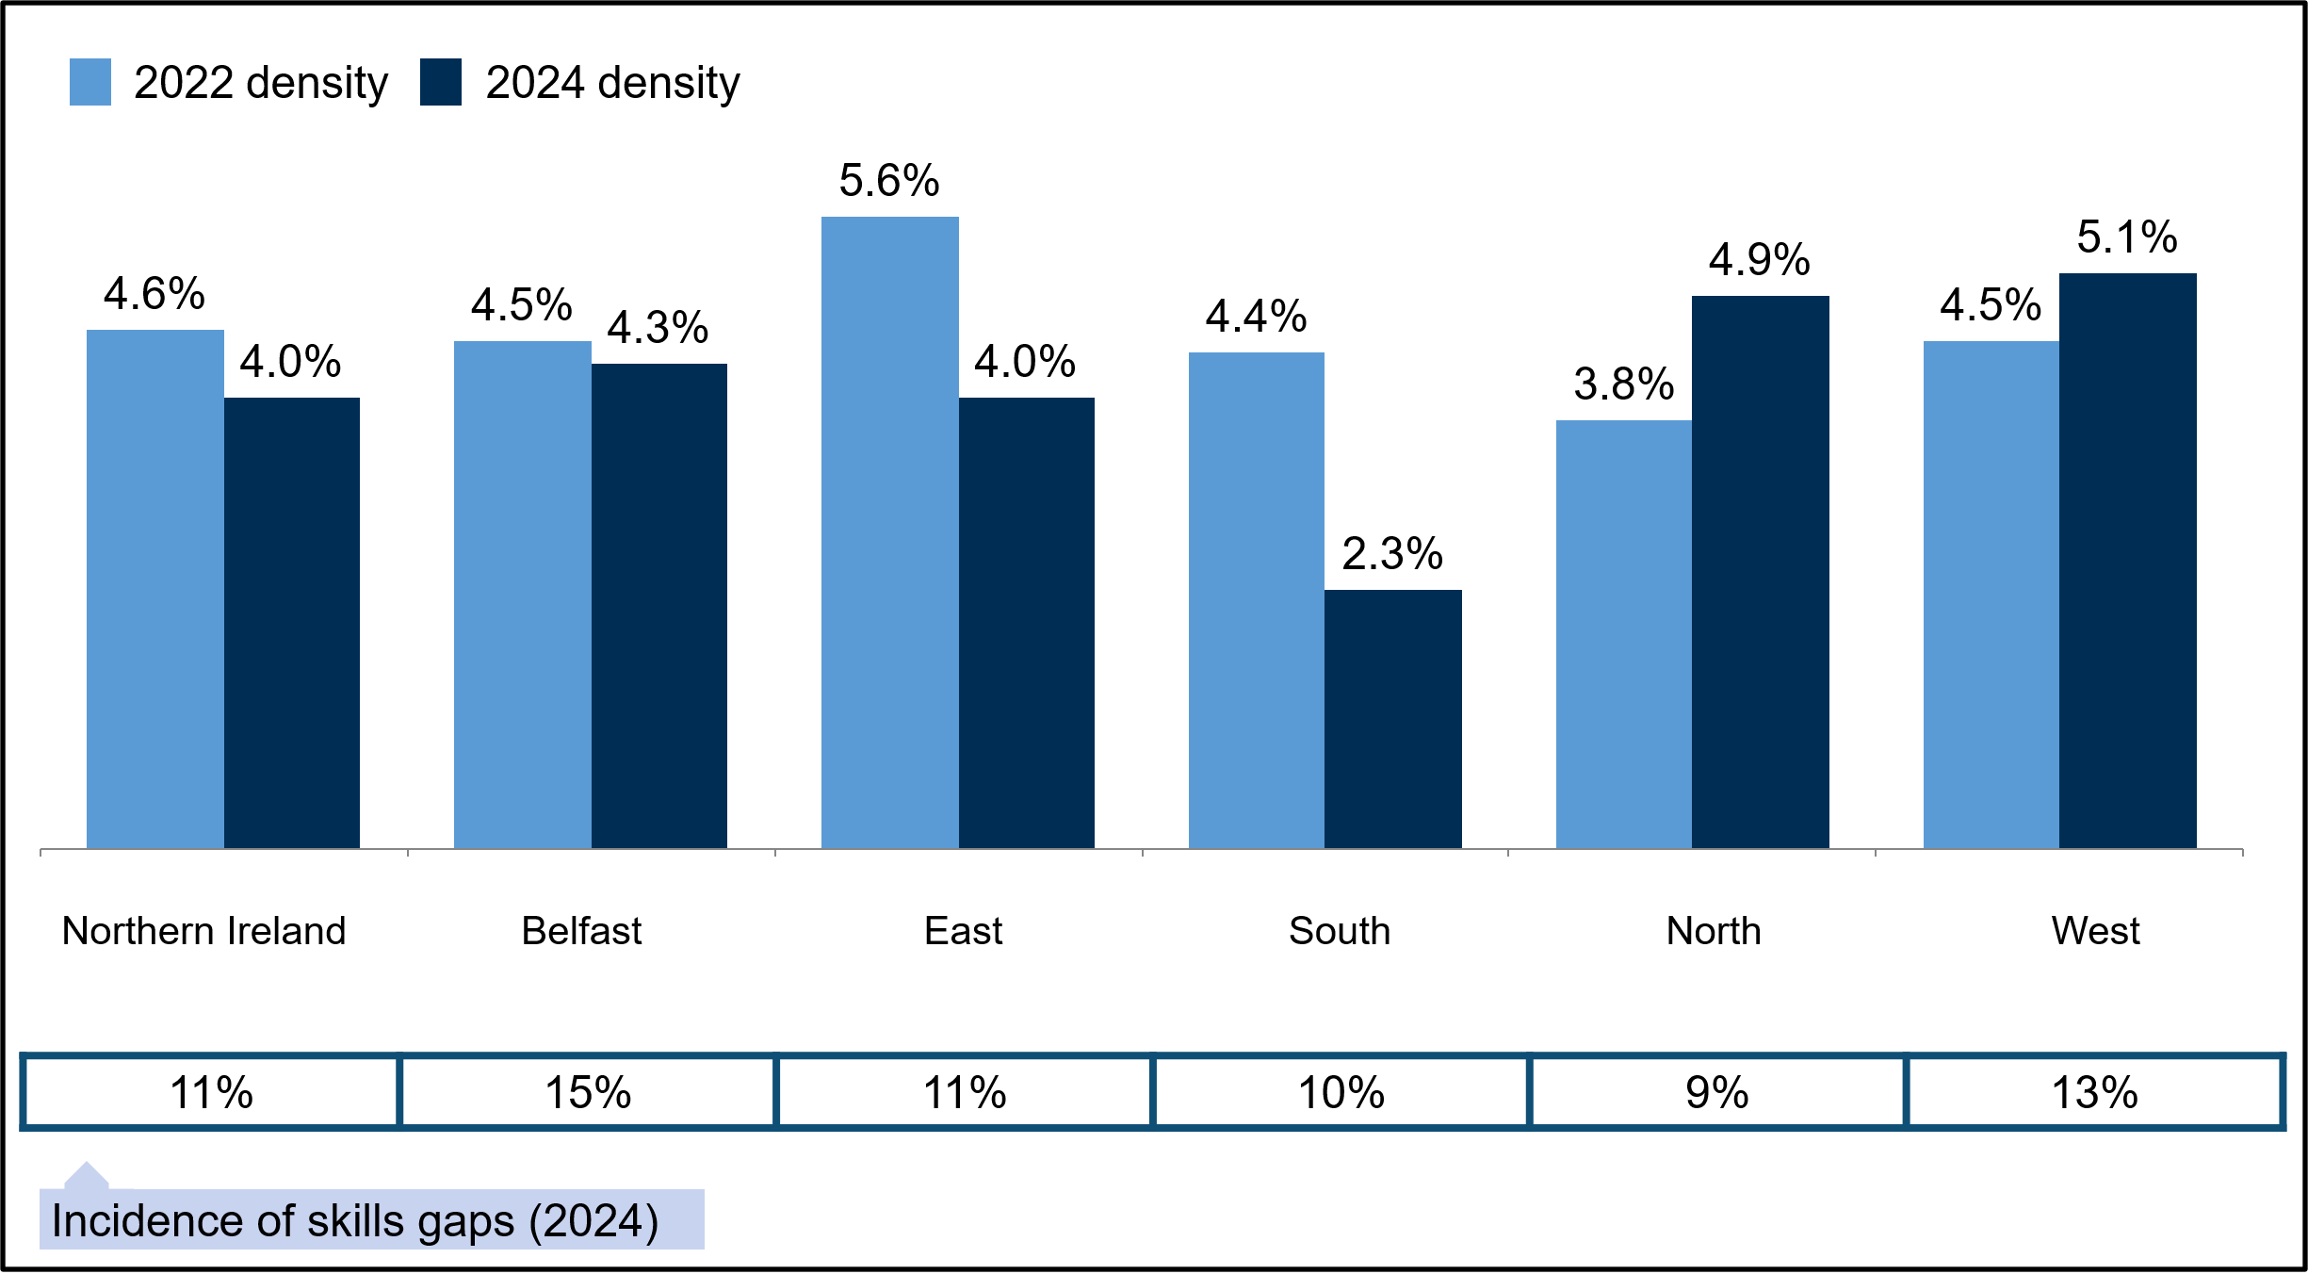
Base: All sites in Northern Ireland (2022: 3,400, Belfast 674, East 942, South 713, North 503, West 568; 2024: 3,388, Belfast 667, East 955, South 693, North 508, West 565).
In general, skills gaps density was highest among those in Skilled trades occupations (7.0%). More broadly, labour-intensive occupations (6.0%) had a higher density of skills gaps than other broad groups; this group includes Machine Operatives (6.1%) and Elementary occupations (5.9%). Sales and Customer Services occupations also had a high skills gap density (6.6%). Meanwhile, the lowest skills gap densities were found among higher skilled occupations (2.0%), in particular among Managers (1.2%). Compared with 2022, Administrative occupations recorded an increase in skills gap density, from 2.4% to 3.5%. In contrast, Caring, Leisure and Other Services occupations experienced a decrease in skills gap density (2.2% from 5.5%), reflecting the decrease observed in the Health and Social Work sector.
Figure 5-3 Density of skills gaps by occupation, 2022 - 2024
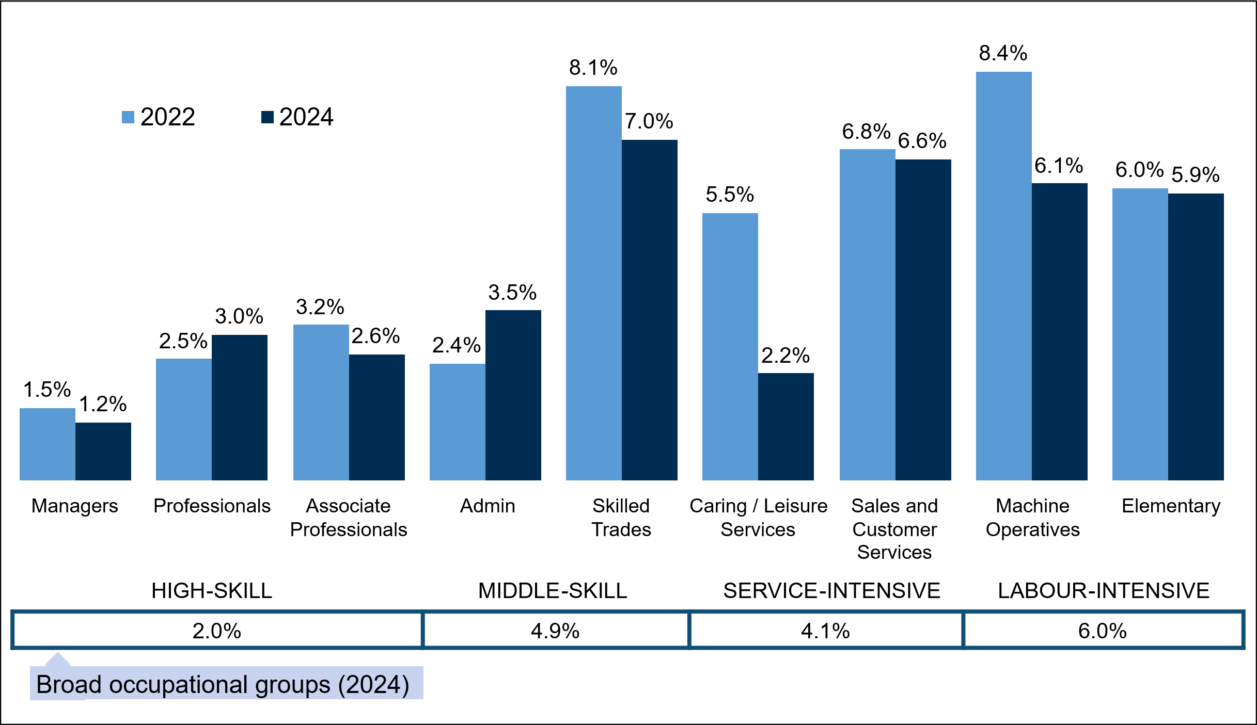
Base: All sites in Northern Ireland (2022: 3,400; occupational base sizes range from 543 for Associate Professionals to 3,264 for Managers, 2024: 3,388; occupational base sizes range from 551 for Associate Professionals to 3,254 for Managers).

Causes of skills gaps
Most skills gaps (78%) were caused at least in part by transient factors. These are the types of causes which would be expected to reduce over time without significant employer intervention, such as staff being new to the role (65%) or their training being incomplete (59%). Approximately one-in-six (17%) skills gaps were caused entirely by transient factors. A similar proportion of skills gaps were caused at least in part by transient factors in 2022 (79%).
Transient factors were more likely to have contributed to skills gaps among employers with 25 or more staff (81%) likely owing to their higher levels of recruitment (93% of these employers had recruited in the last 12 months). Transient factors also contributed to a higher proportion of skills gaps in certain sectors, in particular within, Construction (92%), and Hotels and Restaurants (89%).
Positive transformational causes, such as the introduction of new working practices (26%), the introduction of new technology (25%) and the development of new products and services (17%) contributed to around two-in-five skills gaps (40%). This is consistent with 2022 results (39%). These types of factors were more likely to have contributed to skills gaps among employers with between 25 and 49 employees (45%), and local or central government funded sites (50%).
As shown in Figure 5-4, other common causes of skills gaps included not being able to recruit staff with the required skills and staff lacking motivation, both contributing to just over two-in-five skills gaps (43% and 42% of skills gaps respectively). These were followed by staff having been on training but not improving their performance accordingly (37%), problems retaining staff (32%), and staff having not received the appropriate training (27%). Problems retaining staff contributed to a lower proportion of skills gaps in 2024 than in 2022 (32% vs. 47%), as did being unable to recruit staff with the required skills (43% vs. 51%), and staff not receiving the appropriate training (27% vs. 32%).
Figure 5-4 Causes of skills gaps in occupations followed up (prompted)
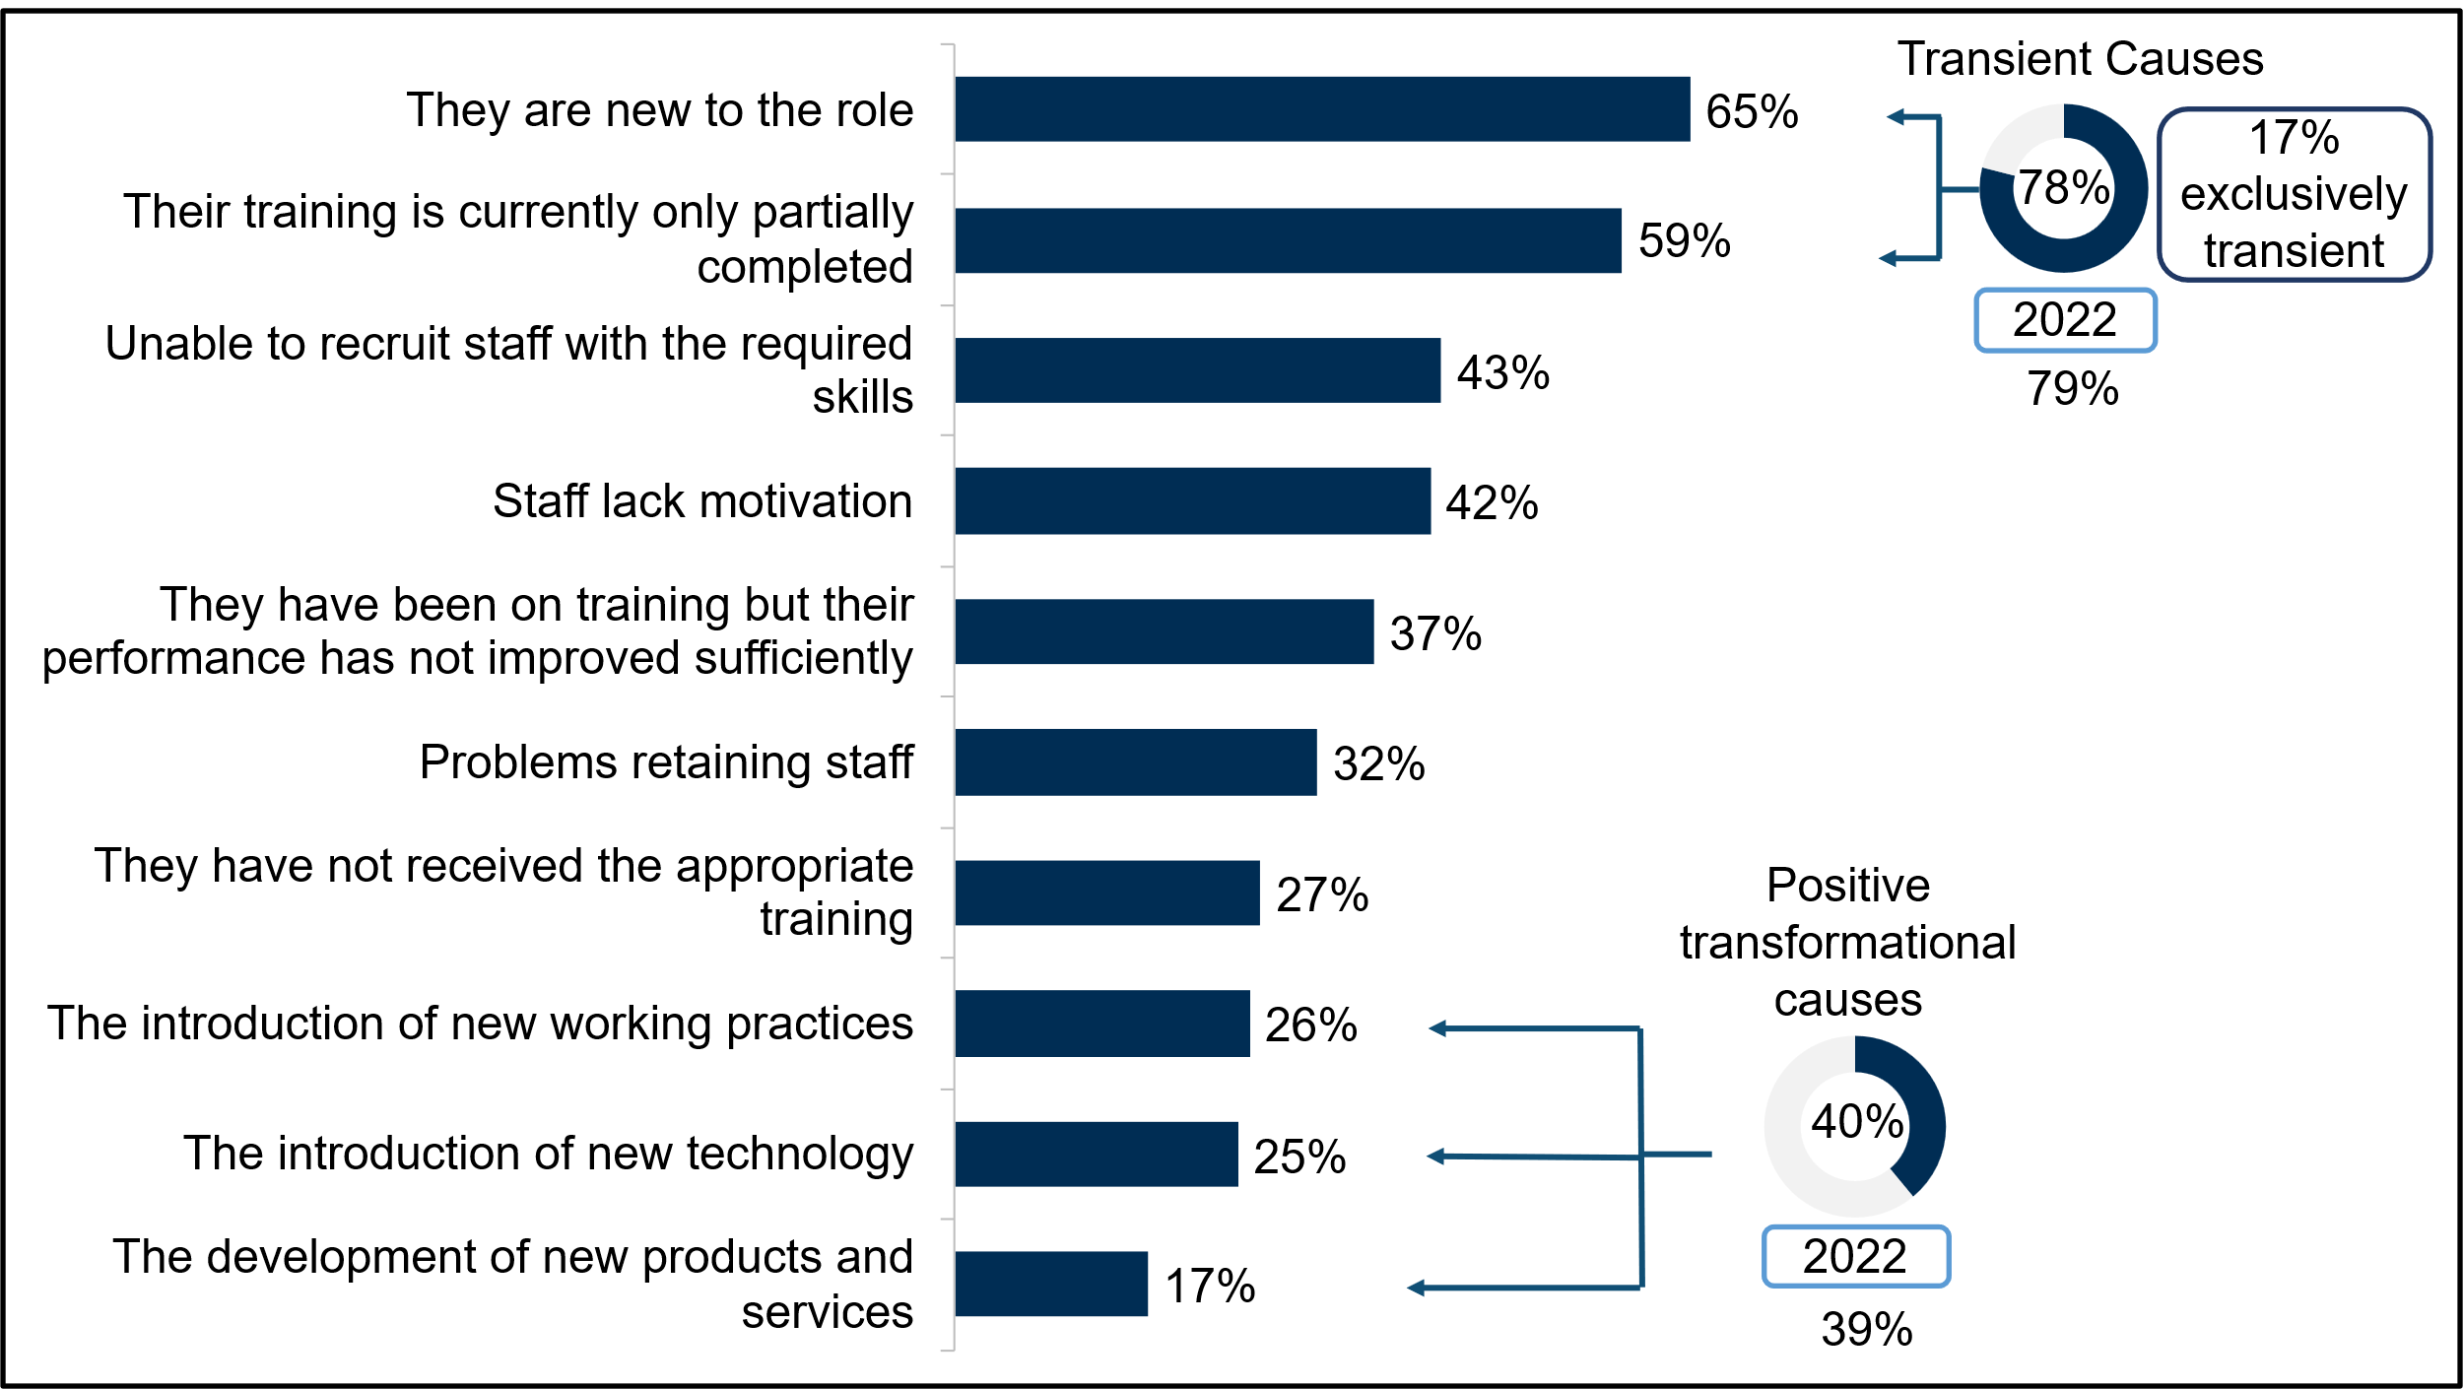
Base: All sites in Northern Ireland with skills gaps (2022: 625; 2024: 599). Figures shown are based on skills gaps for up to 2 occupations randomly selected for each site – so, for example, ‘they are new to the role’ was a cause of 65% of skills gaps followed up.

Skills lacking internally
When exploring the type of skills were lacking among the workforce, the survey split these into two categories: technical and practical skills, specific to the functions of the job role, and people and personal skills, which are “softer”, less tangible skills required to manage oneself and interact with others in the workplace.
The most common technical and practical skill deficiency was creative and innovative thinking, which was lacking among 42% of those with skills gaps. This replaced specialist skills or knowledge needed for the role, which has consistently been the most commonly lacking skill reported by employers within Northern Ireland in the ESS series (41% in 2024, down from 60% in 2022).
When grouping skills into broader categories (as defined in Annex B - Grouped codes), individuals lacking complex analytical skills were the most common type of skills gap, affecting 47% of employees with skills gaps (up from 40% in 2022). This includes a lack of complex problem-solving skills (39%) and more complex numerical or statistical skills (23%).
Operational skills, including knowledge of products and services offered by the organisation (38%) and knowledge of how the organisation works (32%), were lacking in 44% of skills gaps. This was in line with 2022 results.
Approaching two-in-five employees with skills gaps were lacking basic skills (37%), such as basic IT skills (28%), or basic numerical skills (24%). This was also consistent with 2022.
Other specific skills commonly lacking included reading and understanding instructions, manuals and reports (35%), and adapting to new equipment or materials (32%). Writing instructions, manuals and reports was also lacking for roughly one-in-five of those with skills gaps (22%), as was manual dexterity (20%). The full list of skills lacking in the workforce is presented in Figure 5-5.
Figure 5-5 Technical and practical skills lacking among staff with skills gaps followed up (prompted)
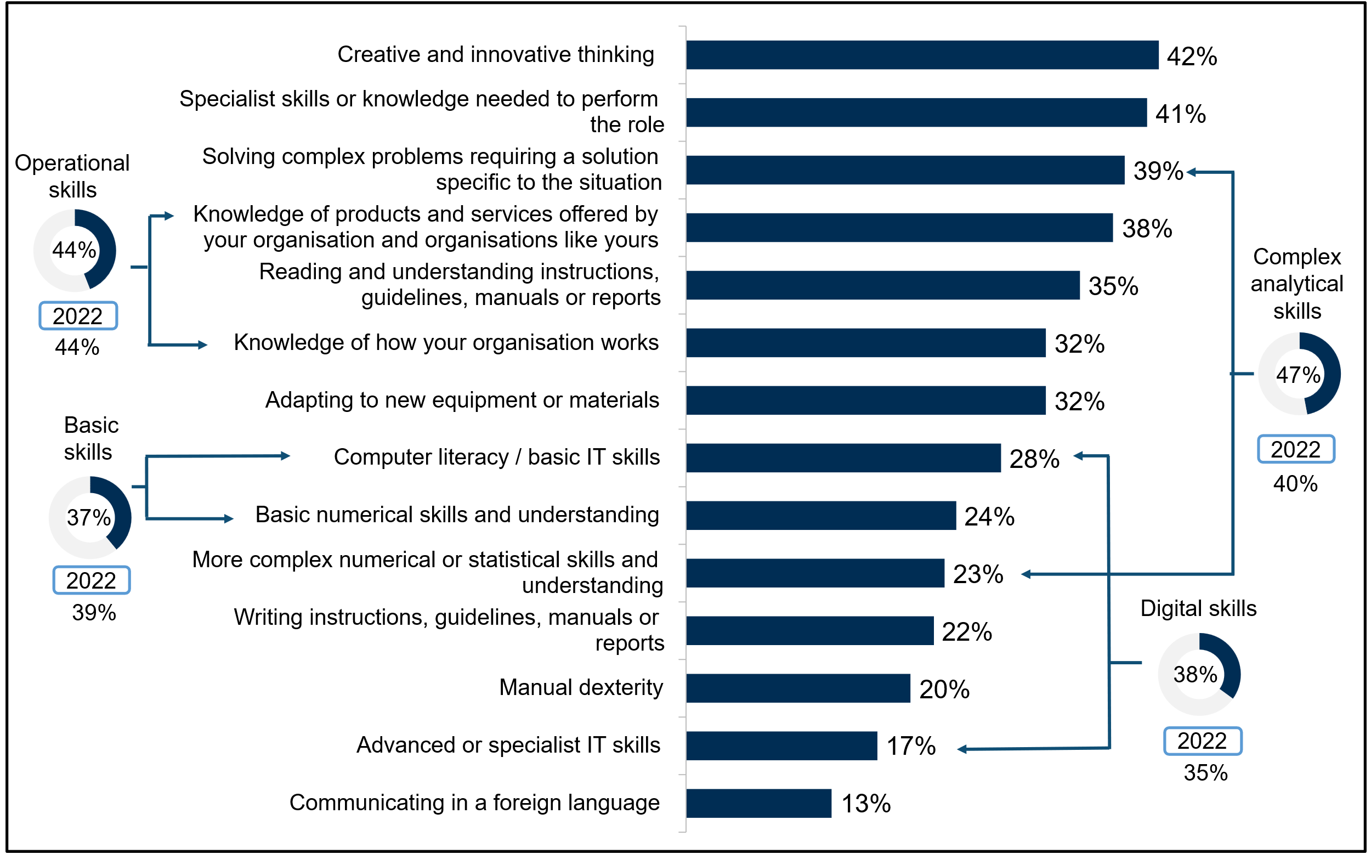
Base: All sites with skills gaps in Northern Ireland (2022: 625; 2024: 599). Figures shown are based on skills gaps for up to 2 occupations randomly selected for each site – so, for example, “specialist skills or knowledge” was lacking in 41% of these skills gaps.
Digital skills were lacking for 38% of employees with skills gaps, similar to the 35% seen in 2022. The most common specific digital skills lacking were basic Microsoft Office skills (42% of digital skills gaps), and foundation digital skills such as turning on devices, typing, changing passwords and connecting to the internet (18%). Around a quarter (26%) of digital skills gaps were in part due to employees lacking the ability to use specialist software or hardware or internal systems, while around one-in-ten were lacking basic internet skills (10%) or the ability to communicate via email (9%).
Turning to people and personal skills, the most common skills lacking were staff being able to manage their own time and prioritise tasks (61%) and team working (52%). These were also the most common people and personal skills lacking in 2022, although there was a decrease in the proportion of employees lacking team working skills (52% compared with 58% in 2022).
When grouping people and personal skills together, the most common type of skills lacking were self-management skills (69%); this includes, as previously discussed, the ability to manage one’s own time, but also managing one’s own feelings or handling the feelings of others (45%). This group of skills was also the most common type lacking in 2022, though a larger proportion of employees with skills gaps were found to lack these skills in 2024 (69% vs. 62% in 2022).
Just over half (51%) of employees with skills gaps were not fully proficient in management and leadership skills. This was a similar proportion to 2022 (55%). This broader category included a lack of skills in managing or motivating other staff (37%), persuading or influencing others (32%) and setting objectives and planning resources (19%).
Sales and customer handling skills were also lacking among nearly half of employees with skills gaps (47%), up from 40% in 2022. Customer handling skills by itself was lacking for 42% of those with skills gaps, while sales skills were lacking for around a quarter (25%).
Figure 5-6 People and personal skills lacking among staff with skills gaps followed up (prompted)
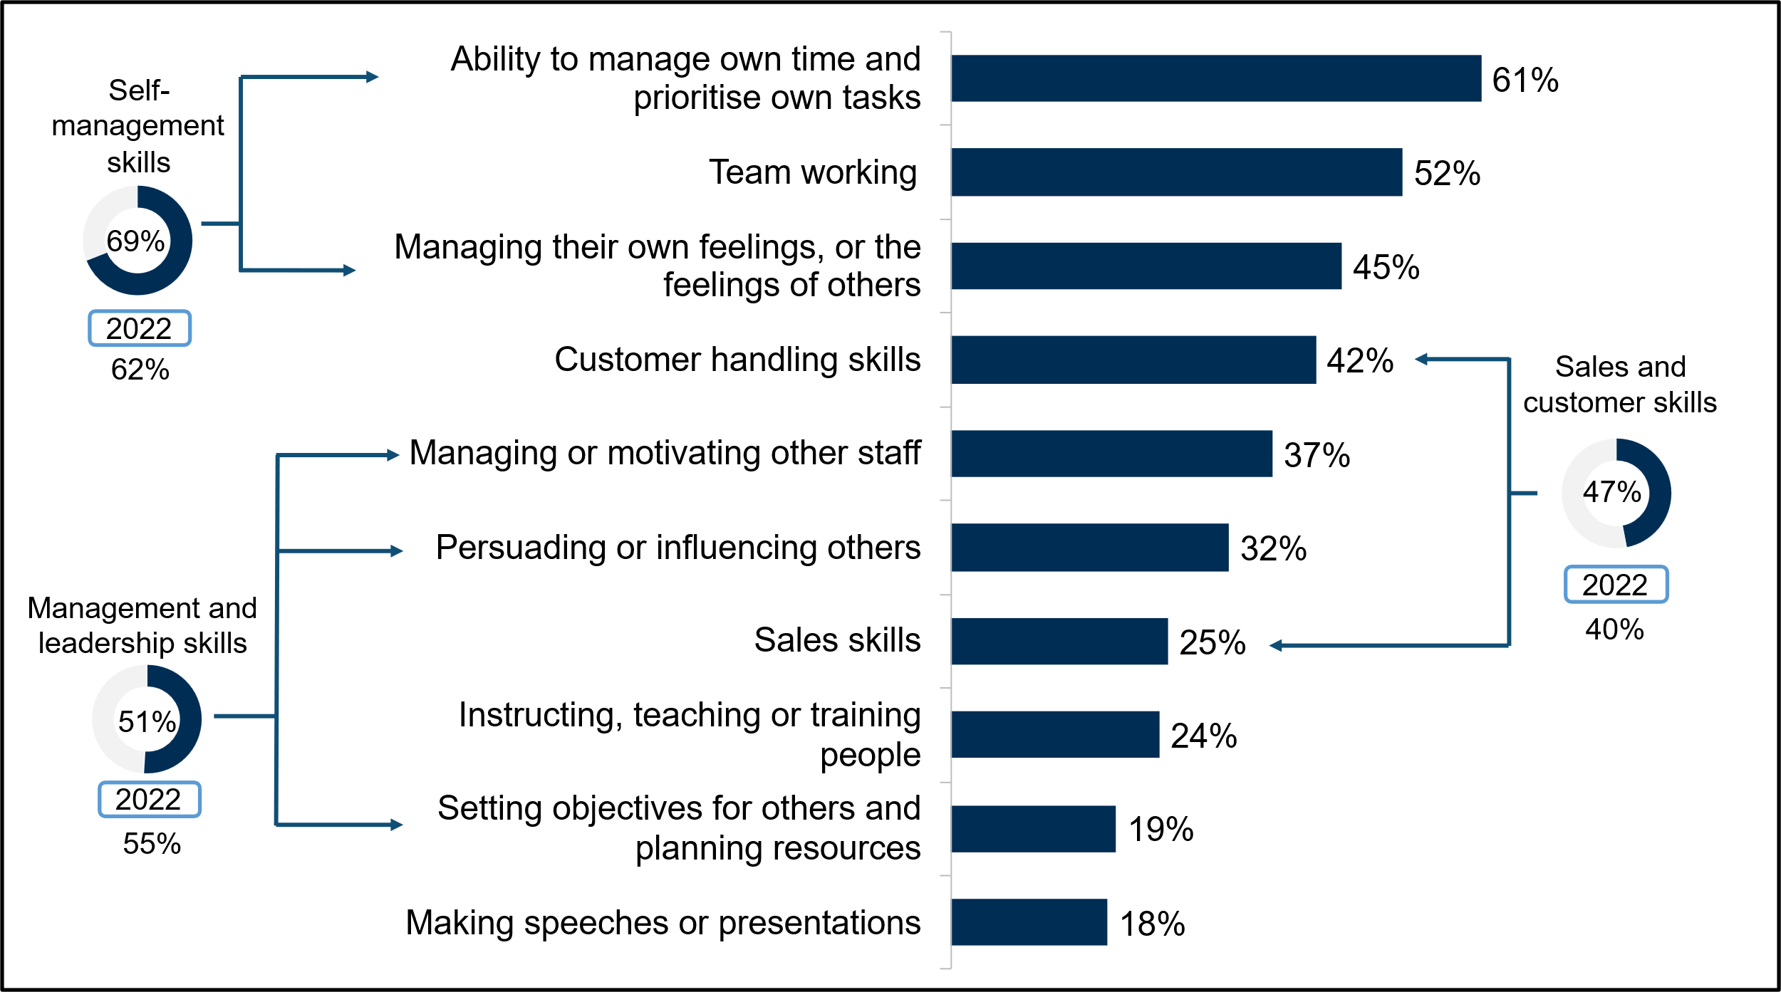
Base: All sites with skills gaps in Northern Ireland (2022: 625; 2024: 599). Figures shown are based on skills gaps for up to 2 occupations randomly selected for each site – so, for example, “team working” was lacking in 52% of these skills gaps.
Other individual people and personal skills lacking included instructing, teaching or training others (24%) and making speeches or presentations (18%). Both of these were broadly consistent with 2022, when they each were lacking for 29% and 15% of employees respectively.
Employers who had staff with skills gaps were asked whether these skills gaps could be at least in part attributed to their efforts towards being more sustainable or reaching carbon neutrality. Under one-in-ten (9%) reported this to be the case, meaning the vast majority (87%) did not attribute skills gaps to a drive towards this objective. The proportion who attributed skills gaps (at least in part) to such efforts was lower than in 2022 (16%).

Impact of skills gaps on employers
Two-thirds (67%) of employers with skills gaps reported that these had an impact on their site’s performance. For just over half (56%), this was a minor impact, however, one-in-ten (10%) experienced a major impact. Although the proportion of employers reporting any impact remained similar to 2022 (67% vs. 68%), there was a decrease in the proportion who felt this impact was major (10% vs. 16%).
Employers with non-transient skills gaps were more likely to report any impact of their skills gaps (73%, vs. 36% among those with transient skills gaps only), and more likely to say this impact was major (12% vs. 1%). By size, sites with 2 to 4 staff were most likely to report a major impact of skills gaps (18%).
Figure 5-7 presents the types of impact that employers experienced due to their skills gaps. The most common impact, as in previous years, was an increase in workload for other staff (53%), followed by higher operating costs (32%). Approximately a quarter of employers reported having difficulties introducing new working practices (27%), or difficulties meeting quality standards (23%). Most impacts were reported at similar levels to 2022, although a lower proportion reported that their skills gaps had delayed them developing new products (14% vs. 19%), bringing this back in line with 2019 (14%). Employers in Belfast were much more likely to feel their skills gaps had delayed them developing new products than in other areas (24%), particularly compared with the East (7%).
Figure 5-7 Overall impact of skills gaps and specific implications of skills gaps (prompted), 2022 – 2024
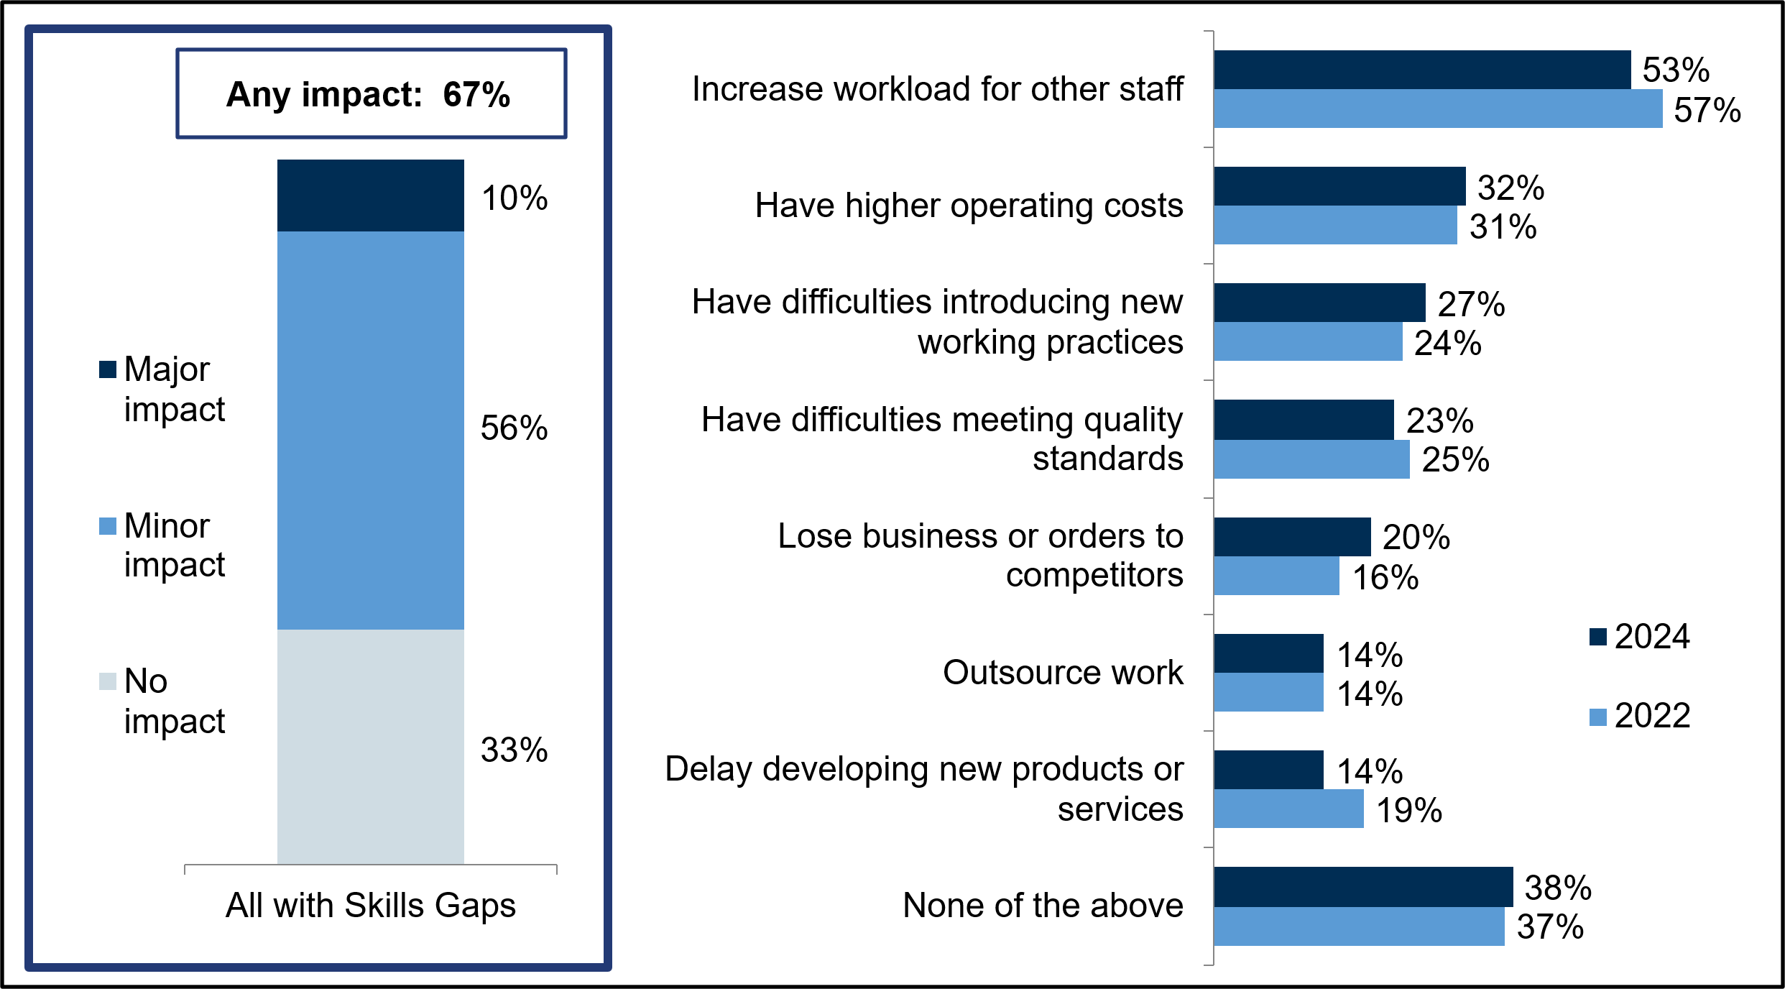
Base: All sites with skills gaps in Northern Ireland (2022: 625; 2024: 599).

Under-use of skills and qualifications
Around one-third (33%) of employers in Northern Ireland had underutilised staff. These are staff with qualifications and skills higher than the level required by their role. This is a lower proportion than in 2022, when 37% of employers reported having at least one underutilised employee, but similar to 2019 (35%).
Employers with between 5 and 24 staff were most likely to have underutilised staff (37%). By comparison, underutilisation was less prevalent among employers with 25 or more employees (29%). By sector, employers in Education (44%), Hotels and Restaurants (41%), and Wholesale and Retail (40%) were most likely to have underutilised staff. More broadly, as in 2022, underutilisation was more common in the charity and voluntary sector (43%).
In employment terms, 7% of the Northern Irish workforce were considered underutilised, consistent with the 8% reported in 2022. By size, employees were more likely to be underutilised in smaller sites, with 19% of the workforce underutilised at sites with 2 to 4 staff, compared with 2% at sites employing 100 or more staff. Figures were broadly consistent with 2022, except for among those employing 25 to 49 staff where underutilisation decreased (10% in 2022 vs. 5% in 2024). By sector, employers in the Hotels and Restaurants sector were the most likely to report underutilisation, with 12% of the workforce reported as underutilised.

Upskilling
Upskilling refers to the employer anticipation of the need for their staff to acquire new skills in the next 12 months. Overall, 55% of employers in Northern Ireland expected to need to upskill staff in the next 12 months. This is lower than in 2022 (64%) and 2019 (63%). This decline in upskilling needs was driven by employers with between 5 and 24 staff in particular, among whom 57% expected to need to upskill compared with 70% who reported this in 2022. There were also large decreases among Primary Sector and Utilities (39% vs. 62%), Wholesale and Retail (60% vs. 71%), and Education employers (64% vs. 76%).
As in previous years, smaller employers were least likely to anticipate a need for upskilling in 2024, with just over half reporting this among those with 2 to 4 staff (51%) and those with 5 to 24 staff (57%). However, while those with more than 25 employees were more likely to expect to upskill compared to smaller employers, all larger size bands were similarly likely to each other to report upskilling needs, with the proportion remaining relatively consistent from 72% among those with 25 to 49 staff, to 79% for those with over 100 staff.
By sector, employers in Education were more likely to report a need for upskilling (64%), as were those in Business Services (63%), Health and Social Work (63%), and Wholesale and Retail (60%). In contrast, those in the Primary Sector and Utilities were least likely to have upskilling needs (39%). More broadly, those employers in local or central government were more likely to report a need for upskilling than those in the private sector (66% vs. 54%).
The proportion of employers reporting an upskilling need ranged from 52% in the South to 60% in Belfast, although no region differed significantly from the overall figure.
As shown in Figure 5-8, the most common reasons for needing to upskill included the introduction of new technologies or equipment (35%), new legislative or regulatory requirements (32%) and the introduction of new working practices (30%). These reasons were broadly similar to 2022, although a lower proportion cited all reasons except the introduction of new technology, with a particularly marked decrease in the proportion needing to upskill due to the development of new products and services (28% vs. 37%) or increased competitive pressure (19% vs. 27%).
Employers with 25 or more staff were more likely than average to cite all reasons for upskilling, in particular the introduction of new technology (53% vs. 35% overall), and the introduction of new working practices (47% vs. 30% overall). The largest employers were particularly likely to attribute their need for upskilling to the introduction of new technology (67% of those with 100 or more staff vs. 35% overall), or the development of new products and services (55% vs. 28% overall). In contrast, employers with 2 to 4 staff were less likely than average to cite any of the reasons for upskilling, particularly the introduction of new working practices (24% vs. 30% overall).
By sector, Information and Communications employers were much more likely to attribute their need for upskilling to the introduction of new technology (61% vs. 35% overall), while those in Wholesale and Retail were more likely to cite the development of new products (37%) and increased competitive pressure (27%). New legislative or regulatory requirements were more likely to be anticipated as a reason or upskilling in the Transport and Storage (47% vs. 32% overall), Business Services (45%), and Education (45%) sectors.
Figure 5-8 Overall proportion of employers with a need for upskilling and the reasons for needing to upskill, 2022 – 2024
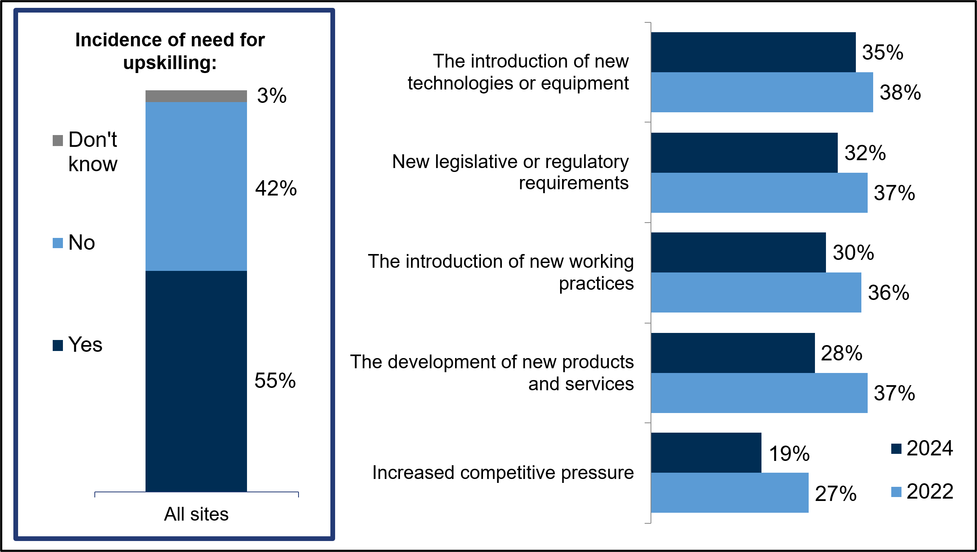
Base: All sites in Northern Ireland (2022 (Modules B and D): 809; 2024 (Modules A and B): 1,702).
Professional occupations were the most likely occupation to have a need for upskilling in the next 12 months (46%), followed closely by Skilled Trades (43%) and Managers (41%). Employers were least likely to expect to need to upskill staff in Elementary occupations (12%). The full list of occupations and how they were affected by a need for upskilling is shown in Figure 5-9.
Figure 5-9 Occupations most affected by the need for upskilling
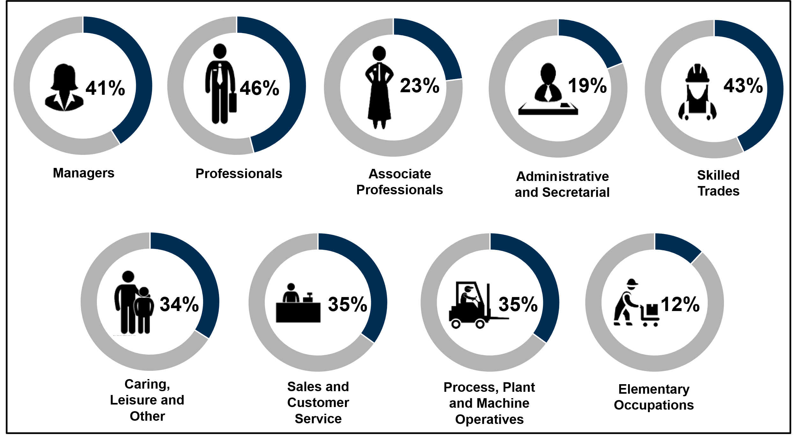
Base: All sites in Northern Ireland that identified an occupation in need of upskilling and employ that particular occupation: Managers (1,002); Professionals (295); Associate Professionals (190); Admin and Secretarial (694); Skilled Trades (276); Caring, Leisure and Other Services (208); Sales and Customer Service (324); Process Plant and Machine Operatives (182); Elementary Occupations (368).
Employers were prompted with the same skills groupings used to establish skills gaps in their current workforce (discussed earlier) and asked which of these they expect would need upskilling in the next 12 months.
In terms of technical and practical skills, the most common specific upskilling needs in the next 12 months were adapting to new equipment or materials (51% with upskilling needs). When considering the broader skills groupings, over half of employers (53%) mentioned upskilling needs in operational skills, including knowledge of the organisation’s products and services (48%) and of how the organisation works (30%). Just under half of employers felt their staff needed upskilling in digital skills (47%) or in complex analytical skills (45%), which included the ability to solve complex problems (39%) and complex numerical or statistical skills (18%). Other individual technical skills commonly in need of upskilling were specialist skills or knowledge needed to perform the role (46%), creative and innovative thinking (45%), reading and understanding (35%), and less commonly, writing instructions, manuals and reports (21%).
Among those with digital upskilling needs, the most common example was upskilling in new or updated company software or systems (44% of those with digital upskilling needs), followed by basic Microsoft Office skills (15%) specialist software or hardware (11%), foundation digital skills (6%) and AI skills (6%).
Looking at people and personal skills, the most common group of skills employers felt were in need of upskilling in the next 12 months were management and leadership skills (50% with upskilling needs), specifically managing and motivating other staff (39%), persuading or influencing others (27%) and setting objectives for others (26%). Self-management skills were expected to need upskilling by 49% of employers, particularly the ability to manage time and prioritise tasks (42%, the most common specific people and personal upskilling need). The need to upskill sales and customer service skills was mentioned by 39% of employers with upskilling needs.

Training and workforce development

Introduction
This chapter explores the training landscape in Northern Ireland in 2024. It looks at the incidence of training and workforce development and the proportion of the workforce that had received training over the last 12 months. It also examines the types of training employers had provided, the barriers and limits to training and employer expenditure on training.

Incidence of training and workforce development
Overall, 56% of Northern Irish employers had arranged or funded training for their staff in the previous 12 months. This is in line with findings from 2022 (58%), when the incidence of training was the lowest recorded since the ESS series began in 2011. As shown in Figure 6-1, 37% had provided off-the-job training to their staff, while 46% had provided on-the-job training. The proportion providing off-the-job training remained stable compared with 2022, continuing the reduction seen since 2019 (42%), while on-the-job training saw a decrease (46% vs. 49% in 2022) but was aligned with 2017 and 2019 levels (48% and 46% respectively).
Figure 6-1: Incidence of any training, off-the-job training and on-the-job training, 2011 – 2024
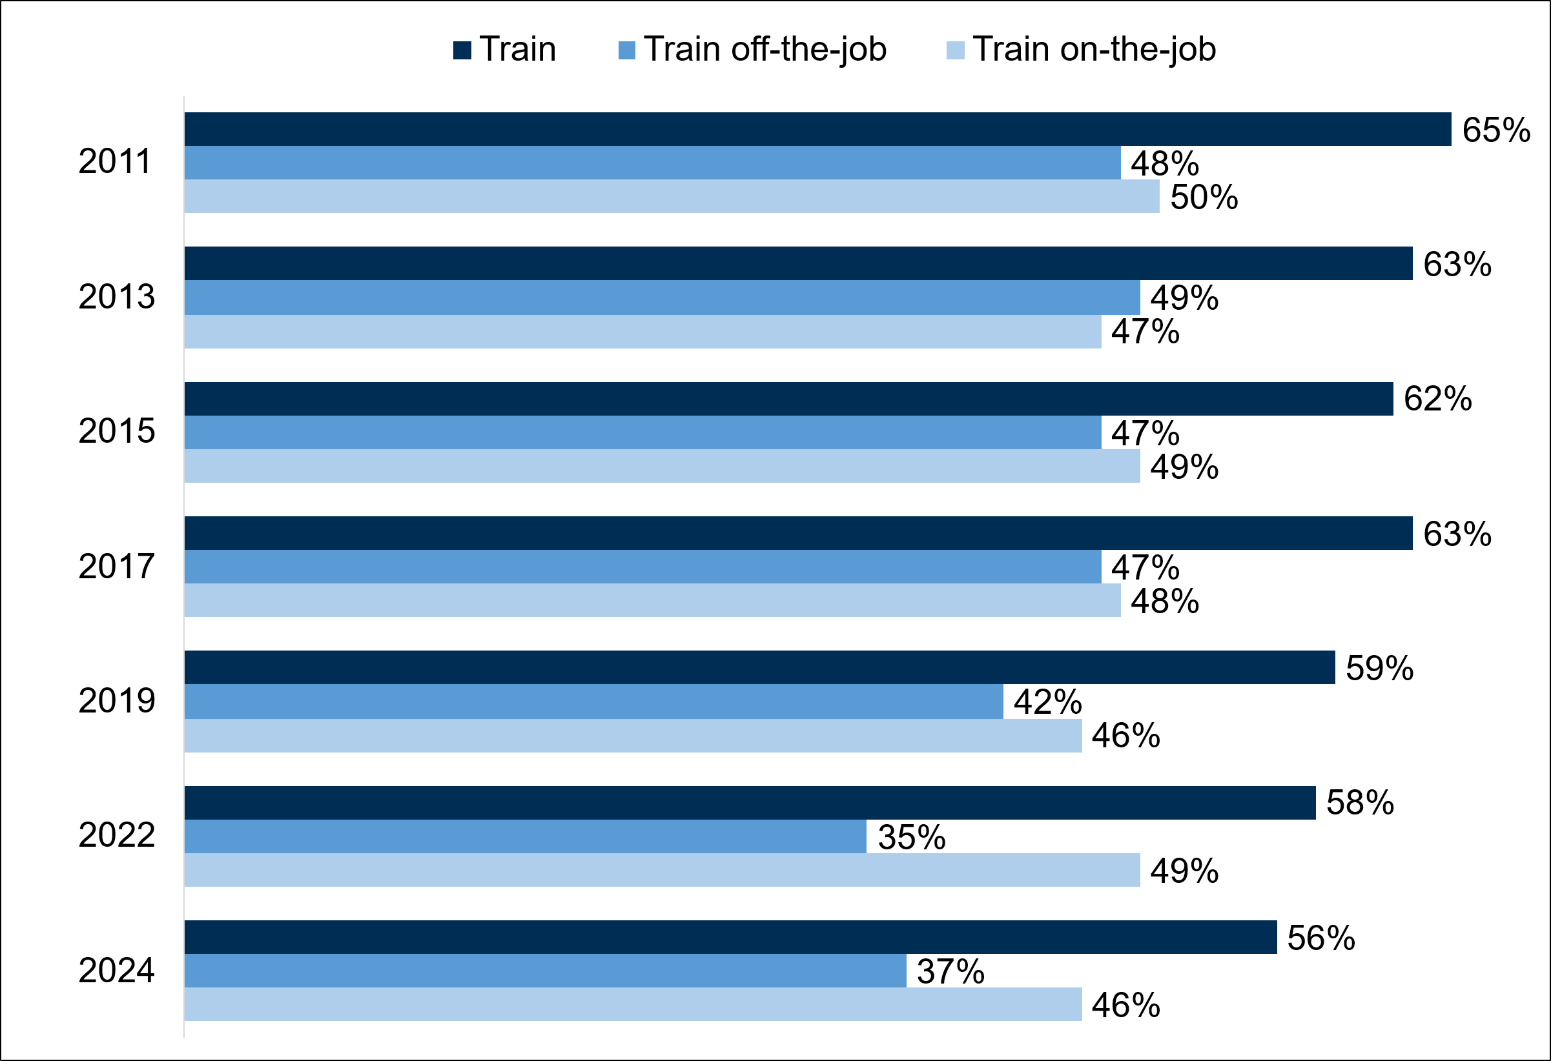
Base: All sites in Northern Ireland (2011: 3,921; 2013: 4,014; 2015: 4,019; 2017: 3,973; 2019: 4,023; 2022: 3,400; 2024: 3,388)
When comparing against the UK as a whole, employers in Northern Ireland were the least likely to provide any form of training (56% vs. 59% on average), as well as off-the-job training (37% vs. 40% on average). For on-the-job training, Northern Irish employers were less likely to have provided this kind of training (46%) than employers in Scotland (53%) and Wales (50%), although the proportion in England was similar (48%).
As seen in 2022, Belfast was the region most likely to have provided any training (67%), on-the-job training (58%) and off-the-job training (44%). By sector, Education (86%), Health and Social Work (83%) and Financial Services (72%) employers were most likely to have provided any training to their staff. Employers in the Primary Sector and Utilities (40%), Construction (47%) and Manufacturing (48%) sectors were least likely to have provided any training. As shown in Figure 6-2, the proportion of employers in Business Services who had arranged or funded any training increased from 2022 (63% vs. 54% in 2022) while the Arts and Other Services sector saw a decrease (52% vs. 64% in 2022).
As in previous years, the proportion of employers providing training generally increased with site size; around four-in-ten (40%) employers with 2 to 4 employees had provided training in the past 12 months compared with 90% of employers with 100 or more employees.
Figure 6-2: Incidence of training by sector, 2022 – 2024
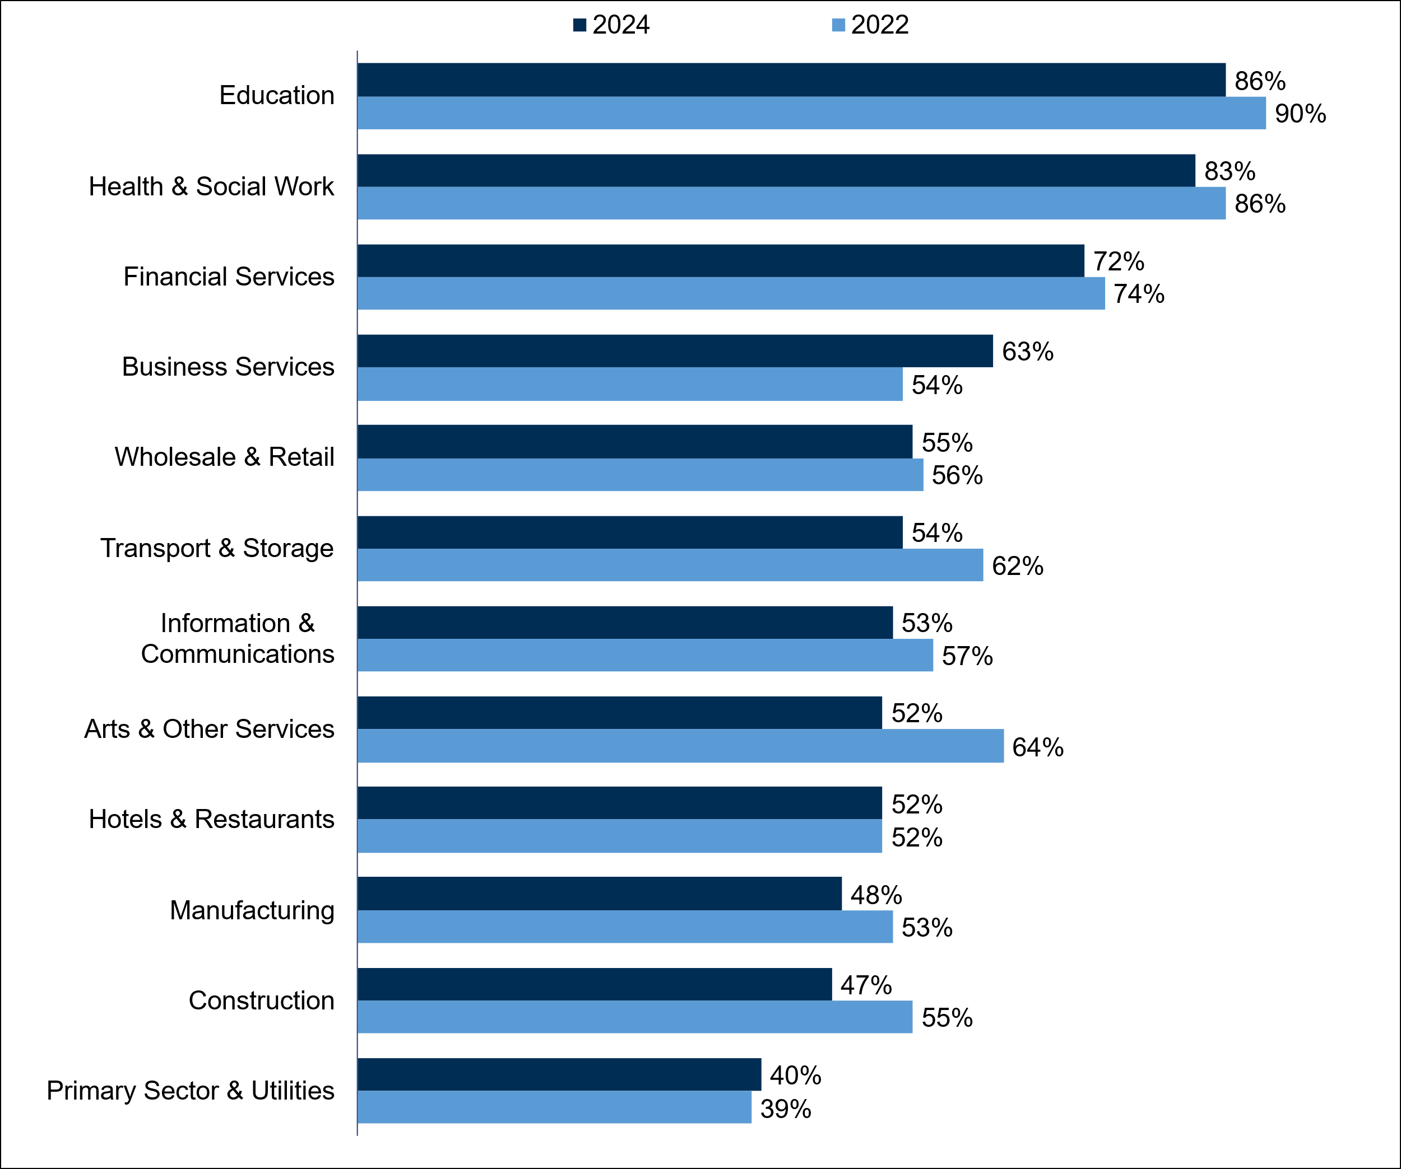
Base: All sites in Northern Ireland (2022 base sizes range from 63 in Information and Communications and 828 in Wholesale and Retail; 2024 base sizes range from 61 in Financial Services to 740 in Wholesale and Retail). Results for Public Administration have been excluded due to low base size in 2024 (28).

Number of training days provided
In 2024, employers in Northern Ireland provided 3 million training days and trained 510,000 staff, equating to 5.8 days of training per trainee and 3.5 days of training per employee. While the total number of trained staff increased from 500,000 in 2022, the number of training days per trainee (5.8 days) and per employee (3.7 days) remained stable. In comparison to the other UK nations, employers in Northern Ireland (5.8 days) provided a similar number of days as those in England (5.6 days) and Scotland (6.0 days), but fewer than employers in Wales (6.6 days).
As in previous years, the number of training days per trainee generally decreased as site size increased. Employers with 2 to 4 employees provided 6.4 days per trainee, whereas those with 25 to 49 employees provided 5.8 days, those with 50 to 99 employees provided 4.8 days, and those with 100 to 249 employees provided 4.1 days. By sector, employers in the Business Services (9.5 days), Financial Services (7.8 days), Education (7.3 days) and Manufacturing (7.2 days) sectors provided the most training days per trainee, while employers in the Information and Communications sector provided the fewest (1.8 days).
By region, employers in the East provided the most training days per trainee (6.5 days) while employers in Belfast provided the most training days per employee (3.9 days). Employers in the North provided the lowest number of both training days per trainee (5.0 days) and per employee (3.0 days).

Proportion of staff trained
Overall, 61% of the Northern Irish workforce had received training in 2024, consistent with 2022 (64%). This was in line with the proportion who received training in Scotland (60%) and England (63%), but lower than in Wales (64%). As in 2022, the proportion of staff trained increased with site size, with 38% of staff trained among sites with 2 to 4 employees compared with 70% for sites with 100 or more. As shown in Table 6-1, employees in the Health and Social Work (80%), Education (75%) and Information and Communication (75%) sectors were most likely to have received training, while employees in the Financial Services sector were the least likely (33%). As in 2022, this pattern was also reflected at different types of sites; employees in the private sector (56%) were least likely to have received training, compared with the charity or voluntary (79%) and public sectors (73%).

Table 6-1: Number and proportion of staff trained, by sector
 | Number of employees trained | % of staff trained
Northern Ireland | 510,900 | 61%
Primary Sector and Utilities | 17,200 | 42%
Manufacturing | 54,800 | 61%
Construction | 20,800 | 50%
Wholesale and Retail | 67,000 | 51%
Hotels and Restaurants | 33,500 | 60%
Transport and Storage | 16,700 | 54%
Information and Communications | 19,000 | 75%
Financial Services | 5,800 | 33%
Business Services | 70,900 | 64%
Education | 59,000 | 75%
Health and Social Work | 110,400 | 80%
Arts and Other Services | 16,600 | 52%
Base: All sites in Northern Ireland (3,388). Sector bases range from 61 in Financial Services to 740 in Wholesale and Retail). Percentages are based on all employment rather than all sites; figures therefore show the proportion of all staff within each subgroup trained over the last 12 months. Results for Public Administration have been excluded due to low base size (28).
By region, employees in Belfast were most likely to have received training (73% of employees), compared with 60% in the North, 58% in both the West and East, and 57% in the South. At an occupational level, Caring, Leisure and Other Services occupations (79%) were most likely to have received training, followed by Professionals (72%). This represents a decrease for Professionals since 2022, where they were the most likely occupation to have received training (72% in 2024 vs. 84% in 2022). As in 2022, Managers were least likely to have received training (45%). Other than Professional occupations, the proportion trained for each other occupation remained in line with 2022, as shown in Figure 6-3.

Figure 6-3: Proportion of staff trained over the last 12 months by occupation, 2022 – 2024
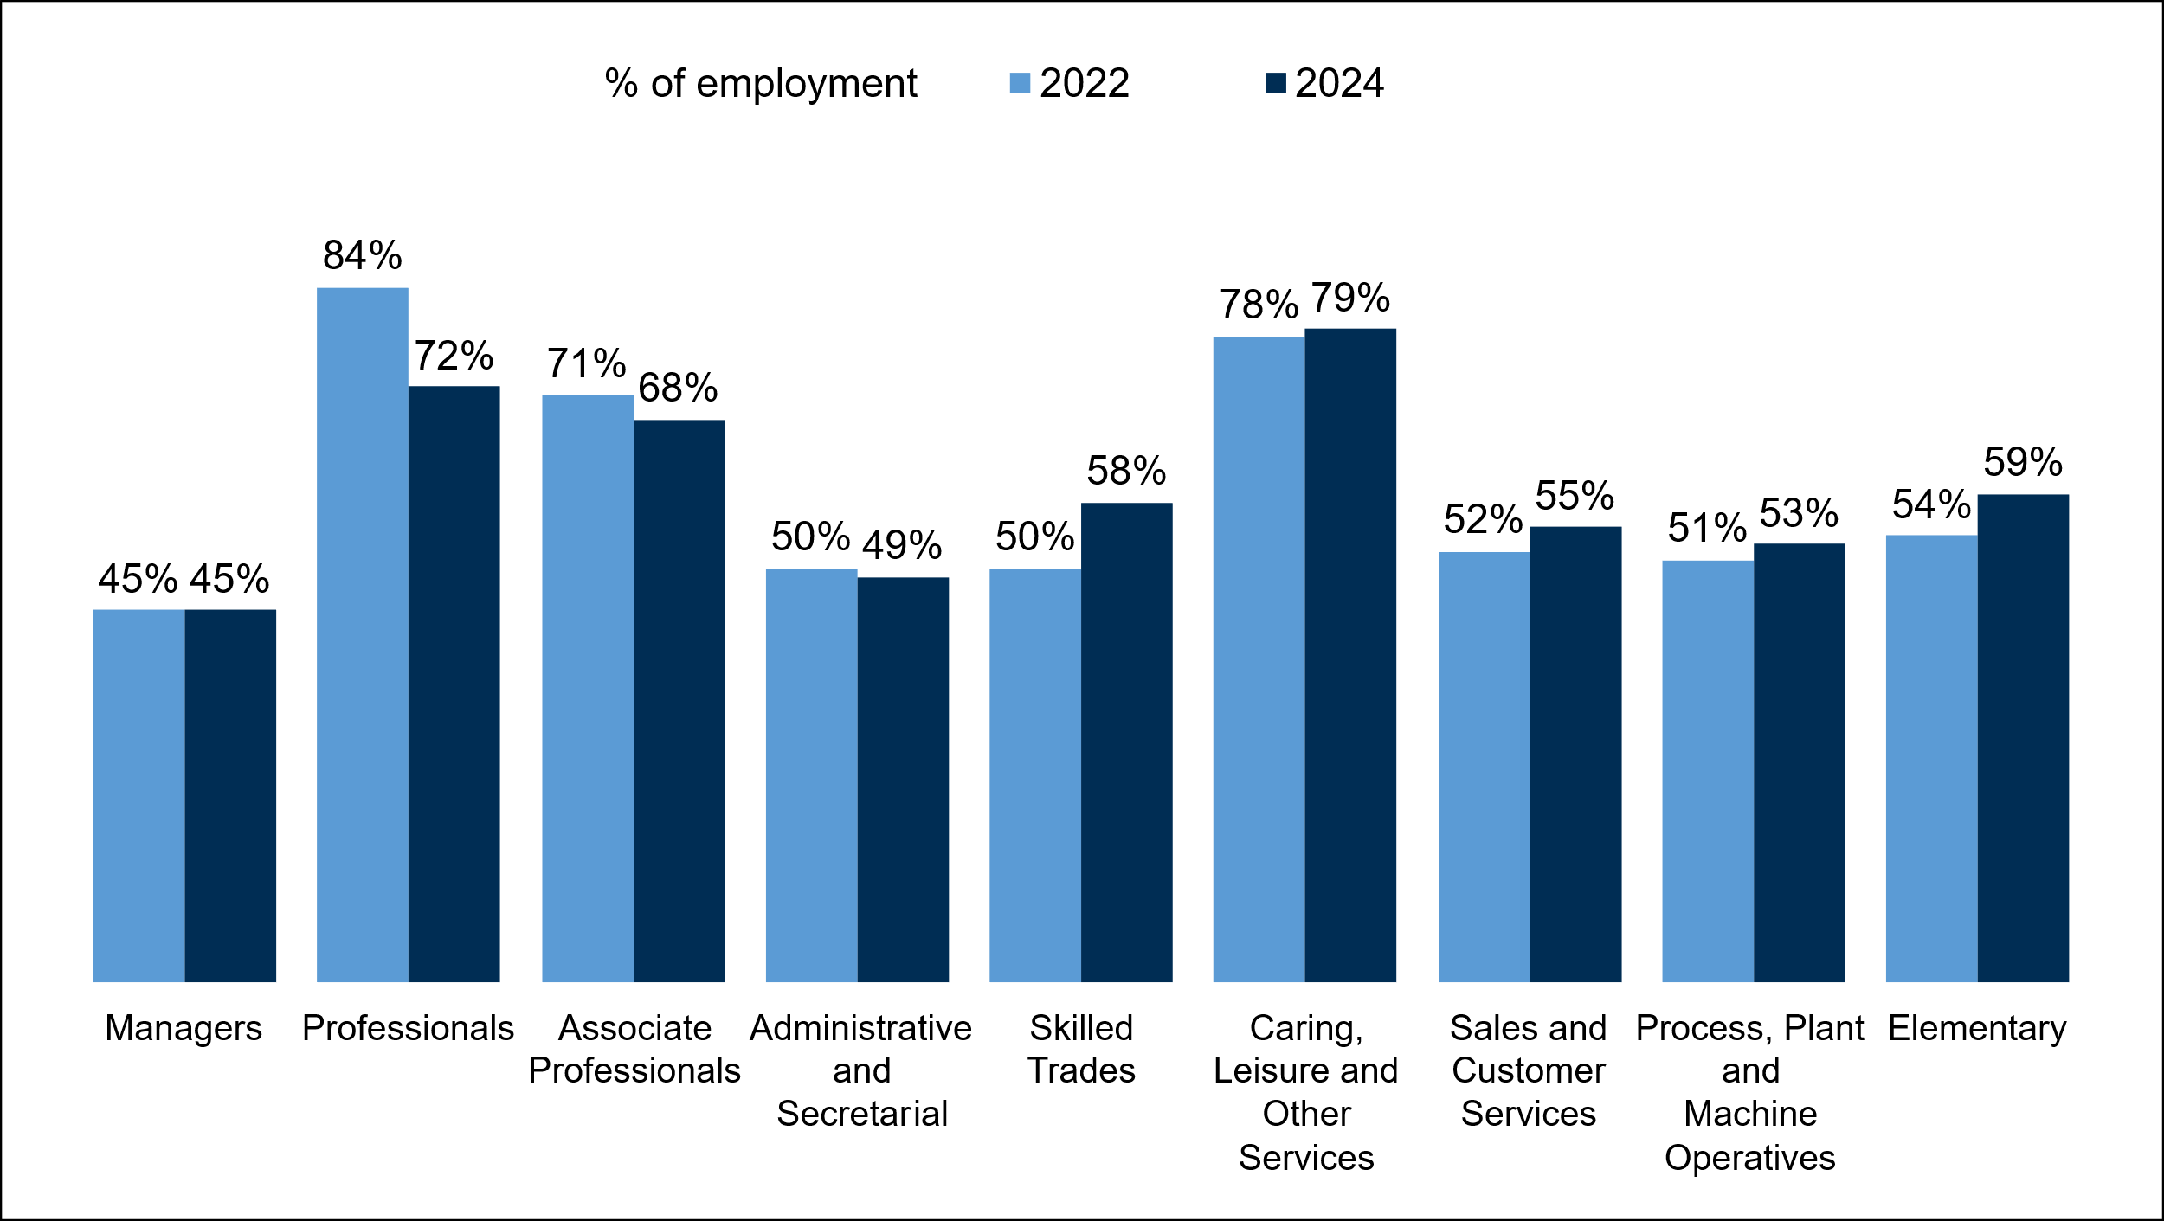Base: All sites in Northern Ireland (2022 base sizes range from 89 for Associate Professionals to 368 for Managers; 2024 base sizes range from 331 for Process, Plant and Machine Operatives to 1,543 for Managers).

Types of training provided
Among training employers, the most common type of training offered was job specific training (81%). As shown in Figure 6-4, this was also the most common type in 2022, although the proportion offering this decreased from 2022 (81% vs. 84%). The next most common types of training were health and safety or first aid training (75%) and basic induction training for new staff (63%). Overall, around two-thirds (64%) of employers offered at least some form of induction training. Other than job specific training, there were no other significant differences in the types of training offered compared with 2022.
Training employers in Northern Ireland were less likely than the UK as a whole to provide job specific training (81% vs. 85% across the UK) and more extensive induction training (33% vs. 37%). England and Scotland were also more likely to offer management training (31% in Northern Ireland vs 35% and 34% respectively). Training employers in the Health and Social Work and Education sectors were notably more likely to offer several kinds of training: job specific training (91% and 86% respectively vs. 81% on average), health and safety/first aid training (89% and 86% vs. 75%), basic induction training for new staff (73% and 78% vs. 63%) and management training (46% and 47% vs. 31%).
By site size, larger employers were more likely to offer each type of training than smaller employers, with this being most notable for:
- Management training (18% for sites with 2 to 4 employees vs. 78% of those with 100 or more employees)
- Basic induction training (41% with 2 to 4 vs. 99% with 100 or more)
- Any induction training (42% with 2 to 4 vs. 99% with 100 or more)
- Supervisory training (21% with 2 to 4 vs. 70% with 100 or more)
Figure 6-4: Types of training provided for employees over the last 12 months, 2022 – 2024
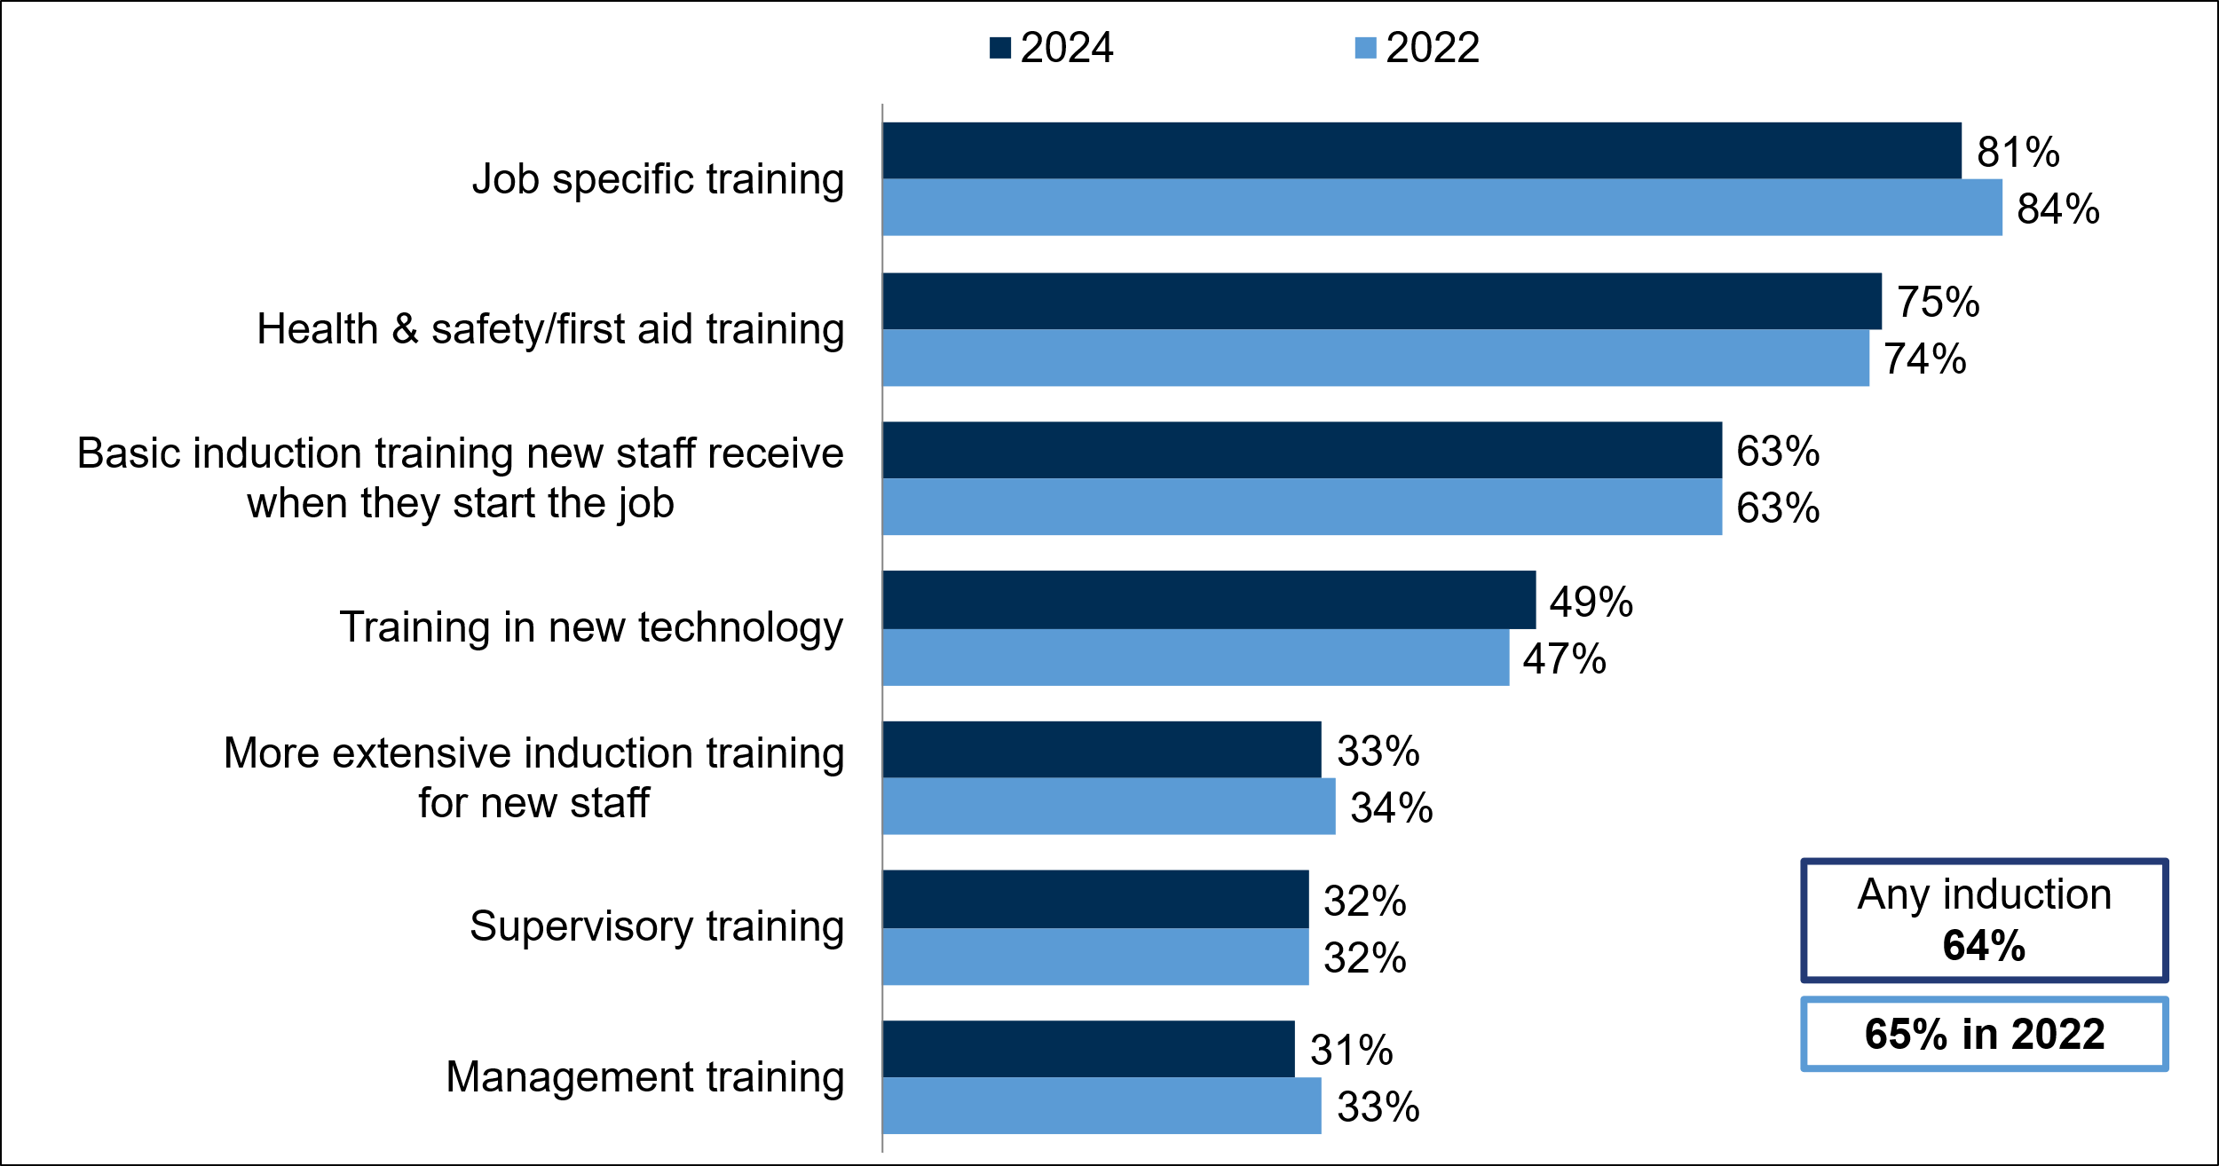Base: All sites in Northern Ireland providing training (2022: 2,428; 2024: 2,388). Responses cited by fewer than 30% not shown.
Around six-in-ten(59%) training employers in Northern Ireland had funded or arranged external training for their staff, in line with 2022 (55%). As in 2022, external training was most commonly sourced from commercial organisations such as consultants or private training providers (45%), followed by regulatory bodies (18%).
Around four-in-ten (37%) training employers had arranged or funded training which contributed towards a nationally recognised qualification in the last 12 months, the same proportion as in 2022. In 2024, 14% of trainees in Northern Ireland had received training towards a nationally recognised qualification, equating to 9% of the total workforce. By size, larger employers were more likely to offer this type of training. Two-thirds (66%) of training employers with 100 or more employees funded or arranged training towards a nationally recognised qualification, compared with 27% of those with 2 to 4 employees. By sector, training employers in the Health and Social Work (52%) and Manufacturing (50%) sectors were most likely to offer training which contributed towards a nationally recognised qualification.
As shown in Table 6-2, where employers had employees training towards a nationally recognised qualification, this was most commonly at Level 4 or above (14%), followed by Level 3 or equivalent (12%). The proportions who had worked towards qualifications at Level 2 or equivalent and qualifications at Level 4 or 5 both decreased from 10% in 2022 to 8% in 2024.

Table 6-2: Level of nationally recognised qualification staff worked towards, 2022 – 2024
 | 2022 | 2024
Level 1 or equivalent | 5% | 4%
Level 2 or equivalent | 10% | 8%
Level 3 or equivalent | 12% | 12%
Level 4/5 | 10% | 8%
Level 6+ | 7% | 7%
Summary: Level 4+ | 14% | 14%
Base: All sites in Northern Ireland providing training (2022: 2,428; 2024: 2,388).
Around one-in-ten (11%) training employers in Northern Ireland had arranged or funded training towards a recognised vocational qualification in 2024, consistent with the proportion in 2022 (14%). The likelihood of arranging or funding this training increased with site size, with 7% of training employers with 2 to 4 employees providing this type of training compared with 23% of employers with 25 or more employees. Training employers in the Business Services sector were more likely to have offered this type of training to their employees (18% vs. 11% on average). Looking at different types of sites, training employers in the charity sector (22%) were more likely than those in the private sector to have offered training towards a recognised vocational qualification (10%).

Barriers and limits on training
Almost three-quarters (73%) of sites that had not provided training to staff over the last 12 months said they did not need to or had not done so because their staff were fully proficient. This was a larger proportion compared with 2022 (68%), returning to the proportion seen in 2019 (73%). It remains, as in previous years, the most cited reason. The next most commonly cited reasons were managers lacking the time to organise training and training not being considered a priority for the site (both 4%).
As in previous years, the smallest employers (with 2 to 4 employees) were least likely to offer any form of training (40%), and this was reflected by these sites being the most likely to report not needing to train (78% compared with 54% of those with 25 or more employees). Conversely, those with 25 or more employees were more likely to cite that training has been arranged and funded elsewhere (8% vs. 2% of sites with 2 to 4 employees), while those with 5 or more employees were more likely to mention that staff learn by experience rather than training (7% vs. 2% of sites with 2 to 4 employees).
By nation, employers in Northern Ireland were the most likely to cite there being no need for training (73% vs. 69% on average across the UK). By sector, Health and Social Work and Wholesale and Retail employers were less likely than average to report that their staff are fully proficient (57% and 67% respectively). Health and Social Work and Education employers were the most likely to report there was no money available for training (both 13% vs. 3% overall). Those in the Health and Social Work sector were also more likely to cite managers lacking time to organise training (11% vs. 4% overall), while Education employers were more likely to report that training is not considered a priority for their site (11% vs. 4% overall).

Figure 6-5: Reasons for not providing training among non-training employers (unprompted), 2022 – 2024
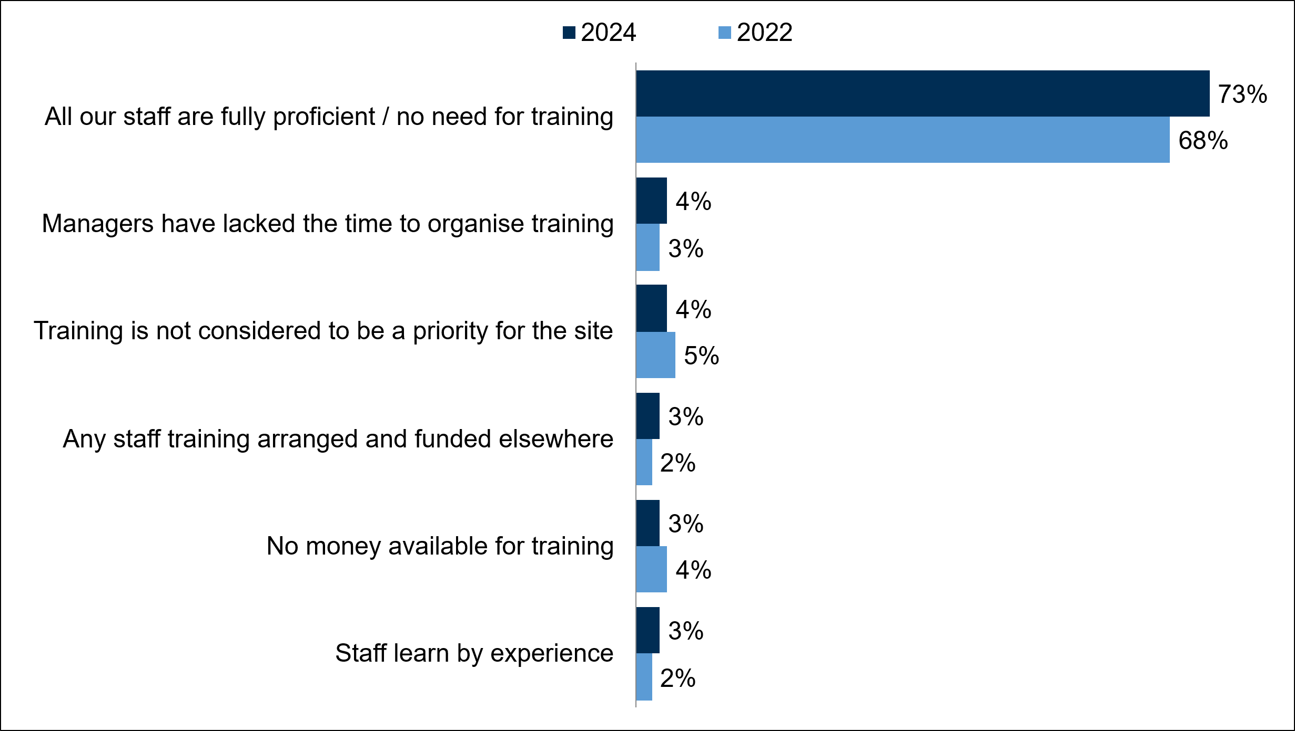
Base: All sites in Northern Ireland that do not provide training, excluding “don’t know” responses (2022: 937; 2024: 933). Responses cited by fewer than 3% in 2024 not shown.
Just under half (46%) of all sites in Northern Ireland that provided training wished they could have provided more, compared to exactly half (50%) who said they would not have provided more. Among those that wanted to provide more, the most cited barriers were staff not being able to spare time to participate in training activities (54%) and a lack of funds for training or that training was too expensive (42%).
If an employer provided all of the training that they wished to (including those who provided no training out of choice) they are said to be in ’training equilibrium’. Overall, 60% of employers in Northern Ireland were in training equilibrium in 2024, while 40% wanted to undertake more training. These results were similar to 2022, when 59% of employers were in training equilibrium while 41% wanted to undertake more training.
A full breakdown of training equilibrium status for employers in Northern Ireland can be found in Figure 6-6.

Figure 6-6: Training equilibrium status of employers
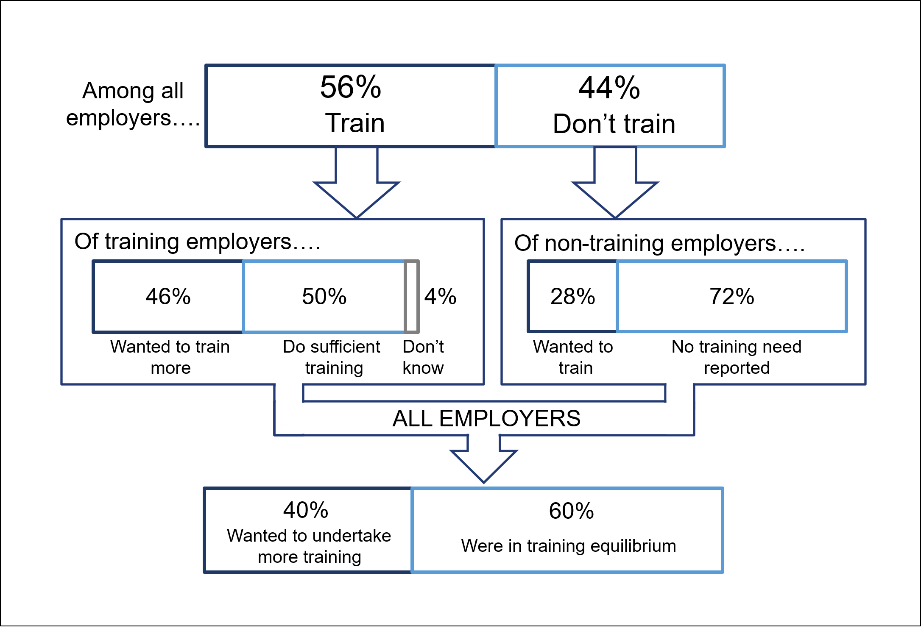Base: All sites in Northern Ireland (3,388); training employers in Northern Ireland (2,388); non-training employers in Northern Ireland, or ‘don’t know responses (1,000).

Employer investment in training
This section is based on the follow-up ‘Investment in Training’ survey which was conducted with employers that had indicated they provide training during the ESS. In total, 883 Northern Irish employers took part in the Investment in Training survey. This section summarises overall training expenditure and how this has changed over time, alongside spend per trainee and employee.
Overall training expenditure in Northern Ireland was £1.4 billion in 2024. This indicates that, when accounting for inflation, training spend has remained stable over recent years, being £1.4 billion in 2019 and £1.5 billion in 2022 (both in 2024 prices). When looking specifically at on-the-job training, employer expenditure on this element decreased by 15% in real terms when compared with 2022; real terms on-the-job training spend was, however, above the level seen in 2015 to 2019. Off-the-job training spend, in contrast, increased in real terms by 8% when compared with 2022, returning to the level seen in 2019. In 2024, overall spend per trainee and per employee decreased (both by £170) when compared with 2022.
As shown in Table 6-3, the largest decrease in training spend was seen in sites with 5 to 24 employees, where spend fell from £566 million in 2022 to £412 million in 2024 (a 27% decrease), which in turn decreased the average spend per employee from £2,700 to £2,000. This is the reverse of the trend seen among this size band between 2019 and 2022 when training spend per employee rose from £2,300 to £2,700. Conversely, the smallest employers (with 2-4 employees) saw an increase in spend between 2022 and 2024 from £171 million to £207 million (a 21% increase), raising the average spend per employee from £2,000 to £2,300 (a continued increase from £1,600 in 2019).
Table 6-3: Total training expenditure and spend per person trained and per employee (2022 – 2024), in 2024 prices
Year |  | 2022 |  |  | 2024
Group | Total | Per trainee | Per employee | Total | Per trainee | Per employee
Unit | £ | £ | £ | £ | £ | £
Total | 1.5bn | 2.9k | 1.8k | 1.4bn | 2.7k | 1.7k
Size | Total | Per trainee | Per employee | Total | Per trainee | Per employee
Unit | £ | £ | £ | £ | £ | £
2 to 4 | 171m | 5.5k | 2.0k | 207m | 6.1k | 2.3k
5 to 24 | 566m | 4.7k | 2.7k | 412m | 3.5k | 2.0k
25 to 49 | 206m | 2.9k | 1.9k | 212m | 2.9k | 1.9k
50 to 99 | 193m | 2.8k | 1.9k | 172m | 2.5k | 1.6k
100 or more | 322m | 1.5k | 1.1k | 392m | 1.8k | 1.2k
Base: All sites in Northern Ireland completing the Investment in Training survey (2022: 1,044; 2024: 883). NB: Figures over 1 billion (bn) are rounded to the nearest 100 million, figures under 1 billion are rounded to the nearest million (m). Figures reported in thousands (k) are rounded to the nearest hundred.
Further information on employer investment in training, including the split between on-the-job and off-the-job training costs and investment, and how spend on individual components is broken down, can be found in the full UK technical report.

Apprenticeships

Introduction
This chapter examines how widely apprenticeships are being provided by employers, the main reasons for not offering them, and future apprenticeship plans.
When discussing ‘formal apprenticeships’, this would include apprenticeships that follow a formal framework, and lead to a nationally recognised qualification.

Offering formal apprenticeships
Around one-in-six (17%) employers in Northern Ireland offered apprenticeships; this included those who employed apprentices at the time of the survey (11%), and those who did not currently employ apprentices but offered apprenticeships (6%). This is a higher proportion than in both 2022 (14%) and 2019 (12%).
In the South, one-in-five employers (20%) offered apprenticeships, a larger proportion than in the North, where just over one-in-ten employers (11%) provided apprenticeships, the lowest rate among the regions.
The likelihood of offering apprenticeships generally increased with site size, ranging from 12% of sites with 2 to 4 employees to 44% with 100 or more employees.
Construction employers were most likely to offer apprenticeships with more than a quarter (28%) of sites doing so, while employers in the Hotel and Restaurants sector were least likely to do so (8%). More broadly, employers in the private sector were more likely to offer apprenticeships (19%) than those in the charity and voluntary sector (10%) and local or central government employers (10%).
Among employers who offered apprenticeships, around nine-in-ten (89%) offered these to new recruits, while almost six-in-ten (59%) only offered them in this way (as opposed to offering them to existing employees). Around four-in-ten (38%) offered apprenticeships to existing employees (8% did so exclusively). Around nine-in-ten (89%) employers offering apprenticeships offered them to individuals aged under 25, almost half of these did so exclusively, accounting for 43% of those who currently offered apprenticeships. Less than half (46%) offered apprenticeships to individuals aged 25 or over.

Future apprenticeships plans
Just under a quarter of employers (24%) reported plans to offer apprenticeships in the future. This represents a decrease compared with 2022 (32%) and 2019 (29%), when around one-in-three indicated similar intentions.
Among sites that currently offered apprenticeships, the majority (82%) intended to continue doing so in the future. In contrast, just over one-in-ten (12%) sites not currently offering apprenticeships had plans to introduce them. This marks a significant decrease from 2022, when nearly a quarter (23%) of sites not already offering apprenticeships indicated they planned to do so in the future.
Reflecting the pattern seen for current provision of apprenticeships, the likelihood of offering apprenticeships in the future generally increased with site size, ranging from 18% among those with 2 to 4 employees, to 56% among those with 100 or more employees (Figure 7-1).
Employers in the Manufacturing sector were almost twice as likely than average (47%) to have plans to offer apprenticeships in the future. In contrast, in addition to being most likely to not offer apprenticeships at the time of the survey, employers in the Hotels and Restaurants sector were also least likely to have plans to offer them in the future (13%).
Figure 7-1 Proportion of employers offering apprenticeships in the future, by site size
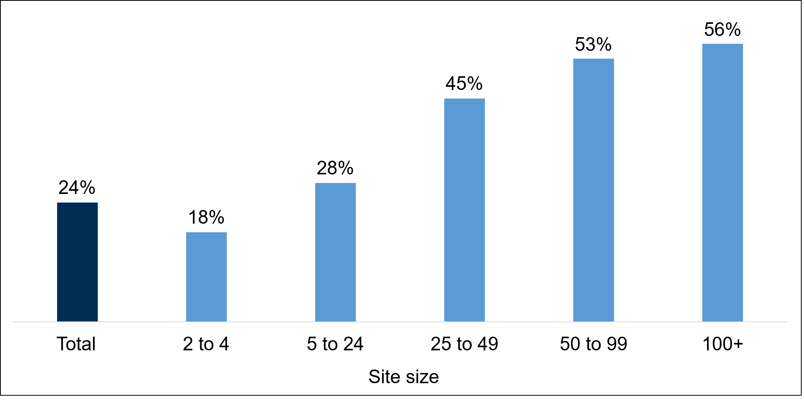Base: All sites in Northern Ireland (Module A) (868)

High Performance Working practices

Introduction
“High Performance Working” (HPW) practices are practices recognised to ensure employee skills are harnessed and nurtured. To be classed as a “High Performance Working Employer” a site must have adopted 7 or more of the 10 practices covered by the survey. A summary of the HPW practices are outlined in Figure 8-1.

Proportion of employers classed as High Performance Working employers and change over time
Overall, 5% of employers in Northern Ireland had adopted 7 or more HPW practices, classing them HPW employers. This was in line with the 6% classed as HPW employers in 2022. As in 2022 the most common HPW practice was having an equal opportunity policy (79%), followed by offering on-or-off-the-job training (58%). (Figure 8-1).
Figure 8-1 Prevalence of High Performance Working practices
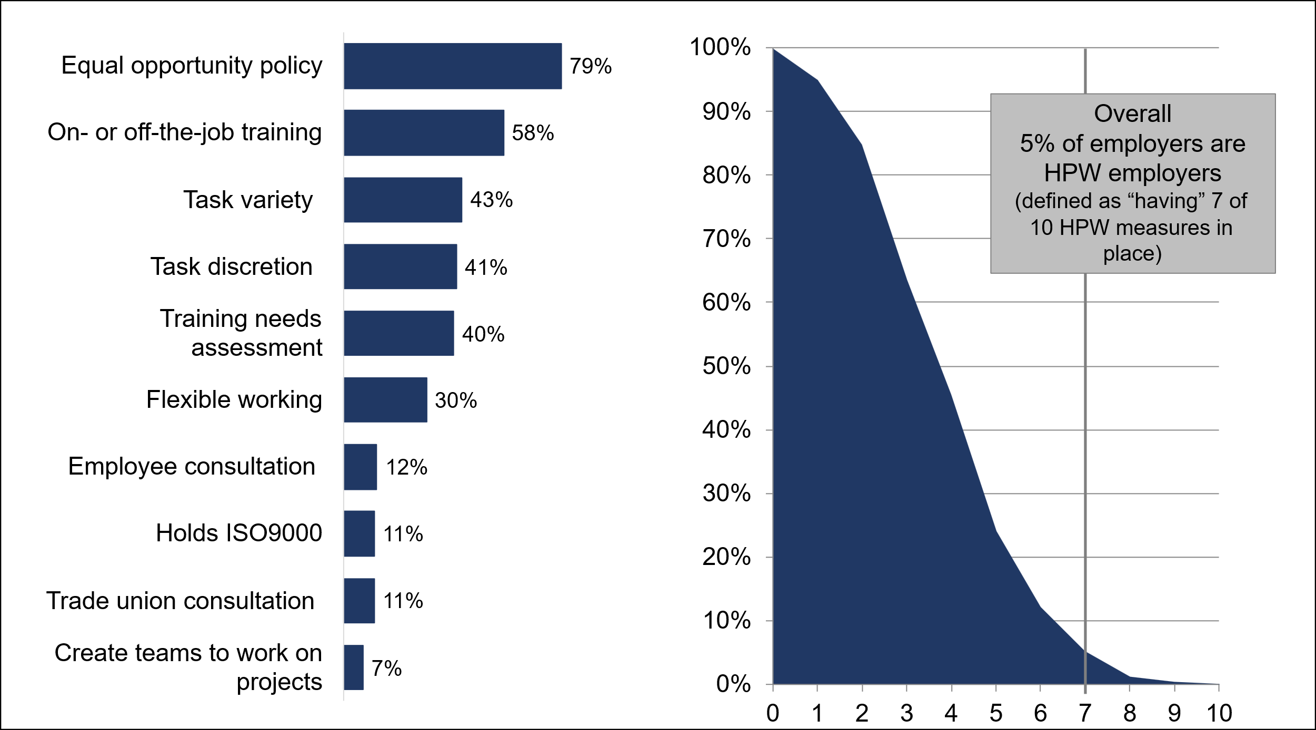
Base: All sites in Northern Ireland (Module D) (882).
By region, employers in Belfast were more likely to be HPW employers (11%) compared with employers in the East (6%), the West (4%), the North (3%) and the South (2%).
Larger employers were more likely to be HPW employers. Close to one-in-five (21%) sites with 100 or more employees were classed as HPW employers compared with 2% of sites with 2 to 4 employees. A full breakdown of by site size is shown in Figure 8-2.

Figure 8-2 Prevalence of High Performance Working practices, by site size
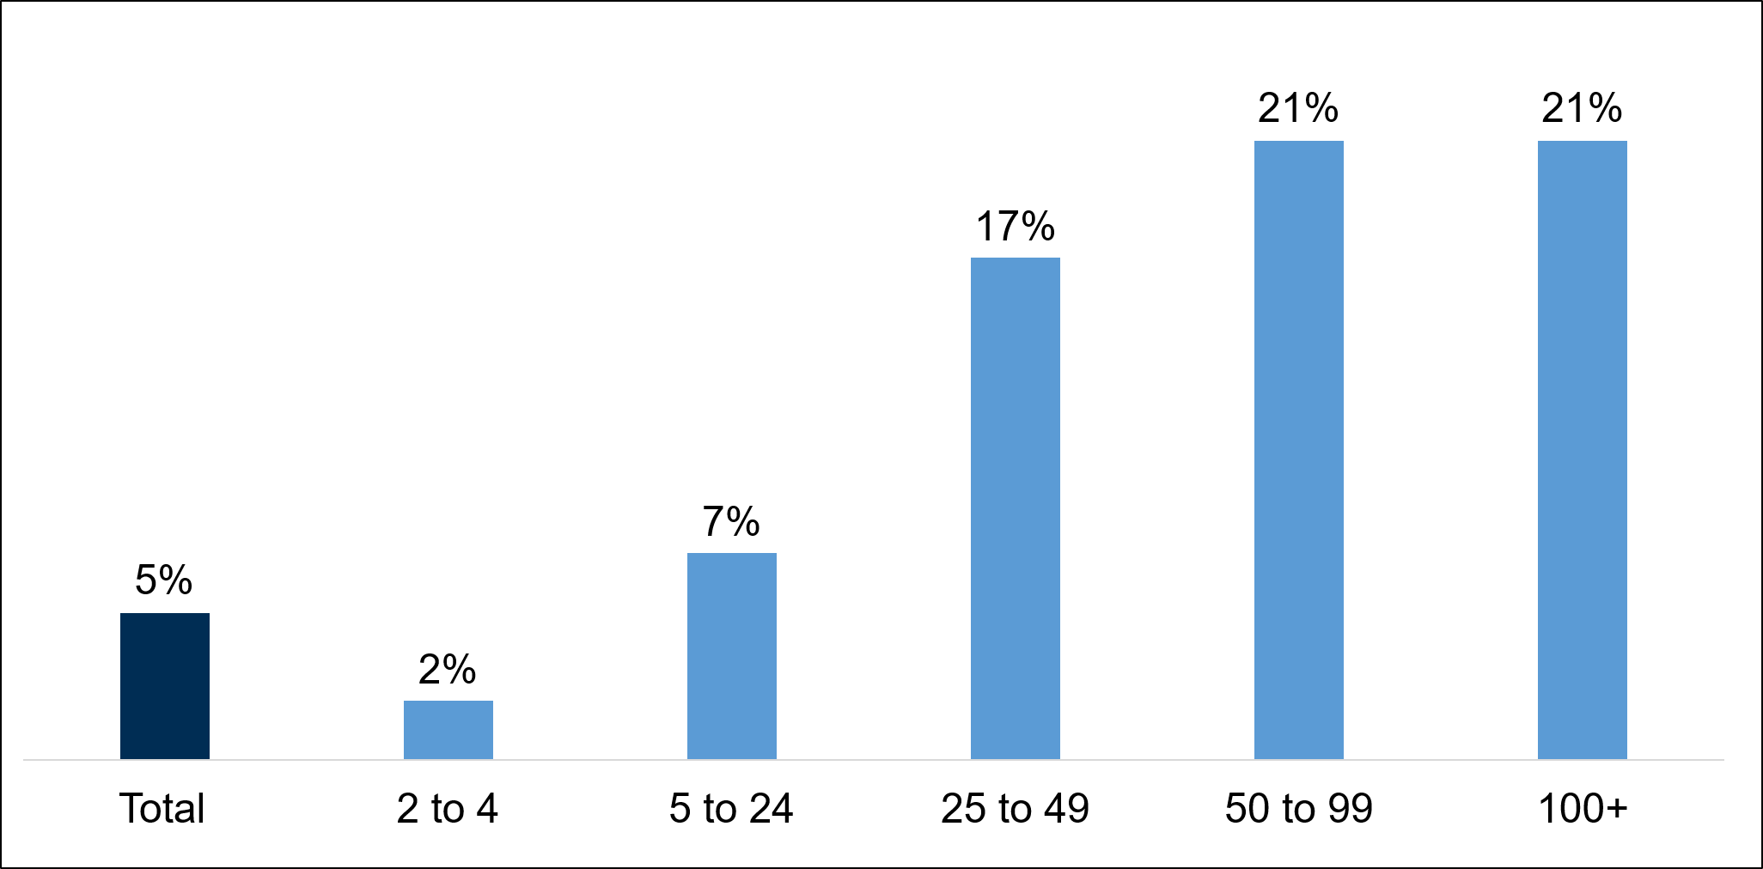
Base: All sites in Northern Ireland (Module D) (882).
Larger employers were also more likely to adopt most specific HPW practices. For example, employers with 100 or more employees were more likely to have an equal opportunity policy (100% vs. 72% with 2 to 4 employees) and have provided on-or-off the job training (95% vs. 44% with 2 to 4 employees). Larger employers were also more likely than average to have a training needs assessment (79% vs. 40%), to consult employees (82% vs. 12%), create teams to work on projects (34% vs. 7%) and have a trade union consultation (53% vs. 11%).
On the other hand, smaller sites with 2 to 4 employees were more likely than larger sites to offer task variety (46% vs. 25% with 100 or more employees), task discretion (45% vs. 18% with 100 or more employees) and flexible working (35% vs. 20% with 100 or more employees).
By sector, Education had the largest proportion of HPW employers (16%), followed closely by Health and Social Work (14%). Education was also the sector most likely to have HPW employers in 2022. Most employers within the Education sector had an equal opportunity policy (91%) and a large proportion offered on-or-off the job training (85%). There were sectoral differences in the specific practices adopted. No Manufacturing employers met the threshold to be classed as a HPW employer, and they were also most likely to not offer or engage with any HPW practices (16%), followed by Construction (13%) and Primary Sector and Utilities (9%) employers. A breakdown by sector by HPW employer prevalence is shown in Figure 8-3.

Figure 8-3 Prevalence of High Performance Working practices, by sector
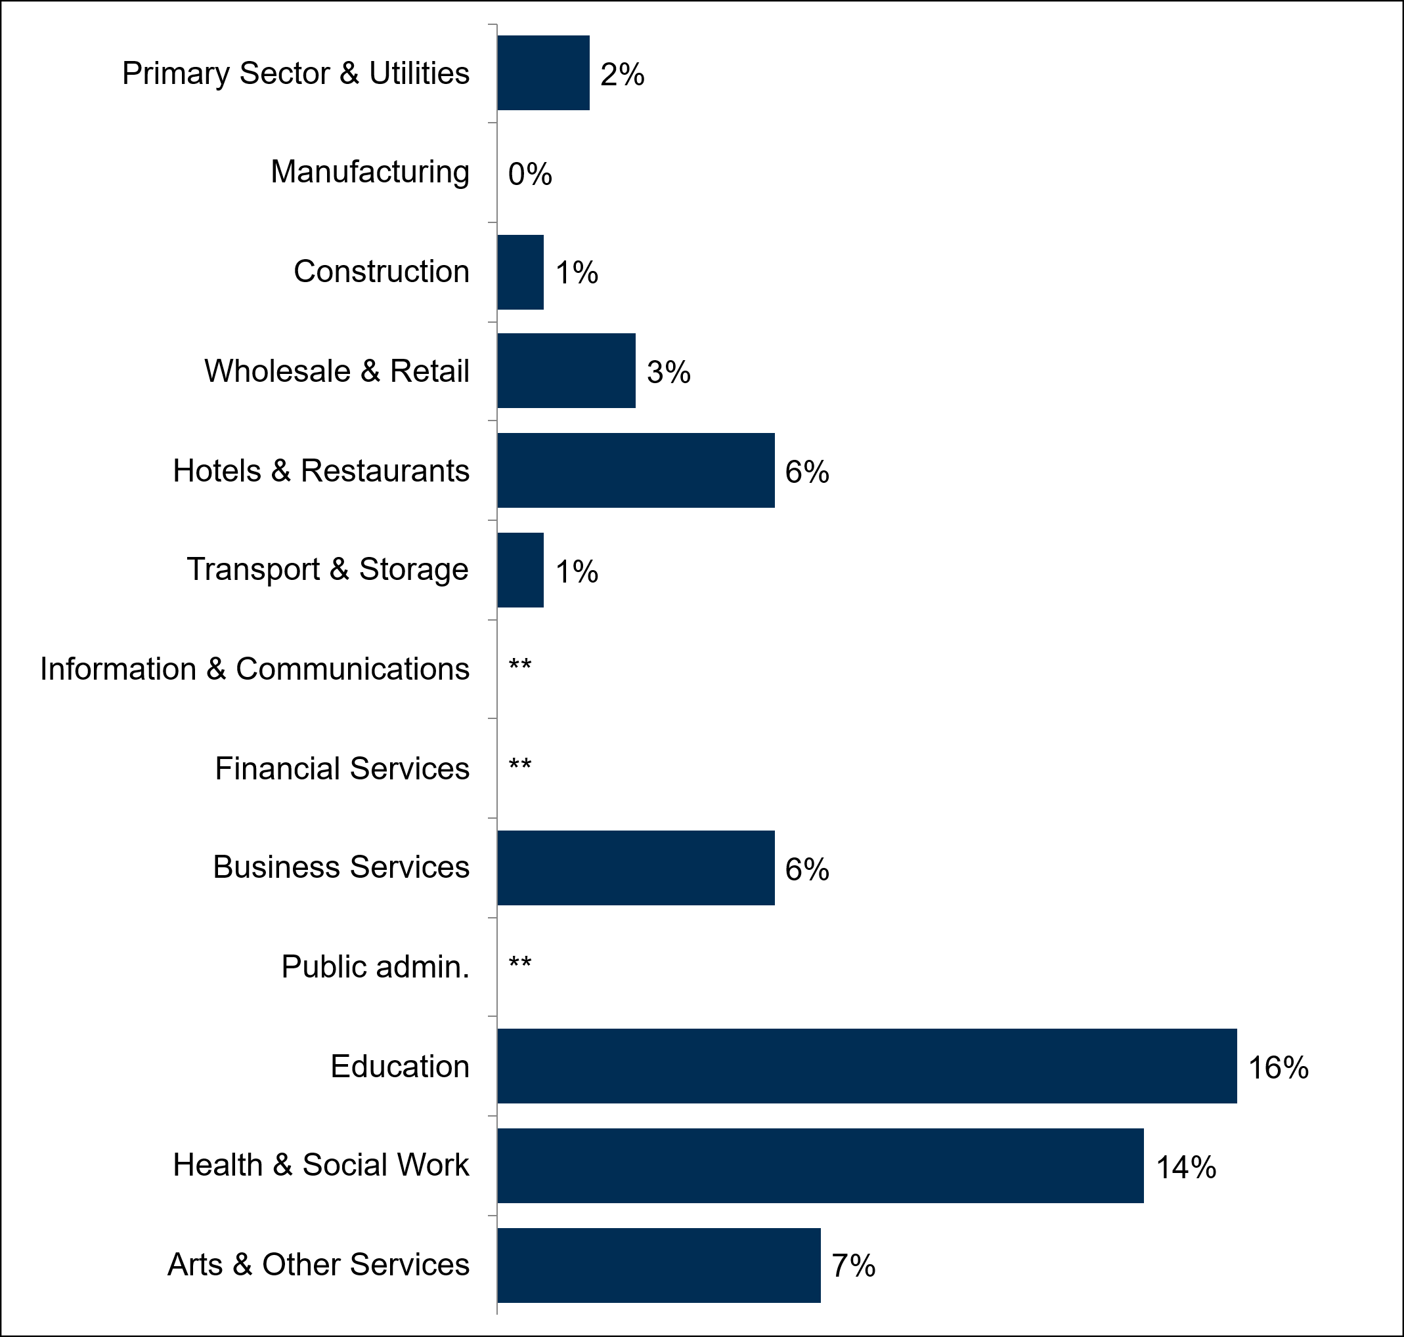
All sites in Northern Ireland (Module D) (882; sector bases range from 33 for Transport and Storage, to 176 for Wholesale and Retail). Public Administration, Information and Communication, and Financial Services data not shown due to low base size.

Artificial Intelligence

Introduction
This section examines the current use of Artificial Intelligence (AI) by employers in Northern Ireland, their future plans for AI adoption, and the extent to which they anticipate AI becoming integrated into their processes and operations in the coming years. For the purposes of these questions, AI was described as ‘machines or software that can imitate human behaviour such as problem-solving, learning, playing and communicating’. 2024 marks the first year that questions on AI were included in the survey.

Use of Artificial Intelligence
Fewer than one-in-ten employers (8%) in Northern Ireland reported using AI. This was lower than in all other UK nations (England; 15%, Wales; 12%, and Scotland; 11%). Use of AI was most common among the largest employers (19% of those with 100 or more employees) and employers with 25 to 49 employees (12%); for other sizebands, the proportion ranged from 6% to 8%. In terms of regional differences, Belfast had the highest proportion of sites using AI (13%), while usage was lowest in the West (4%).
By sector, AI usage was most common in the Information and Communications sector (38%) and also more likely than average in the Business Services sector (12%). The Construction sector was least likely to use AI (4%) (Figure 9-1).
Figure 9-1 Use of AI, by sector
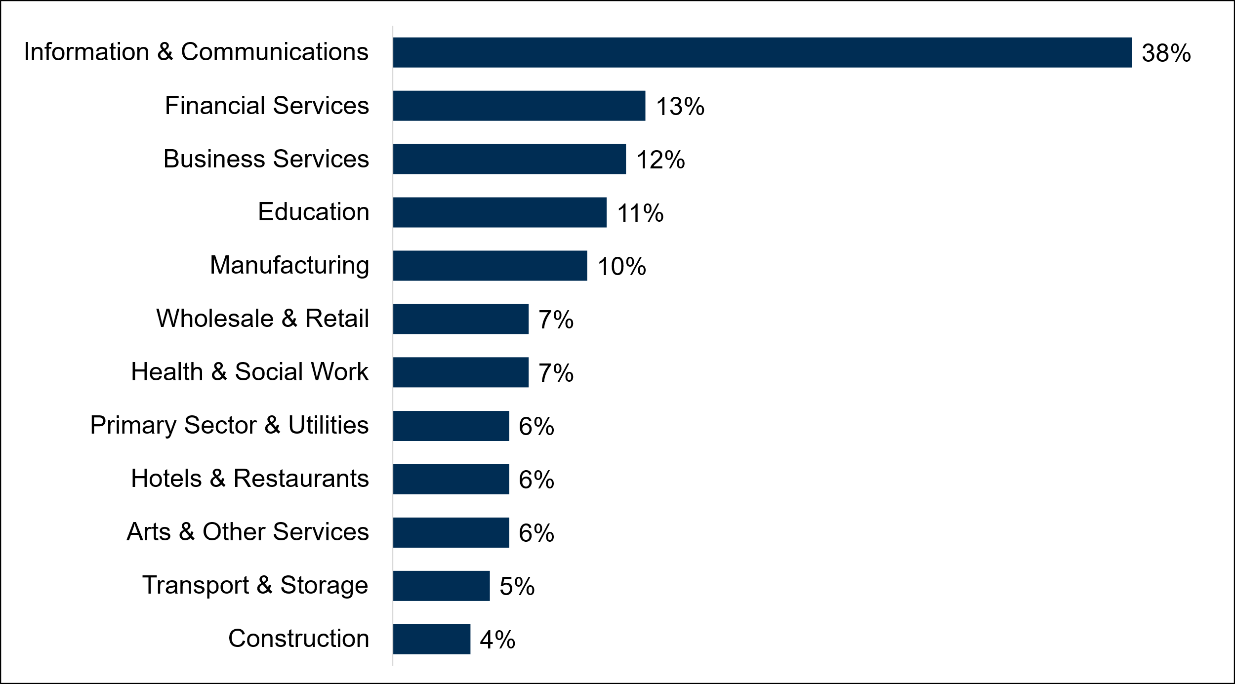
Base: All sites in Northern Ireland (3,388). Sector bases range from 61 in Financial Services and 740 for Wholesale and Retail. Public Administration is not included due to low sample size.

Future use of Artificial Intelligence
Among employers using AI, three-in-five (60%) said they had begun doing so within the previous 12 months, while a further quarter (24%) had adopted AI between one and three years earlier. This highlights that the growth in AI adoption has been a recent development. AI users were also asked the extent to which they expect AI to become embedded into their processes and operations over the next three years. The majority of employers (89%) expected this to happen to at least some extent, including a quarter (25%) who expected this to happen to a great extent.
Among employers not currently using AI, only 8% reported intentions to do so (Figure 9-2). The sectors most likely to have plans to adopt AI in the future were also those with the highest current levels of AI use, including, in particular those in the Information and Communications sector (18%). A large majority (81%) had no plans to adopt AI, with this most likely to be the case among the smallest sites with 2 to 4 employees (85%) and Construction employers (90%).
Figure 9-2 Whether sites are planning to adopt AI and timeframe for adoption (non-users)
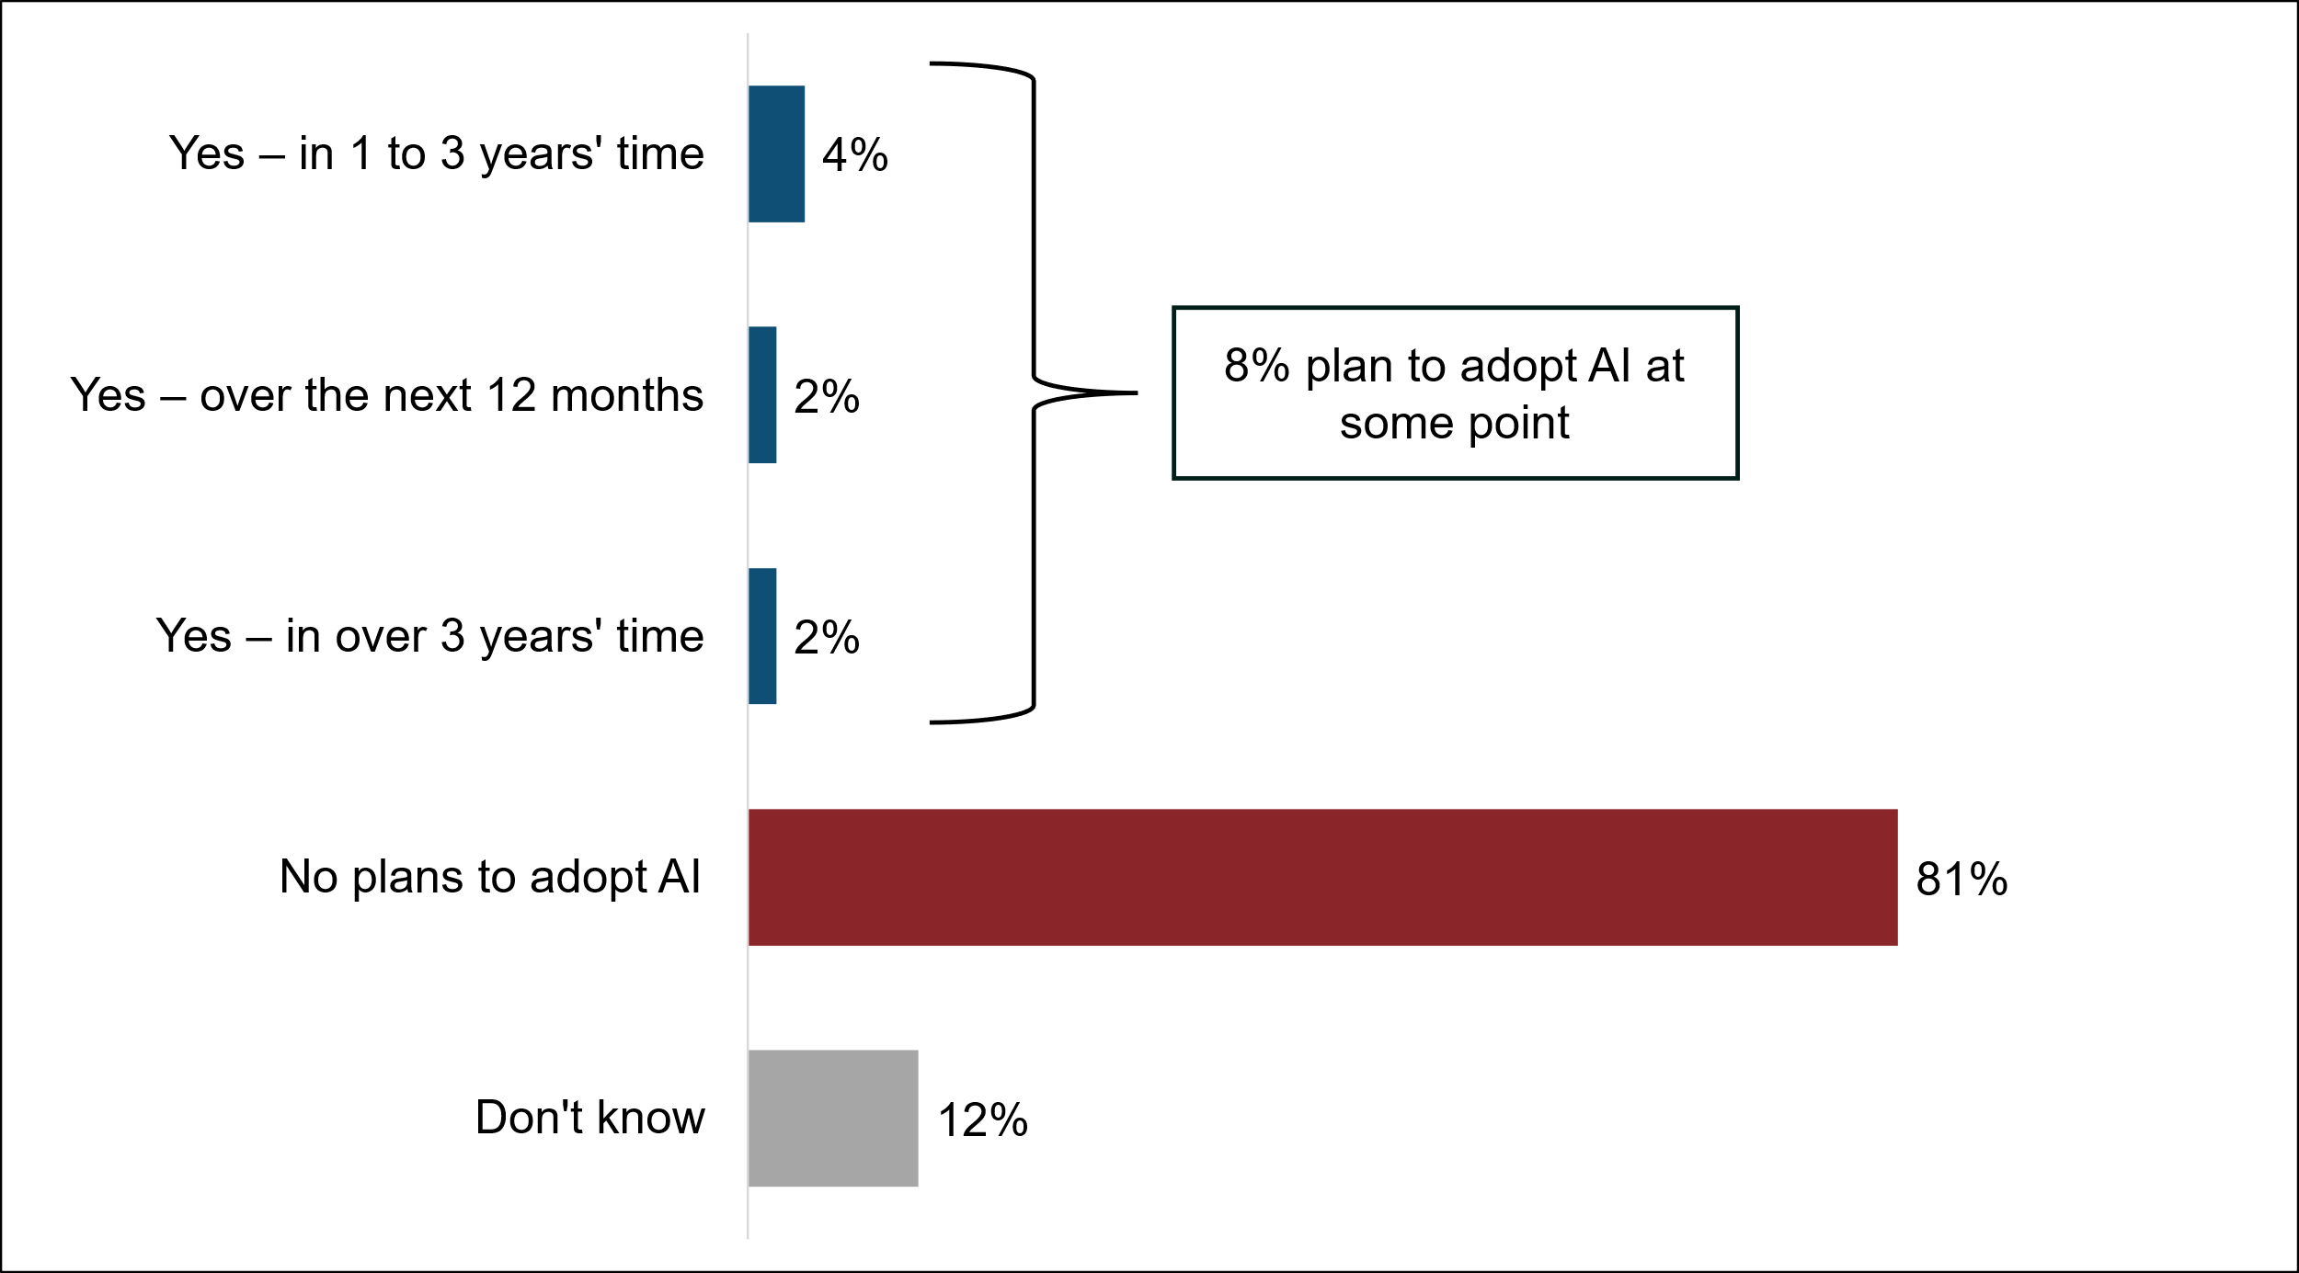
Base: All sites in Northern Ireland that do not use AI (2,946)

National Occupation Standards (NOS)
National Occupational Standards (NOS) describe the knowledge, skills and understanding needed to do a particular job to a nationally recognised level of competence.
NOS can be used by awarding bodies which can create qualifications to train individuals for a job, to create job descriptions and by individuals who can research different types of jobs and match their skills and experience to those needed.
In ESS 2024, employers in Northern Ireland were asked about their awareness and use of NOS.

Awareness of NOS in Northern Ireland
Around half (48%) of sites in Northern Ireland had an awareness of NOS. Just under a third of sites (30%) said that they were aware of NOS and were knowledgeable about what they were. This included 9% of sites who said that they had ‘good knowledge of them and what they include’. Around half (49%) said that they ‘had not heard of NOS’.
Awareness of NOS was higher among sites that had hired staff in the previous 12 months (53% compared to 45% of those who had not recruited in the past year). Awareness was also higher at sites that used AI in their work processes (62% compared to 48% at sites that did not use AI). Sites that had skills gaps were also more likely to say they had an awareness of NOS compared to those who did not have any skills gaps (59% compared to 47% respectively). Sites operating in the Health and Social Work sector were most likely to have an awareness of NOS (59%) compared to other sectors. There was no variation by the number of employees at the site.

The use of NOS in Northern Ireland
Around a fifth (19%) of sites had used NOS in some way and that included 4% of sites using NOS in at least four ways. Close to four-fifths (78%) of sites reported that they had not used NOS at all. NOS were most commonly used to develop training plans in line with sites’ skills needs and to develop job descriptions or guide recruitment criteria (both 13%).
Sites with skills gaps were more likely than sites who did not to use NOS in any way (29% compared to 18% respectively). Sites operating in the charity sector (29%) and public sector (26%) were most likely to have used NOS compared to profit seeking sites (18%). Similarly to awareness, sites utilising AI were more likely to be using NOS than those that were not using AI (28% compared to 19% respectively). By sector, NOS were most commonly used by sites in the Health and Social Work sector (35%), followed by Construction (24%), and Education and Arts and Other Services (both 22%). A full breakdown of NOS usage by sector is shown in Figure 10-1.
Figure 10-1 Proportion of sites in each sector using National Occupational Standards
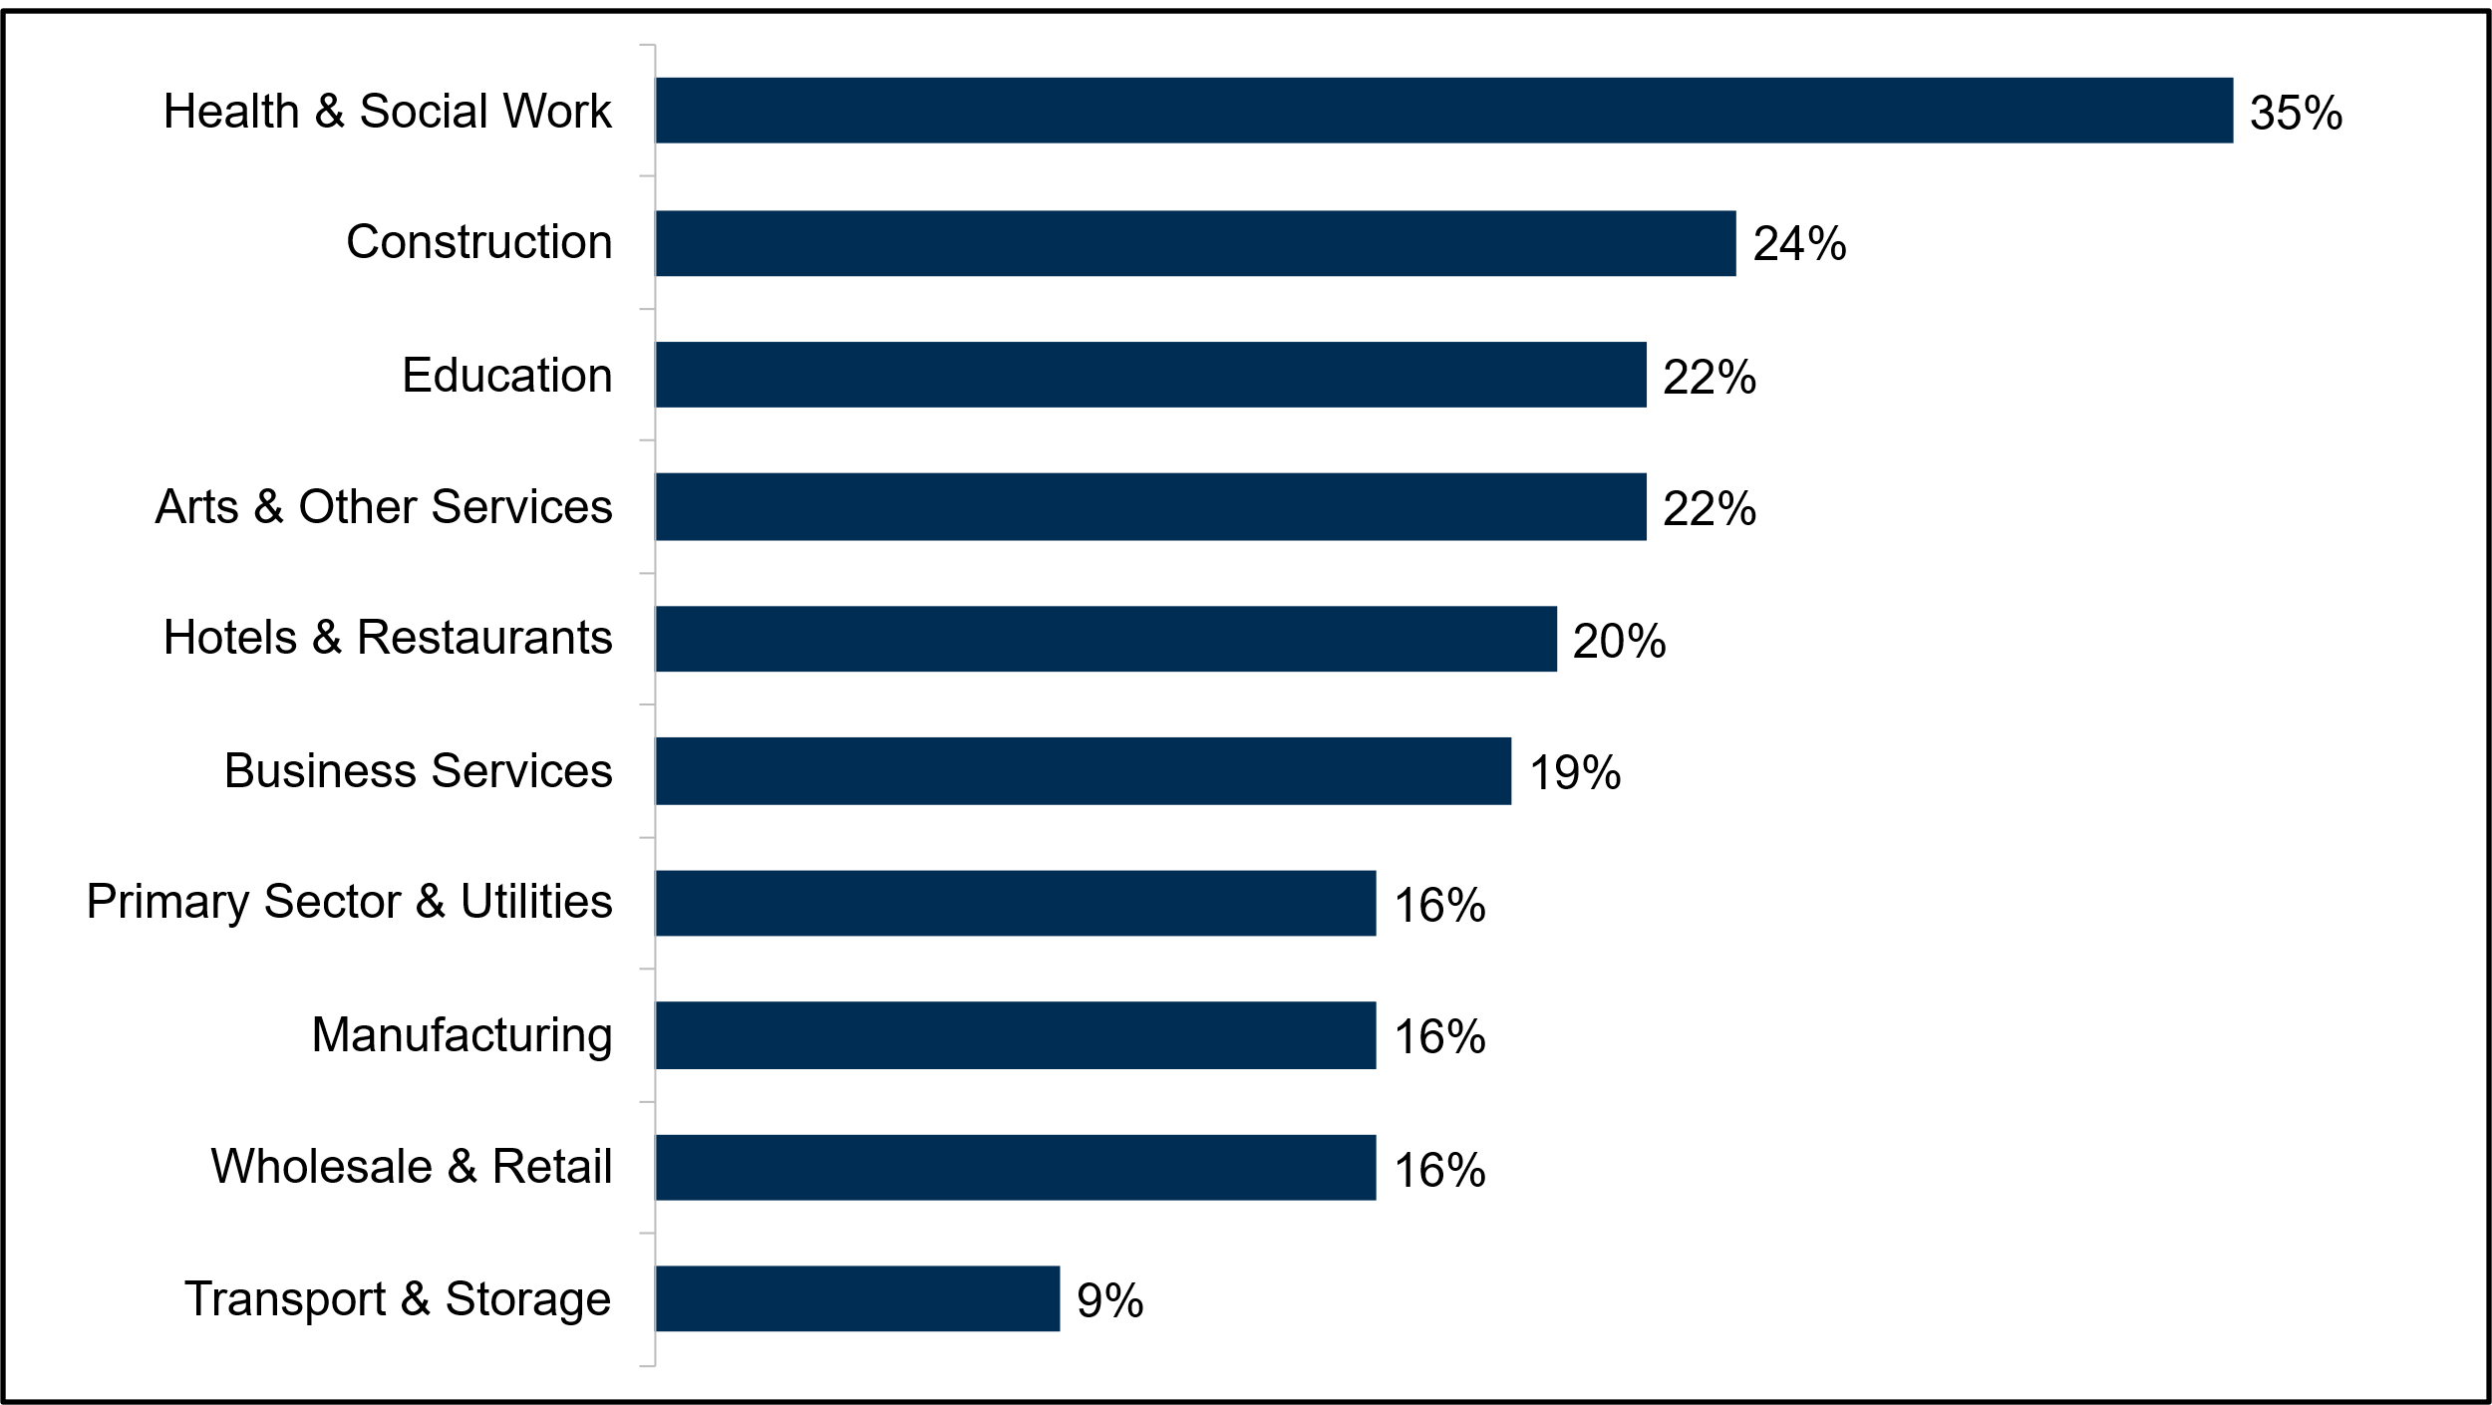
Base: All sites in Northern Ireland (Module D): 882. Where base sizes are under 30 within a sector, this data is not shown.

Methodology
The 2024 Employer Skills Survey (ESS) is the second time ESS findings have been published by the Northern Ireland Executive (following the first publication in 2022). The figures for surveys prior to 2022 (ESS 2011, Employer Perspectives Survey (EPS) 2013, ESS 2013, EPS 2014, ESS 2015, EPS 2016, ESS 2017, and ESS 2019) that are referred to in this publication are published in research reports by the UK Government Department for Education (DfE).
The population from which the sample was taken was based on all ‘sites’ in Northern Ireland that had at least two employees (including owners and working proprietors), but not including any workers not on the payroll, like self-employed contractors or agency staff. This approach matches previous iterations of the survey and has been taken as it tends to be much easier for survey respondents to think in terms of the overall ‘headcount’ for their site – including both working proprietors and employees – than to think about their organisation as a whole, particularly among large organisations with many individual sites.
However, the ESS survey excluded the self-employed (with no employees). The question approach for this group would need to be somewhat different, since they are by definition not employers. There is also an absence of robust population figures for this group, meaning robust and representative sampling and weighting is difficult to achieve.
The survey encompassed sites from across the whole of the Northern Ireland, covering all sectors of the economy (the commercial, public and charitable spheres). The profile of this population for sampling was established through Office for National Statistics (ONS) data from the March 2023 Inter-Departmental Business Register (IDBR), the most up-to-date business population figures available at the time of the survey. For weighting, the March 2024 IDBR figures were used as the most up to date figures available.
ESS 2024 was the second in the series to use a Random Probability Sampling (RPS) approach (following the same methodology as 2022), where all sample issued is processed according to agreed protocols until all leads are exhausted. This means that units sampled from given population cells have an equal and known probability of being sampled.
Telephone interviews were conducted between June 2024 and January 2025. Data was collected via Computer-Assisted Telephone Interviewing (CATI). A total of 3,388 interviews were achieved with employers in Northern Ireland. Large sections of the survey were modularised to ensure that ESS and legacy questions from the EPS could be covered without adding significantly to interview length. Sites were randomly allocated to one of four modules during the survey. A core section of the survey was asked of all employers, while modular questions were assigned to one or more modules, depending on the required sample size, and employers randomly assigned to answer a module. Table 11-1 shows the number of completed interviews in each module, for Northern Ireland sites.
Table 11-1: Interviews achieved in Northern Ireland, per module
Module A | Module B | Module C | Module D
868 | 834 | 804 | 882
The overall response rate for Northern Ireland was 66%, calculated as ‘achieved interviews’ as a proportion of all respondents who started the survey. This is in line with UK-level response rate (65%) and response rates in England (63%), Scotland (63%) and Wales (71%).
Further detailed technical information is available in the UK-level technical report, published on the DfE website. Data regarding which codes were used for grouped categories can be found within the full UK report that will be published later this year on the DfE website. Further data can be accessed in Northern Ireland published data tables accompanying this report.

Annexes

Annex A – Definitions
Vacancy density
The number of vacancies as a proportion of all employment.
Hard-to-fill vacancies
Vacancies that employers struggle to fill.
Skill-shortage vacancy (SSV)
A specific type of hard-to-fill vacancy that occurs when an employer cannot find applicants with the required skills, qualification, or experience to do a job.
SSV density
The number of SSVs as a proportion of all vacancies.
Skills gaps
Skills gaps exist when an employer thinks a worker does not have enough skills to perform their job with full proficiency. Skill gaps apply to existing employees.
Skills gaps density
The number of employees that lack full proficiency as a proportion of all employment.
Off-the-job training
Training that takes place away from the employee’s immediate work location / position. It can be elsewhere on the employer’s premises or off the premises as long as it is funded and arranged by the employer.
On-the-job training
Training that the employer funds or arranges that takes place where the employee normally works (for example, at their desk). This would be activities recognised as training by staff rather than the sort of learning by experience which could take place all the time.

Training equilibrium

Employers that are in ‘training equilibrium’ had no desire to undertake more training than they had delivered in the previous 12 months (or in the case of non-training employers, no desire for any training).
Results for training employers are derived from a survey question which explicitly asked if they would like to have provided more training than they were able to over the past 12 months.
Results for non-training providing sites have been determined from their reasons for not training, rather than a direct question. Those answering that they had not provided any training because it was not considered to be a priority for their site, because all their staff were fully proficient, or they had no need for training were regarded as being in training equilibrium and having no perceived need to undertake training. Those not giving any of these reasons were classified as wanting to have undertaken training (i.e., not in training equilibrium). Additionally, training employers that answered ‘don’t know’ when asked if they would have liked to train more were classified as not being in training equilibrium.
More detail about the methodology and weighting process can be found in the technical report on the DfE website.

Annex B - Grouped codes
Table B- 1 Grouped technical and practical skills
Complex analytical skills | Operational skills | Digital skills | Basic skills
Solving complex problems requiring a solution specific to the situation | Knowledge of products and services offered by your organisation and organisations like yours | Computer literacy / basic IT skills | Computer literacy / basic IT skills
More complex numerical or statistical skills and understanding | Knowledge of how your organisation works | Advanced or specialist IT skills | Basic numerical skills and understanding

Table B- 2 Grouped people and personal skills
Management and leadership skills | Sales and customer skills | Self-management skills
Persuading or influencing others | Sales skills | Ability to manage own time and prioritise own tasks
Managing or motivating staff | Customer handling skills | Managing their own feelings, or handling the feelings of others
Setting objectives for others and planning human, financial and other resources | - | -

Table B- 3 Grouped digital skills
Design, animation and graphics skills | Basic internet skills | Basic digital skills
Animation skills | Communicating via email | Foundation digital skills – such as turning on devices typing changing passwords connecting to the internet
Multimedia production skills | Completing transactions online | Basic Microsoft Office applications skills (Word Excel PowerPoint Outlook etc.)
Graphic design / design engineering skills (incl. Computer Aided Design [CAD] skills) | Using the internet to find solutions to problems | -
- | Being safe and legal online – e.g., understanding online risks and threats | -

Table B- 4 Grouped causes of skills gaps
Transient factors | Positive transformational factors
They are new to the role | The development of new products and services
Their training is currently only partially completed | The introduction of new working practices
- | The introduction of new technology

Key Findings
Key findings (2015 – 2024)
Vacancies and skill-shortage vacancies | 2015 | 2017 | 2019 | 2022 | 2024
% of sites with any vacancies | 13% | 16% | 14% | 21% | 17%
% of vacancies as a proportion of all employment | 2.7% | 3.1% | 3.1% | 5.0% | 3.6%
% of sites with any hard-to-fill vacancies | 4% | 6% | 7% | 15% | 11%
% of sites with skill-shortage vacancies | 3% | 5% | 4% | 9% | 7%
% of all vacancies that are skill-shortage vacancies | 14% | 21% | 22% | 35% | 25%
Number of vacancies | 19,700 | 23,200 | 24,000 | 39,500 | 29,900
Number of skill-shortage vacancies | 2,800 | 4,900 | 5,400 | 13,700 | 7,500
Internal skills challenges | 2015 | 2017 | 2019 | 2022 | 2024
% of sites with any staff not fully proficient | 9% | 12% | 10% | 11% | 11%
Number of staff not fully proficient | 24,000 | 28,000 | 26,300 | 36,700 | 33,400
Number of staff not fully proficient as a % of total workforce | 3.3% | 3.8% | 3.3% | 4.6% | 4.0%
% of sites with an upskilling requirement | n/a | 62% | 63% | 64% | 55%
% of sites reporting skills under-use | 28% | 37% | 35% | 37% | 33%
% of staff underutilised | 7.8% | 9.4% | 9.7% | 8.3% | 6.8%
Training | 2015 | 2017 | 2019 | 2022 | 2024
% of sites training any staff over the last 12 months | 62% | 63% | 59% | 58% | 56%
% of sites providing off-the-job training in the last 12 months | 47% | 47% | 42% | 35% | 37%
% of sites providing on-the-job training in the last 12 months | 49% | 48% | 46% | 49% | 46%
% of workforce trained | 64% | 60% | 62% | 64% | 61%
Total training expenditure | £1.3bn | £1.5bn | £1.4bn | £1.5bn | £1.4bn
Off-the-job training expenditure | £718m | £833m | £713m | £662m | £715m
On-the-job training expenditure | £579m | £662m | £640m | £795m | £680m
Training expenditure per employee | £1,800 | £2,010 | £1,720 | £1,840 | £1,670
Training expenditure per trainee | £2,800 | £3,330 | £2,770 | £2,900 | £2,730
Base: All sites in Northern Ireland (2015: 4,019; 2017: 3,973; 2019: 4,023; 2022: 3,400; 2024: 3,388). The number of vacancies, skill-shortage vacancies and staff not fully proficient are rounded to the nearest 100. Historic training spend figures are shown in 2024 prices.

Please note this measure only takes into consideration employers’ direct experiences of applicants lacking suitable skills and does not include hard-to-fill vacancies that received no applicants, even if this absence of applicants was caused by a shortage of the required skills or qualifications. It is also worth noting that a high incidence of SSVs does not necessarily imply those skills are lacking in the local labour market, since it may simply be that those with the requisite skills are not interested in applying due to the unattractiveness of the role (aspects such as the pay or conditions).
Up to a maximum of two occupations asked about.
Note, the 2 to 4 sizeband has a relatively low base size of 34 employers with SSVs and the 100 or more sizeband only has a base size of 38.
Please note that the figure for employers with 100 or more staff should be treated with caution due to a low base size (47).
This finding should be treated with caution due to a lower base size (33).
Results for investment in training are derived from the Investment in Training follow-up study with a proportion of the ESS 2024 sample that indicated they provided training to staff.
Rounded to the nearest 10,000
Rounded to the nearest 10,000
Note that when looking at employers that had provided training, the Financial Services and Information and Communications sectors had low base sizes of 48 and 40 respectively. As such, results for these sectors should be treated with caution.
Due to different base sizes for particular subgroups or within different years of the ESS survey, some figures may be reported as ‘higher’ or ‘lower’ than others (indicating a statistically significant difference) despite the same or smaller percentage point differences when compared to figures reported as being ‘consistent’ or ‘similar’, and vice versa.
Results for non-trainers have been determined from their reasons for not training, rather than a direct question. Those answering that they had not provided any training because training was not considered to be a priority for their site, because all their staff were fully proficient, or they had no need for training were regarded as being in skills equilibrium and having no perceived need to undertake training. Those not giving any of these reasons were classified as wanting to have undertaken training. Additionally, training employers that answered ‘don’t know’ when asked if they would have liked to train more were classified as not being in training equilibrium.
Caution is advised in interpreting findings relating to sites with 100 or more employees as the base is 30.
Although the Financial Services result is higher than Business Services, this did not test as statistically significant due to the lower sample size for this group.

